

National University of Computer and Emerging Sciences



Panda Mall

Asjad Iftikhar…………18L-0951

Muhammad Zain…………18L-1109

Tayyab Waseem …………18L-1017

Supervisor:Mr. Razi-uddin

B.S. Computer Science

Final Year Project

December 2021

Anti-Plagiarism Declaration

This is to declare that the above publication produced under the:

**Title: ____Panda Mall___________________________________________________** is the sole contribution of the author(s) and no part hereof has been reproduced on **as it is** basis (cut and paste) which can be considered as Plagiarism. All referenced parts have been used to argue the idea and have been cited properly. I/We will be responsible and liable for any consequence if violation of this declaration is determined.

Date: 29th, December, 2021

Student 1

Name: Asjad Iftikhar

Signature: _______________________

Student 2

Name: Muhammad Zain

Signature: _______________________

Student 3

Name: Tayyab Waseem

Signature: _______________________

Table of Contents

Table of Contents i

List of Tables iv

List of Figures vi

Abstract 1

Chapter 1: Introduction 2

1.1 Goals and Objectives 2

1.2 Scope of the Project 2

Chapter 2: Literature Survey / Related Work 4

2.1 Predictive Maintenance for Industrial IoT of Vehicle Fleets using Hierarchical Modified Fuzzy Support Vector Machine 4

2.1.1 Datasets and Hypothesis 4

2.1.2 Results 4

2.1.3 Conclusion 5

2.2 Machine Learning Methods for Vehicle Predictive Maintenance using Off-board and On-board data 5

2.2.1 On-board data Acquisition: 5

2.2.2 Off-board data Acquisition: 6

2.3 PwC Predictive Maintenance 4.0 6

2.3.1 The type of Assets which companies do maintenance for 7

2.3.2 Predictive Maintenance Maturity Level 7

2.3.3 Future Plans for Predictive Maintenance 4.0 7

2.3.4 Implementation Approach Predictive Maintenance 4.0 7

2.3.5 Three additional building blocks 7

Chapter 3: Requirements and Design 8

3.1 Functional Requirements 8

3.1.1 Functional requirements for Administrators 8

3.1.2 Functional requirements for General Users 10

3.1.3 Functional requirements for System 10

3.2 Non-Functional Requirements 10

3.2.1 Performance 10

3.2.2 Sustainability 10

3.2.3 Usability 11

3.2.4 Reliability 11

3.3 Hardware and Software Requirements 11

3.3.1 Hardware Requirement 11

3.3.2 Software Requirement 11

3.4 System Architecture 11

3.4.1 High-Level Architecture 11

3.4.2 Low-Level Architecture 12

3.4.3 Component Diagram 13

3.5 Architectural Strategies 15

3.5.1 Spring Boot, Python, Vue.js 15

3.5.2 Future plans for enhancing software 15

3.5.3 User interface paradigms 15

3.5.4 Error detection and recovery 16

3.5.5 Reuse of software components to implement different parts of system 16

3.5.6 Memory management policies 16

3.6 Use Cases 17

3.6.1 Login Account 17

3.6.2 View Inspections List 17

3.6.3 Inspection Details 18

3.6.4 View Issues List 18

3.6.5 Issues Details 19

3.6.6 Edit Issue 19

3.6.7 Create Inspection Template 20

3.6.8 Update Inspection Template Type 20

3.6.9 Add Item to Existing Template 21

3.6.10 Remove Inspection Template Item 21

3.6.11 Update Inspection Item Type 22

3.6.12 Create Issue 23

3.6.13 Ignore Inspection 24

3.6.14 Merge Issues 25

3.6.15 View all Service Requests 25

3.6.16 Create new Service Request 26

3.6.17 Examine Service Request 26

3.6.18 View Work Orders 27

3.6.19 Examine Work Order 27

3.6.20 Create new Work Order 28

3.6.21 Select Inspection Template 28

3.6.22 Creating New Inspection 29

3.6.23 Add Issue in Work Order 29

3.6.24 User Assignment 30

3.6.25 Asset Information 30

3.6.26 Work Order Assignment 31

3.6.27 Timing 31

3.6.28 Parts and Cost 32

3.6.29 View Assets 32

3.6.30 Create Asset 33

3.6.31 Select Asset Category 34

3.6.32 Add Asset Image 34

3.6.33 Add an assignment 35

3.6.34 Delete an assignment 36

3.6.35 View Usages 36

3.6.36 View filtered usages of an asset 37

3.6.37 View Consumptions 37

3.6.38 View filtered consumptions of an asset 38

3.6.39 Edit Profile 38

3.6.40 View User Profile 39

3.6.41 View Assets Assignment History 39

3.6.42 Change Password 40

3.6.43 View User Management Page 40

3.6.44 Add a New Role 41

3.6.45 Delete a Role 42

3.6.46 Update a Role 43

3.6.47 View All User groups 43

3.6.48 View a User group 44

3.6.49 Remove a Member from a User Group 45

3.6.50 Add a Member to a User Group 46

3.6.51 Create a User Group 46

3.6.52 Create a User 47

3.6.53 View a User’s Personal Information Page 47

3.6.54 Edit User’s Personal Information 48

3.7 GUI 49

3.8 Database Design 69

3.8.1 ER Diagram 69

3.8.2 Data Dictionary 73

3.9 System Requirements 94

3.9.1 Hardware Requirements 94

3.9.2 Software Requirements 94

3.10 Design Considerations 95

3.10.1 Assumptions and Dependencies 95

3.10.2 General Constraints 95

3.11 Development Methods 96

3.12 Class diagram 97

3.13 Sequence diagram 102

3.14 Policies and Tactics 135

3.14.1 Libraries and Database 135

3.14.2 Coding guidelines and conventions 135

3.14.3 Testing the software 135

3.14.4 Maintaining the software 135

3.14.5 Protocol 135

3.14.6 Accessing the application 136

Chapter 4: Implementation 137

4.1 Apache ignite Configuration 137

4.2 Devices Registration 137

4.3 Asset Registration 137

4.4 Asset inspection 137

4.5 Issues 137

4.6 Work order 138

Chapter 5: Conclusion 139

References 140

List of Tables

Table 1: Login Account 17

Table 2: View Inspections List 17

Table 3: Inspection Details 18

Table 4: View Issues List 18

Table 5: Issues Details 19

Table 6: Edit Issue 19

Table 7: Create Inspection Template 20

Table 8: Update Inspection Template Type 20

Table 9: Add Item to Existing Template 21

Table 10: Remove Inspection Template Item 21

Table 11: Update Inspection Item Type 22

Table 12: Create Issue 23

Table 13: Ignore Inspection 24

Table 14: Merge Issues 25

Table 15: View all Service Requests 25

Table 16: Create new Service Request 26

Table 17: Examine Service Request 26

Table 18: View Work Orders 27

Table 19: Examine Work Order 27

Table 20: Create new Work Order 28

Table 21: Select Inspection Template 28

Table 22: Creating New Inspection 29

Table 23: Add Issue in Work Order 29

Table 24: User Assignment 30

Table 25: Asset Information 30

Table 26: Work Order Assignment 31

Table 27: Timing 31

Table 28: Parts and Cost 32

Table 29: View Assets 32

Table 30: Create Asset 33

Table 31: Select Asset Category 34

Table 32: Add Asset Image 34

Table 33: Add an assignment 35

Table 34: Delete an assignment 36

Table 35: View Usages 36

Table 36: View filtered usages of an asset 37

Table 37: View Consumptions 37

Table 38: View filtered consumptions of an asset 38

Table 39: Edit Profile 38

Table 40: View User Profile 39

Table 41: View Assets Assignment History 39

Table 42: Change Password 40

Table 43: View User Management Page 40

Table 44: Add a New Role 41

Table 45: Delete a Role 42

Table 46: Update a Role 43

Table 47: View All User groups 43

Table 48: View a User group 44

Table 49: Remove a Member from a User Group 45

Table 50: Add a Member to a User Group 46

Table 51: Create a User Group 46

Table 52: Create a User 47

Table 53: View a User’s Personal Information Page 48

Table 54: Edit User’s Personal Information ........................................................................... 48

Table 55: Image Voices 73

Table 56: Inspection Template 73

Table 57: Inspection Items 74

Table 58: Inspection Item Category 74

Table 59: Inspection Report 75

Table 60: Inspection Report Category 75

Table 61: Inspection Report Field 76

Table 62: Issue Reporting 77

Table 63: Assign 78

Table 64: Time 78

Table 65: Work Order 79

Table 66: Plannings 80

Table 67: Costs 80

Table 68: Issue Resolutions 81

Table 69: Part Used 81

Table 70: Tracking Report 82

Table 71: User Action 82

Table 72: Asset 83

Table 73: Consumption 84

Table 74: Usage 85

Table 75: Asset Field 86

Table 76: Asset Images 86

Table 77: Attachments 86

Table 78: Category 86

Table 79: Field Template 87

Table 80: Field 87

Table 81: Company 88

Table 82: Company Field 88

Table 83: Employee Category 89

Table 84: User 89

Table 85: User Field 90

Table 86: User Preferences 90

Table 87: User Group Members 91

Table 88: User Groups 91

Table 89: Role 91

Table 90: Permission 92

Table 91: Notifications 92

Table 92: Assignment Record 93

Table 93: Assignment Record Archive 93

Table 94: Reminder 94

Table 95: Firebase User Tokens 94

List of Figures

Figure 1: High Level System Architecture 11

Figure 2: Low Level System Architecture 12

Figure 3: Asset Personnel Service Component 13

Figure 4: Inspection Service Component 14

Figure 5: Works Order Service Component 15

Figure 6: Login 49

Figure 7: Dashboard 49

Figure 8: Inspections List 50

Figure 9: Inspection Details 50

Figure 10: Issues List 51

Figure 11: Issue Details 1 51

Figure 12: Issue Details 2 52

Figure 13: Inspection Template Creation 52

Figure 14: Issue Creation 53

Figure 15: Work Orders 53

Figure 16: Creating Work Order 1 54

Figure 17: Creating Work Order 2 54

Figure 18: View Work Orders 55

Figure 19: Work Order Details 55

Figure 20: Assigning Work Orders 56

Figure 21: Work Orders Timing 56

Figure 22: Parts and Cost 57

Figure 23: Assets 57

Figure 24: View Asset 1 58

Figure 25: View Asset 2 58

Figure 26: View Asset 3 59

Figure 27: View Asset 4 59

Figure 28: View Asset 5 60

Figure 29: Create New Asset 60

Figure 30: View Usage 61

Figure 31: View Consumption 61

Figure 32: Profile Overview 62

Figure 33: Asset Assignment History 62

Figure 34: Change Password 63

Figure 35: Change Other's Password 63

Figure 36: Notifications 1 64

Figure 37: Notifications 2 64

Figure 38: User Management 65

Figure 39: Roles and Permissions 65

Figure 40: User Groups 66

Figure 41: Create User Group 66

Figure 42: Create User 67

Figure 43: Personal Information 67

Figure 44: User Group Profile 68

Figure 45: ER Diagram 1 69

Figure 46: ER Diagram 2 70

Figure 47: ER Diagram 3 71

Figure 48: ER Diagram 4 72

Figure 49: Asset Management Service 97

Figure 50: Work Order Service 98

Figure 51: Asset Personnel Service 99

Figure 52: Inspection Service 100

Figure 53: Device Template Service 101

Figure 54: Work Order Time Assignment 102

Figure 55: Work Order Parts and Cost added 103

Figure 56: Work Order Assignment 104

Figure 57: View Issue List 105

Figure 58: View Issue Detail 106

Figure 59: View Inspection List 107

Figure 60: View Inspection Detail 108

Figure 61: View All Service Requests 109

Figure 62: Asset List 110

Figure 63: View All Work Orders 111

Figure 64: Update Item to Existing Template 112

Figure 65: Remove Item to Existing Template 113

Figure 66: Update Inspection Template 114

Figure 67: Login 115

Figure 68: Examine Service Requests 116

Figure 69: Examine Work Order 117

Figure 70: Edit Issue 118

Figure 71: Create New Service Request 119

Figure 72: Create New Work Order 120

Figure 73: Create Issue 121

Figure 74: Create Inspection Template 122

Figure 75: Asset Information 123

Figure 76: Add Item to Existing Template 124

Figure 77: Add a Member in User Group 125

Figure 78: Add a New Role 125

Figure 79: Add an Assignment 126

Figure 80: Add an Asset Image 126

Figure 81: Change Password 127

Figure 82: Create a User group 127

Figure 83: Create Asset 128

Figure 84: Delete a Role 128

Figure 85: Delete an Assignment 129

Figure 86: Edit a Profile 129

Figure 87: Remove a Member from User Group 130

Figure 88: Select Asset Category 130

Figure 89: Update a Role 131

Figure 90: View All User Groups 131

Figure 91: View Asset Assignment History 132

Figure 92: View Consumptions 132

Figure 93: View Filtered Consumptions of an Asset 133

Figure 94: View Filtered Usages of an Asset 134

Figure 95: View Usages 134

Figure 96: View User Profile 135

# Abstract

Pakistan's eCommerce market grew by 90% in 2020, contributing to a global growth rate of 29%. Panda Mall is a web-based Recommendation System (RS) which recommends products from various online shopping stores in Pakistan based on customer preferences. It aims to solve the problem of choice overload [1] created as a result of hundreds of online shopping stores opening to cash in Pakistan’s eCommerce boom and to combat the lockdowns imposed in the wake of Covid-19 pandemic. The main idea is to register products available from these online shopping stores using automated scrapping and manual registration in the system and recommend to registered customers based on preferences, feedback and history. Instead of visiting multiple websites and hundreds of products, a customer can signup and let Panda Mall do all the browsing and filtering to display a manageable number of products in a modern and elegant interface. The website developed in this project use PostgreSQL for the data storage, Python Django for backend business layer and machine learning algorithms implementation, React.JS for the front end. The fundamental idea is to enhance online shopping experience similar to how physical shopping malls enhanced the shopping experience for retail stores.

# Introduction

During the COVID-19 pandemic online apparel shopping stores, in Pakistan, have grown exponentially in number. One major challenge for customers is that at any given time there are hundreds of stores to buy from, which makes shopping a tedious task. With advancement in machine learning and data science, an obvious solution is a recommendation system which assist the buyers in decision making, similar to how Netflix [5] provides a recommendation system for its subscribers to choose the best movies.

The goal of this project is to develop an automated system that can scrape and collect data on clothing products, then optimize and analyze it using Artificial Intelligence and Data Science to make recommendations based on user preferences and purchase history.

Our primary focus will be on gathering data by registration or automatic scraping, processing the data, and displaying the recommendations in a user-friendly online interface. We will also keep track of each user's previous purchases in order to improve over time.

Data about brands and products will be obtained from:

1. Websites of brands directly.
2. Registration at Panda Mall

The results obtained from the model will be presented in a simplified web interface along with all the necessary information for customers to make a buying decision with ease.

This document primarily covers how the system works and the concepts that were employed in its development. The work done in this scope is explained in the following chapter. Furthermore, in Chapter 3, all of our system's requirements, both functional and non-functional are described, as well as the system architecture, strategies and use cases. Chapter 4 covers the implementation and operation of our system. Finally, chapter 5 explains the overview, the obstacles that were encountered, and the breakdown of future work.

## Goals and Objectives

The primary goals and objectives of this project are:

* To design a user-friendly website that helps in recommending the best clothing products for the user.
* To provide a platform where items of multiple stores will be listed for recommendation.
* To use Machine Learning (ML) models such as collaborative filtering to produce efficient and effective recommendation engine.

## Scope of the Project

The project will be implemented in three components. In first component, brands and product data will be collected from both automated web scrappers and a manual store registration process at Panda Mall website. After data analysis, it will be exported to the second component. Second component will use this data to train a machine learning model using a custom-built variation of collaborative filtering algorithm.

* Third component will consist of creating a website module for the users. User can register on the website. With the account user can search a product of their interest. The items can be filtered with the various options size, color and preferred brand etc. Items displayed on the result query will filter through the options before it is fed as input to the model trained in component two, the output will contain a filtered list of the best recommended products for the particular user. After the purchase of product, users will be reminded to fill out the feedback against the purchase. This feedback will be permanently recorded for future recommendations.

# 

# Literature Survey / Related Work

## Functional Tensor Factorization

Hu et al. [2] researched on personalized clothing recommendation systems. He presented a functional tensor factorization approach to describe user-item and item-item interaction.

## Collaborative Filtering

Nogueira et al. [3] proposed a new collaborative filtering algorithm for better accuracy in clothing recommendation systems. After a lot of research, we have inclined towards collaborative filtering method for our recommendation system as we have found it more effective and accurate in these types of recommendation systems. Landia in [4] explains challenges faced during construction of fashion recommendation system. He has organized challenges into two categories namely retailer related and customer related. The prior consists of short lifetime of items and high volume of items, whereas seasonality and rapidly changing customer preferences make up some of the customer related challenges. Majority of the recommendation systems deal with products from a single clothing store unlike our system which will deal with different type of clothes from different clothing stores.

.

# Requirements and Design

## Functional Requirements

### Functional requirements for Users

* System will allow user to login by authenticating user login credentials.
* System will allow user to create a new account by providing required information.
* System will allow user to reset password via email.
* System will allow user to logout.
* System will allow user to edit profile.
* System will display clothing products based on user’s profile.
* System will allow user to filter out products based on Type.
* System will allow user to filter out products based on Sizes.
* System will allow user to filter out products based on Colors.
* System will allow user to filter out products based on Waists.
* System will allow user to filter out products based on Price Range.
* System will allow user to filter out products based on Discount factor.
* System will allow user to filter out products based on Brands.
* System will allow user to view selected product details.
* System will allow user to buy product by redirecting to respected page.
* System will allow user to add products to favorites.
* System will allow user to give feedback on the product bought.

### Functional requirements for General Users

* General User of Erohal can view an update their work orders.
* General User of Erohal can view and log their work order time.
* General User of Erohal can view and set their Notifications and Reminders.
* General User of Erohal can create Issues.
* General User of Erohal can view and create Inspection Reports.
* General User of Erohal can update Assets.
* General User of Erohal can add Asset usages and consumption.
* General User of Erohal can update Assets.
* General User of Erohal can add Asset usages and consumption.

### Functional requirements for System

* Erohal sends Notifications and Reminders to Administrator and General Users.
* Erohal detects anomalies in the operation of Assets well before user inspections.
* Erohal identifies beforehand, when an Asset can malfunction and create preventative maintenance schedules for it.
* Erohal allows IoT to send monitored data for Inspection Reports.
* Erohal allows IoT to monitor Asset Usages and Consumption.
* Erohal generates credentials and authenticates Users.

## Non-Functional Requirements

### Performance

* All data views are paginated to allow limited and required information to prevent long load times.
* Erohal is capable of handling as many as 500 simultaneous requests with load balancing.
* Views and UI's are loaded within at max 1.5 seconds, despite complex mappings as it will be developed on a lightweight Vue framework.

### Sustainability

* Erohal is accessible from any web browser and device meeting the specified hardware and software requirements.

### Usability

* Erohal will have an intuitive and user-friendly design, making it easy to use.
* Users interacting with Erohal will be able to respond and interact within 4 seconds of viewing the interface.

### Reliability

* Erohal will be 100% available during business hours of 9 a.m. to 8 p.m.

## Hardware and Software Requirements

### Hardware Requirement

* At least 3Mbps of internet speed is required.

### Software Requirement

* Any browser that supports notification permissions.

## System Architecture

Following is the diagram representing the system architecture of our project:

### High-Level Architecture

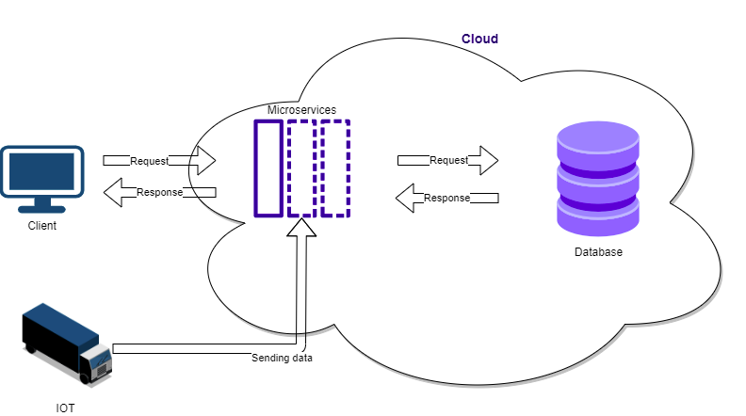

Figure 1: High Level System Architecture

Diagram for high level system architecture.

As showcased in above image, in terms of the high-level architecture design we will expose an application program interface (API) to utilize our software. Our system will primarily follow microservice architecture with all the elements, principles and types in it for server-side development. Since our system is deployed on a cloud server, which clients can access from anywhere, it will be based on client server architecture for that part. The system will be following layered architecture because our system contains three layers presentation layer, business layer and database layer. Presentation layer consists of the interface of the system developed in Quasar, a framework of vue.js. Business layer consists of the business logic of the system in spring boot microservices. Finally, we have the database layer containing all the data of the system, this layer uses Apache Ignite as a DBMS.

### Low-Level Architecture

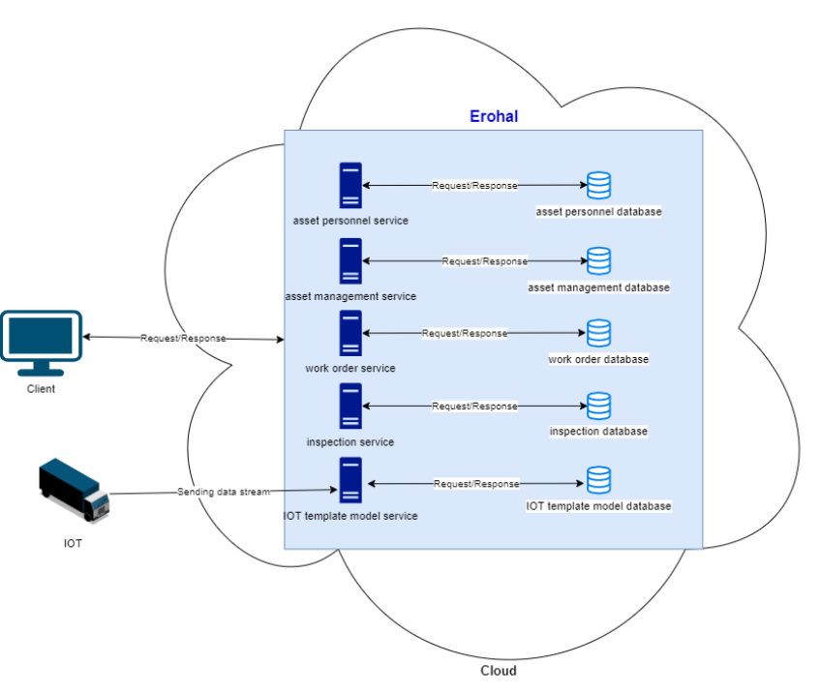

Figure 2: Low Level System Architecture

Diagram for low level system architecture.

As showcased in the above image, users will be able to send a request to the server in order to perform operations. The users have to first authenticate through our System residing in the cloud. Moreover, all services will be able to communicate with each other through Kafka calls (Posta, 2016). Following data flow architecture, data from the IOT devices will be sent to IOT template model service, which then will be stored in its database and further passed on to inspection service for predictive maintenance.

### Component Diagram

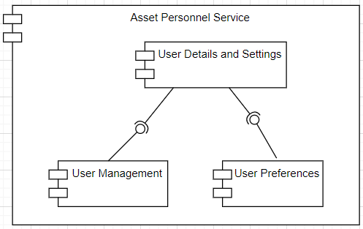

Figure 3: Asset Personnel Service Component

Component Diagram of Asset Personnel Service.

Asset personnel service primarily deals with user profile and settings. Apart from having user authentication details, user management and user preferences also make up this service. In the User management module, there are options to create a user or a user group, and also manage roles and permissions of a user, such as, giving all or selected/custom rights to each user. Whereas, in user preference, a user can set his basic preference related to language, currency, time zone etc. Finally, after the initial setup, a user will be able to view his profile and can add or modify his personal information and details, including his credentials.

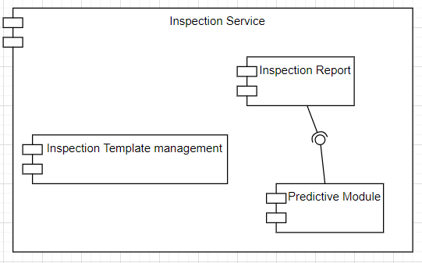

Figure 4: Inspection Service Component

Component Diagram of Inspection Service.

Inspection service components will include inspection template management, predictive module and inspection reports. Inspection template management will be responsible for creating and managing inspection templates that will be used in inspections of an asset. The predictive module will take previous history of an asset and its current data and provides information for predictive fault detection. Inspection report module will take predictive fault detection information and generate a report which can later be used for creating issues and work order assignment.

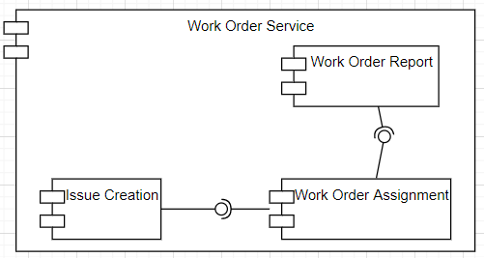

Figure 5: Works Order Service Component

Component Diagram of Work Order Service.

Work order service components will include issue creation, work order assignment and work order report. Issue creation will take input from an inspection report and generate an issue based on that inspection report. Work order assignment will assign the work order to relevant personnel based on the issues created by the issue creation module. Work order report will generate a report on maintenance of an asset.

## Architectural Strategies

### Spring Boot, Python, Vue.js

Web applications are usually divided into server and client side with a database. For DBMS we are using Apache Ignite which provides fast data manipulation with its in-memory storage facility. For server-side programming spring boot will be used which is a java-based framework as it provides great facilities for API development. Python is the best programming language when it comes to data science. The fast-built-in libraries of python make it the ideal option in today’s advanced IT solutions. The methods we would be using require complex numerical and scientific calculations which are well accommodated by python. So, our machine learning based predictive models will be developed using python. For the client-side development, we are using Quasar which is a Vue.js based framework.

### Future plans for enhancing software

Currently, for the scope of our final year project the application would target only the predictive maintenance of vehicles and more specifically trucks. In future we would make the process of predictive maintenance more generalized for any asset owned by a person or organization.

### User interface paradigms

For the user interface, the eight golden rules for interface designing would be utilized which are part of the standards of human computer interaction laid by Ben Shneiderman [9]. This is essential for implementation of a good UI design. Overall interface will be user friendly so that novice users will not have to face any difficulties to use our system.

### Error detection and recovery

If a user performs any restricted or unrelated action then proper error handling will be done by giving him appropriate response for that action and providing him the facility to correct his mistakes and re-perform his action.

### Reuse of software components to implement different parts of system

Spring boot has built-in libraries for object relational mapping, we will be using Ignite Repository for object relational mapping. Spring boot also provides built-in annotations to convert data objects in JSON format. We will be using built-in CSS provided by bootstrap to design our interfaces.

### Memory management policies

Our system will not store any user data offline. Users should have an internet connection to use our system and all the data will be fetched from DB placed on cloud at runtime.

## Use Cases

### Login Account

|  |  |  |  |  |
| --- | --- | --- | --- | --- |
| **Name** | | Login Account | | |
| **Actors** | | Admin | | |
| **Summary** | | Admin will be able to login into account. | | |
| **Pre-Conditions** | | Admin is registered in the system. | | |
| **Post-Conditions** | | Admin will be login successfully | | |
| **Special Requirements** | | None | | |
| **Basic Flow** | | | | |
| **Actor Action** | | | **System Response** | |
| 1 | Admin open the login page. | | 2 | Login page is displayed asking for email and password |
| 3 | Enter valid credentials and press submit. | | 4 | System verify the credentials and redirects the user to the home page. |
| **Alternative Flow** | | | | |
| **Actor Action** | | | **System Response** | |
| 3 | User enter invalid email or password. | | 4-A | Alter the user if incorrect login credentials and system prompt the error message: *Incorrect email or password entered.* |

### View Inspections List

|  |  |  |  |  |
| --- | --- | --- | --- | --- |
| **Name** | | View Inspections List | | |
| **Actors** | | Admin | | |
| **Summary** | | Admin will be able to see list of all the inspection. | | |
| **Pre-Conditions** | | Admin is logged in. | | |
| **Post-Conditions** | | Records of all the inspections will be displayed. | | |
| **Special Requirements** | | None | | |
| **Basic Flow** | | | | |
| **Actor Action** | | | **System Response** | |
| 1 | Clicks on inspection tab. | | 2 | List of inspections is displayed. |
| **No Alternative Flow** | | | | |

### 

### Inspection Details

|  |  |  |  |  |
| --- | --- | --- | --- | --- |
| **Name** | | Inspection Details | | |
| **Actors** | | Admin | | |
| **Summary** | | Admin will be able to see details of an inspection. | | |
| **Pre-Conditions** | | Admin should be on inspections tab. | | |
| **Post-Conditions** | | Details about an inspection are displayed. | | |
| **Special Requirements** | | None | | |
| **Basic Flow** | | | | |
| **Actor Action** | | | **System Response** | |
| 1 | Clicks on the search button on the right of the inspection. | | 2 | Detailed information about a specific inspection is displayed. |
| **No Alternative Flow** | | | | |

### View Issues List

|  |  |  |  |  |
| --- | --- | --- | --- | --- |
| **Name** | | View Issues List | | |
| **Actors** | | Admin | | |
| **Summary** | | Admin will be able to see all the issues. | | |
| **Pre-Conditions** | | Admin is logged in. | | |
| **Post-Conditions** | | Records of all the issues will be displayed. | | |
| **Special Requirements** | | None | | |
| **Basic Flow** | | | | |
| **Actor Action** | | | **System Response** | |
| 1 | Clicks on Issues tab. | | 2 | List of issues is displayed. |
| **No Alternative Flow** | | | | |

### Issues Details

|  |  |  |  |  |
| --- | --- | --- | --- | --- |
| **Name** | | Issue Details | | |
| **Actors** | | Admin | | |
| **Summary** | | Admin will be able to see details of a particular issue. | | |
| **Pre-Conditions** | | Admin should be on issues tab. | | |
| **Post-Conditions** | | Details of an issue will be displayed. | | |
| **Special Requirements** | | None | | |
| **Basic Flow** | | | | |
| **Actor Action** | | | **System Response** | |
| 1 | Clicks on the search button on the right of the issue. | | 2 | Detailed information about a specific issue is displayed. |
| **No Alternative Flow** | | | | |

### Edit Issue

|  |  |  |  |  |
| --- | --- | --- | --- | --- |
| **Name** | | Edit Issue | | |
| **Actors** | | Admin | | |
| **Summary** | | Admin will be able to edit details of a particular issue. | | |
| **Pre-Conditions** | | Admin can see details of an issue. | | |
| **Post-Conditions** | | Details of an issue are updated. | | |
| **Special Requirements** | | None | | |
| **Basic Flow** | | | | |
| **Actor Action** | | | **System Response** | |
| 1 | Clicks on the “Edit issue” button. | | 2 | Write operations are enabled for changing. |
| 3 | Enters the new information, clicks “Update issue” button. | | 4 | Issue will be updated and admin will be informed with a pop up message. |
| **Alternative Flow** | | | | |
| 3-A | Clicks on “cancel update” button. | | 4-A | Asks for confirmation of action. |
| 5 | Clicks on positive confirmation. | | 6 | Cancel updates and display issue details. |
| 5-A | Clicks on negative confirmation. | | 6-A | Returns to the updating process. |

### Create Inspection Template

|  |  |  |  |  |
| --- | --- | --- | --- | --- |
| **Name** | | Create Inspection Template | | |
| **Actors** | | Admin | | |
| **Summary** | | Admin will be able to create a template for inspections. | | |
| **Pre-Conditions** | | Admin must be logged in. | | |
| **Post-Conditions** | | A new inspection template is created. | | |
| **Special Requirements** | | None | | |
| **Basic Flow** | | | | |
| **Actor Action** | | | **System Response** | |
| 1 | From settings Admin selects “manage templates”. | | 2 | Create template form appears on the screen. |
| 3 | Fill all the required fields in the form and click “create” button. | | 4 | A confirmation message will be displayed on the screen. |
| **No Alternative Flow** | | | | |

### Update Inspection Template Type

|  |  |  |  |  |
| --- | --- | --- | --- | --- |
| **Name** | | Update Type Inspection Template | | |
| **Actors** | | Admin | | |
| **Summary** | | Admin will be able to update type of an existing inspection template. | | |
| **Pre-Conditions** | | The template should already exist. | | |
| **Post-Conditions** | | The type of template is updated. | | |
| **Special Requirements** | | None | | |
| **Basic Flow** | | | | |
| **Actor Action** | | | **System Response** | |
| 1 | Admin selects the asset category from a drop down. | | 2 | System enables the template selection drop down. |
| 3 | Admin selects the template he/she wants to update from the drop down. | | 4 | System will enable write operations for that template. |
| 5 | User selects the type of template from the drop down and clicks update button. | | 6 | Type of the template will be updated. |
| **No Alternative Flow** | | | | |

### Add Item to Existing Template

|  |  |  |  |  |
| --- | --- | --- | --- | --- |
| **Name** | | Add Item to Existing Template | | |
| **Actors** | | Admin | | |
| **Summary** | | Admin will be able to add new inspection items to the template. | | |
| **Pre-Conditions** | | The template should already exist. | | |
| **Post-Conditions** | | A new item will be added to the inspection template. | | |
| **Special Requirements** | | None | | |
| **Basic Flow** | | | | |
| **Actor Action** | | | **System Response** | |
| 1 | Admin selects the asset category from a drop down. | | 2 | System enables the template selection drop down. |
| 3 | Admin selects the template in which he/she wants to add a new item from the drop down | | 4 | System will enable write operations for that template. |
| 5 | Admin fills all the required fields and clicks “add item” button. | | 6 | New item will be added to the inspection template. |
| **No Alternative Flow** | | | | |

### Remove Inspection Template Item

|  |  |  |  |  |
| --- | --- | --- | --- | --- |
| **Name** | | Remove Inspection Template Item | | |
| **Actors** | | Admin | | |
| **Summary** | | Admin will be able to remove an inspection item from a template. | | |
| **Pre-Conditions** | | The template and the item should already exist. | | |
| **Post-Conditions** | | An inspection item will be removed. | | |
| **Special Requirements** | | Node | | |
| **Basic Flow** | | | | |
| **Actor Action** | | | **System Response** | |
| 1 | Admin selects the asset category from a drop down. | | 2 | System enables the template selection drop down. |
| 3 | Admin selects the template from which he/she wants to remove an item from the drop down | | 4 | System will enable write operations for that template. |
| 5 | Admin selects the desired item from the bottom of the screen. | | 6 | System will expand that item. |
| 7 | Admin clicks on the delete button. | | 8 | Item will be deleted from the template. |
| **No Alternative Flow** | | | | |

### Update Inspection Item Type

|  |  |  |  |  |
| --- | --- | --- | --- | --- |
| **Name** | | Update Inspection Item Type | | |
| **Actors** | | Admin | | |
| **Summary** | | Admin will be able to update type of inspection item from a template. | | |
| **Pre-Conditions** | | The template and the item should already exist. | | |
| **Post-Conditions** | | An inspection item’s type will be updated. | | |
| **Special Requirements** | | Node | | |
| **Basic Flow** | | | | |
| **Actor Action** | | | **System Response** | |
| 1 | Admin selects the asset category from a drop down. | | 2 | System enables the template selection drop down. |
| 3 | Admin selects the template of which he/she wants to update type of an item from the drop down | | 4 | System will enable write operations for that template. |
| 5 | Admin selects the desired item from the bottom of the screen. | | 6 | System will expand that item. |
| 7 | Admin selects the required type from a drop down and clicks “update template” button. | | 8 | Type of the item will be changed. |
| **No Alternative Flow** | | | | |

### Create Issue

|  |  |  |  |  |
| --- | --- | --- | --- | --- |
| **Name** | | Create Issue | | |
| **Actors** | | Admin | | |
| **Summary** | | Admin will be able to create issue from an inspection. | | |
| **Pre-Conditions** | | Admin must be logged in and has opened details of an inspection. | | |
| **Post-Conditions** | | A new issue will be created. | | |
| **Special Requirements** | | Inspection item must be failed to create a new issue. | | |
| **Basic Flow** | | | | |
| **Actor Action** | | | **System Response** | |
| 1 | Admin selects the inspection item that is failed from the bottom of the screen. | | 2 | System will expand the inspection item and show its details. |
| 3 | Admin clicks on “create new issue” button. | | 4 | A new form will appear. |
| 5 | Admin fills all the fields in the form and clicks “create issue” button. | | 6 | System creates a new issue and displays a confirmation message. |
| **No Alternative Flow** | | | | |

### Ignore Inspection

|  |  |  |  |  |
| --- | --- | --- | --- | --- |
| **Name** | | Ignored Failed Inspection | | |
| **Actors** | | Admin | | |
| **Summary** | | Admin will be able to ignore an inspection. | | |
| **Pre-Conditions** | | Admin must be logged in and has opened details of an inspection. | | |
| **Post-Conditions** | | An inspection will be ignored. | | |
| **Special Requirements** | | Inspection item must be failed. | | |
| **Basic Flow** | | | | |
| **Actor Action** | | | **System Response** | |
| 1 | Admin selects the inspection item that is failed from the bottom of the screen. | | 2 | System will expand the inspection item and show its details. |
| 3 | Admin clicks on “ignore” button. | | 4 | A pop up will appear asking for comments. |
| 5 | Admin enters comments regarding the inspection item and clicks “ignore issue” button. | | 6 | Issue will be ignored with a confirmation message. |
| **No Alternative Flow** | | | | |
| 5-A | Admin selects “cancel” button. | | 6-A | The pop up will disappear and inspection item’s details are displayed again. |

### Merge Issues

|  |  |  |  |  |
| --- | --- | --- | --- | --- |
| **Name** | | Merge Issues | | |
| **Actors** | | Admin | | |
| **Summary** | | Admin will be able to merge multiple issues. | | |
| **Pre-Conditions** | | Admin must be logged in and has opened details of an inspection. | | |
| **Post-Conditions** | | Multiple issues will be merged. | | |
| **Special Requirements** | | Inspection item must be failed. | | |
| **Basic Flow** | | | | |
| **Actor Action** | | | **System Response** | |
| 1 | Admin selects the inspection item that is failed from the bottom of the screen. | | 2 | System will expand the inspection item and show its details. |
| 3 | Admin clicks on “Merge with existing” button. | | 4 | A pop up will appear and with a drop down in it. |
| 5 | Admin selects the issue from the drop down and clicks “merge” button. | | 6 | System will merge the issues. |
| **No Alternative Flow** | | | | |

### View all Service Requests

|  |  |  |  |  |
| --- | --- | --- | --- | --- |
| **Name** | | View Service Requests | | |
| **Actors** | | Admin | | |
| **Summary** | | Admin will be able to see all service requests. | | |
| **Pre-Conditions** | | Admin should be login in the system. | | |
| **Post-Conditions** | | Admin should see all service requests successfully | | |
| **Special Requirements** | | None | | |
| **Basic Flow** | | | | |
| **Actor Action** | | | **System Response** | |
| 1 | Admin click on service request from left side menu. | | 2 | All service requests will be displayed. |
| **Alternative Flow** | | | | |
| **Actor Action** | | | **System Response** | |
| 1 | Admin click on service request from left side menu. | | 2-A | If there is no service request then admin will see nothing. |

### Create new Service Request

|  |  |  |  |  |
| --- | --- | --- | --- | --- |
| **Name** | | Create new service request | | |
| **Actors** | | Admin | | |
| **Summary** | | Admin will be able to create new service request. | | |
| **Pre-Conditions** | | Admin should be registered in the system and also on the service request section. | | |
| **Post-Conditions** | | Admin should be able to create new service request successfully. | | |
| **Special Requirements** | | None | | |
| **Basic Flow** | | | | |
| **Actor Action** | | | **System Response** | |
| 1 | Admin click on create new in service request page. | | 2 | Another page open with all the requirements of create new service request. |
| 3 | Select service type and title. | | 4 | Allow the admin to write on type and title. |
| 5 | Admin can select a file for service request. | | 6 | System shows file explore for selecting a data file. |
| 7 | Admin click on open. | | 8 | A new file will be attached. |
| 8 | Click on create service request | | 10 | New service request will be created |
| **Alternative Flow** | | | | |
| **Actor Action** | | | **System Response** | |
| 1 | Admin click on create service request button. | | 2-A | If there remain one requirement unfilled then system will show the admin that these fields are required. |

### Examine Service Request

|  |  |  |  |  |
| --- | --- | --- | --- | --- |
| **Name** | | View individual service request. | | |
| **Actors** | | Admin | | |
| **Summary** | | Admin will be able to see service request of particular person. | | |
| **Pre-Conditions** | | Admin should be registered in the system and also on service request section. | | |
| **Post-Conditions** | | Admin should be able to examine each service request. | | |
| **Special Requirements** | | None | | |
| **Basic Flow** | | | | |
| **Actor Action** | | | **System Response** | |
| 1 | Admin click on left side search button. | | 2 | Another page open with all the information of that service request will open. |
| **No Alternative Flow** | | | | |

### View Work Orders

|  |  |  |  |  |
| --- | --- | --- | --- | --- |
| **Name** | | View work orders | | |
| **Actors** | | Admin | | |
| **Summary** | | Admin will be able to see all work orders. | | |
| **Pre-Conditions** | | Admin should be login in the system. | | |
| **Post-Conditions** | | Admin should see all work orders successfully | | |
| **Special Requirements** | | None | | |
| **Basic Flow** | | | | |
| **Actor Action** | | | **System Response** | |
| 1 | Admin click on work orders from left side menu. | | 2 | All work orders will be displayed. |
| **No Alternative Flow** | | | | |

### Examine Work Order

|  |  |  |  |  |
| --- | --- | --- | --- | --- |
| **Name** | | View individual work order. | | |
| **Actors** | | Admin | | |
| **Summary** | | Admin will be work order of particular issue. | | |
| **Pre-Conditions** | | Admin should be registered in the system and also on work order section. | | |
| **Post-Conditions** | | Admin should be able to examine that work order. | | |
| **Special Requirements** | | None | | |
| **Basic Flow** | | | | |
| **Actor Action** | | | **System Response** | |
| 1 | Admin click on left side search button. | | 2 | Another page open with all the information of that work order will open. |
| **No Alternative Flow** | | | | |

### Create new Work Order

|  |  |  |  |  |
| --- | --- | --- | --- | --- |
| **Name** | | Create new work order | | |
| **Actors** | | Admin | | |
| **Summary** | | Admin will create new service request. | | |
| **Pre-Conditions** | | Admin should be registered in the system and also on the work order section or examining the issue or can also create work order in issue section by selecting a particular issue. | | |
| **Post-Conditions** | | Admin should be able to create new work order of a selected issue section successfully. | | |
| **Special Requirements** | | There should be an issue of asset. | | |
| **Basic Flow** | | | | |
| **Actor Action** | | | **System Response** | |
| 1 | Admin click on create new in work order. | | 2 | Redirect the admin in issue section where all issues all visible. |
| 3 | Select a particular issue. | | 4 | Issue will be selected. |
| 5 | Admin then again click on create. | | 6 | System will show the admin to create work order for existing work order or create new. |
| 7 | Admin select one new option. | | 8 | A new work order will be created. |
| **Alternative Flow** | | | | |
| **Actor Action** | | | **System Response** | |
| 1 | Admin click on create work order button. | | 2-A | If there remain one requirement unfilled then system will show the admin that these fields are required. |

### Select Inspection Template

|  |  |  |  |  |
| --- | --- | --- | --- | --- |
| **Name** | | Select Inspection Template. | | |
| **Actors** | | Admin | | |
| **Summary** | | Admin will select existing inspection template in creating new work order. | | |
| **Pre-Conditions** | | Admin should be registered in the system and also creating new work order. | | |
| **Post-Conditions** | | System will add new inspection template in creating work order. | | |
| **Special Requirements** | | None | | |
| **Basic Flow** | | | | |
| **Actor Action** | | | **System Response** | |
| 1 | Admin click on left side add existing inspection template button. | | 2 | Another page open asking to admin what type of inspection you want i.e. asset, asset category, work order. |
| 3 | Admin select one of category. | | 4 | A new inspection template will add. |
| **No Alternative Flow** | | | | |

### Creating New Inspection

|  |  |  |  |  |
| --- | --- | --- | --- | --- |
| **Name** | | Creating new Inspection. | | |
| **Actors** | | Admin | | |
| **Summary** | | Admin will create new inspection for work order. | | |
| **Pre-Conditions** | | Admin should be registered in the system and also creating new work order. | | |
| **Post-Conditions** | | System will add new inspection for creating work order. | | |
| **Special Requirements** | | None | | |
| **Basic Flow** | | | | |
| **Actor Action** | | | **System Response** | |
| 1 | Admin click on left side ‘+’ button. | | 2 | Another page open asking to admin what type of inspection you want. |
| 3 | Admin select one of category. | | 4 | Category will add in inspection. |
| 5 | Admin can also add more fields about inspection for work order. | | 6 | All this will be stored in inspection template. |
| **No Alternative Flow** | | | | |

### Add Issue in Work Order

|  |  |  |  |  |
| --- | --- | --- | --- | --- |
| **Name** | | Add issue in work order. | | |
| **Actors** | | Admin | | |
| **Summary** | | Admin will add issue in work order. | | |
| **Pre-Conditions** | | Admin should be registered in the system and also creating new work order. | | |
| **Post-Conditions** | | System will add new issue in that work order. | | |
| **Special Requirements** | | None | | |
| **Basic Flow** | | | | |
| **Actor Action** | | | **System Response** | |
| 1 | Admin click on add issue button which is at the bottom. | | 2 | System will ask the admin for issue. |
| 3 | Admin will select category. | | 4 | An issue category will be added. |
| **No Alternative Flow** | | | | |

### User Assignment

|  |  |  |  |  |
| --- | --- | --- | --- | --- |
| **Name** | | User Assignment. | | |
| **Actors** | | Admin | | |
| **Summary** | | Admin will assign work order to user or group. | | |
| **Pre-Conditions** | | Admin should be registered in the system and also creating new work order. | | |
| **Post-Conditions** | |  | | |
| **Special Requirements** | | None | | |
| **Basic Flow** | | | | |
| **Actor Action** | | | **System Response** | |
| 1 | Admin user assignment. | | 2 | System will ask admin for user or group. |
| 3 | Admin will select one option. | | 4 | Work order will be assigned. . |
| **No Alternative Flow** | | | | |

### Asset Information

|  |  |  |  |  |
| --- | --- | --- | --- | --- |
| **Name** | | Asset Information. | | |
| **Actors** | | Admin | | |
| **Summary** | | Admin will see asset information in work order. | | |
| **Pre-Conditions** | | Admin should be registered in the system and also creating new work order. | | |
| **Post-Conditions** | | Admin will see asset information. | | |
| **Special Requirements** | | None | | |
| **Basic Flow** | | | | |
| **Actor Action** | | | **System Response** | |
| 1 | Admin will click on asset information. | | 2 | System will show the information about the asset. |
| **No Alternative Flow** | | | | |

### Work Order Assignment

|  |  |  |  |  |
| --- | --- | --- | --- | --- |
| **Name** | | Work Order Assignment. | | |
| **Actors** | | Admin | | |
| **Summary** | | Admin will see that whom the work order was assigned. | | |
| **Pre-Conditions** | | Admin should be registered in the system and also examining work order. | | |
| **Post-Conditions** | | Admin will see work order assignment. | | |
| **Special Requirements** | | None | | |
| **Basic Flow** | | | | |
| **Actor Action** | | | **System Response** | |
| 1 | Admin will click on assignment. | | 2 | System will show information of assigned work order. |
| **No Alternative Flow** | | | | |

### Timing

|  |  |  |  |  |
| --- | --- | --- | --- | --- |
| **Name** | | Timing. | | |
| **Actors** | | Admin | | |
| **Summary** | | Admin will see of timing of work order and can also add time. | | |
| **Pre-Conditions** | | Admin should be registered in the system and also examining work order. | | |
| **Post-Conditions** | | Admin will see timing of work order. | | |
| **Special Requirements** | | None | | |
| **Basic Flow** | | | | |
| **Actor Action** | | | **System Response** | |
| 1 | Admin will click on timing. | | 2 | System will show the timing. |
| 3 | Admin click on add time. | | 4 | System will ask time and work order category. |
| 5 | Admin will write all information and timing | | 6 | System will add new time. |
| **No Alternative Flow** | | | | |

### Parts and Cost

|  |  |  |  |  |
| --- | --- | --- | --- | --- |
| **Name** | | Parts and Cost. | | |
| **Actors** | | Admin | | |
| **Summary** | | Admin will see parts and cost. He can also add parts and cost in work order. | | |
| **Pre-Conditions** | | Admin should be registered in the system and also examining work order. | | |
| **Post-Conditions** | | Admin will see added parts of work order and also add parts and their cost. | | |
| **Special Requirements** | | None | | |
| **Basic Flow** | | | | |
| **Actor Action** | | | **System Response** | |
| 1 | Admin will click on parts and costs. | | 2 | System will show added parts and cost in work order. |
| 3 | Admin click on add parts. | | 4 | System will ask parts information. |
| 5 | Admin will click add costs. | | 6 | System will ask category and cost. |
| 7 | Admin will click Add button. | | 8 | New parts and cost will be added. |
| **No Alternative Flow** | | | | |

### View Assets

|  |  |  |  |  |
| --- | --- | --- | --- | --- |
| **Name** | | View Assets | | |
| **Actors** | | Admin, User | | |
| **Summary** | | User will be able to view his/her assets | | |
| **Pre-Conditions** | | User should be logged in. | | |
| **Post-Conditions** | | User successfully viewed his/her assets | | |
| **Special Requirements** | | None | | |
| **Basic Flow** | | | | |
|  | **Actor Action** | | **System Response** | |
| 1 | User clicks on the assets from Dashboard. | | 2 | System loads the assets page. |
| **Alternative Flow** | | | | |
| 1 | User clicks on the assets from the side menu. | | 2-A | System loads the assets page. |

### Create Asset

|  |  |  |  |  |
| --- | --- | --- | --- | --- |
| **Name** | | Create Asset | | |
| **Actors** | | Admin, User | | |
| **Summary** | | User will be able to add assets | | |
| **Pre-Conditions** | | User should be on Assets page | | |
| **Post-Conditions** | | Admin and User added assets successfully | | |
| **Special Requirements** | | None | | |
| **Basic Flow** | | | | |
| **Actor Action** | | | **System Response** | |
| 1 | User clicks on Create Asset. | | 2 | Create New Asset page is displayed, showing asset detail, asset description, asset category, gallery and attachments needed to be filled. |
| 3 | User enters the details and press save. | | 4 | System checks the necessary fields needed to be filled and create that asset.  System prompts the success message: *Asset added successfully.* Redirects the user back to Assets page. |
| **Alternative Flow** | | | | |
| **Actor Action** | | | **System Response** | |
| 3 | User miss important fields and press save. | | 4-A | System highlighted the required fields in red and prompts the error message:  *Please fill required fields!* |

### Select Asset Category

|  |  |  |  |  |
| --- | --- | --- | --- | --- |
| **Name** | | Select Asset Category | | |
| **Actors** | | Admin, User | | |
| **Summary** | | User will be able to select the asset category from dropdown while creating new asset | | |
| **Pre-Conditions** | | User should be on Create Asset page. | | |
| **Post-Conditions** | | User successfully selected an asset category | | |
| **Special Requirements** | | None | | |
| **Basic Flow** | | | | |
|  | **Actor Action** | | **System Response** | |
| 1 | User clicks on the dropdown menu on Asset Category section | | 2 | System pops the dropdown of already added asset categories. |
| 3 | User clicks on the desired asset category. | | 4 | System highlighted the selected category. |
| **Alternative Flow** | | | | |
| 1 | User unable to click on the dropdown menu on Asset Category section | | 2-A | System does not have any added category. |

### Add Asset Image

|  |  |  |  |  |
| --- | --- | --- | --- | --- |
| **Name** | | Add Asset Image | | |
| **Actors** | | Admin, User | | |
| **Summary** | | User will be able to add an asset image while creating new asset | | |
| **Pre-Conditions** | | User should be on Create Asset page. | | |
| **Post-Conditions** | | User successfully added an asset image | | |
| **Special Requirements** | | None | | |
| **Basic Flow** | | | | |
|  | **Actor Action** | | **System Response** | |
| 1 | User selects the gallery tab on Create New Asset page. | | 2 | System displays the gallery tab with a big plus icon on it. |
| 3 | User clicks on the plus icon. | | 4 | System pops the open window showing files stored on your local machine. |
| 5 | User selects the image and clicks on open. | | 6 | System inserts the image on the gallery tab. |
| **Alternative Flow** | | | | |
| 5 | User selects file other than that of image and clicks on open. | | 6-A | System does not add other files. |

### Add an assignment

|  |  |  |  |  |
| --- | --- | --- | --- | --- |
| **Name** | | Add an assignment | | |
| **Actors** | | Admin, User | | |
| **Summary** | | User will be able to add assignments of an asset | | |
| **Pre-Conditions** | | User should be on view Asset page | | |
| **Post-Conditions** | | Admin and User added an assignment successfully | | |
| **Special Requirements** | | None | | |
| **Basic Flow** | | | | |
| **Actor Action** | | | **System Response** | |
| 1 | User selects the Assignment tab. | | 2 | System displays the assignment tab. |
| 3 | User clicks on the add button. | | 4 | System pops a small window showing dropdown list of available users. |
| 5 | User clicks on dropdown menu of the available users. | | 6 | System shows the list of the available users. |
| 7 | User selects the desired user. | | 8 | System displays his/her name on the dropdown. |
| 9 | User clicks on the assign button. | | 10 | System assigned the user and prompts the successful message: *Asset Assigned to user Successfully*. |
| **Alternative Flow** | | | | |
| **Actor Action** | | | **System Response** | |
| 9 | User clicks on the assign button after selecting an already assigned user. | | 10-A | System does nothing and prompts the error message:  *Please assign another user!* |

### Delete an assignment

|  |  |  |  |  |
| --- | --- | --- | --- | --- |
| **Name** | | Delete an assignment | | |
| **Actors** | | Admin, User | | |
| **Summary** | | User will be able to delete assignments of an asset | | |
| **Pre-Conditions** | | User should be on view Asset page | | |
| **Post-Conditions** | | Admin and User deleted an assignment successfully | | |
| **Special Requirements** | | None | | |
| **Basic Flow** | | | | |
| **Actor Action** | | | **System Response** | |
| 1 | User selects the Assignment tab. | | 2 | System displays the assignment tab. |
| 3 | User clicks on the delete icon. | | 4 | System pops a small window showing warning whether you user want to delete it or not. |
| 5 | User selects I’m sure. | | 6 | System delete the assigned user and prompts the successful message: *User Un-assigned Successfully*. |
| **Alternative Flow** | | | | |
| **Actor Action** | | | **System Response** | |
| 5 | User No instead of I’m sure. | | 6-A | System returns to the previous page. |

### View Usages

|  |  |  |  |  |
| --- | --- | --- | --- | --- |
| **Name** | | View Usages | | |
| **Actors** | | Admin, User | | |
| **Summary** | | User will be able to view his/her asset usages | | |
| **Pre-Conditions** | | User should be logged in. | | |
| **Post-Conditions** | | User successfully viewed his/her assets usages | | |
| **Special Requirements** | | None | | |
| **Basic Flow** | | | | |
|  | **Actor Action** | | **System Response** | |
| 1 | User clicks on the usage from the side menu. | | 2 | System loads the usages page. |

### View filtered usages of an asset

|  |  |  |  |  |
| --- | --- | --- | --- | --- |
| **Name** | | View filtered usages of an asset | | |
| **Actors** | | Admin, User | | |
| **Summary** | | User will be able to view filtered usages of an asset | | |
| **Pre-Conditions** | | User should be on Usages page | | |
| **Post-Conditions** | | Admin and User viewed filtered usages of his/her asset successfully | | |
| **Special Requirements** | | None | | |
| **Basic Flow** | | | | |
| **Actor Action** | | | **System Response** | |
| 1 | User clicks on the dropdown menu in usages page. | | 2 | System displays the list of all his/her assets. |
| 3 | User selects the desired asset. | | 4 | System selects that asset. |
| 5 | User selects start date and end date and then clicks on filter button. | | 6 | System shows all the usages of the selected asset from start date till end date. |
| **Alternative Flow** | | | | |
| **Actor Action** | | | **System Response** | |
| 5 | User clicks on filter button without selecting start date and end date. | | 6-A | System displays all the usages of selected asset from the day it was created till now. |

### View Consumptions

|  |  |  |  |  |
| --- | --- | --- | --- | --- |
| **Name** | | View Consumptions | | |
| **Actors** | | Admin, User | | |
| **Summary** | | User will be able to view his/her assets consumptions | | |
| **Pre-Conditions** | | User should be logged in. | | |
| **Post-Conditions** | | User successfully viewed his/her assets consumptions | | |
| **Special Requirements** | | None | | |
| **Basic Flow** | | | | |
|  | **Actor Action** | | **System Response** | |
| 1 | User clicks on the Consumption from the side menu. | | 2 | System loads the consumptions page. |

### View filtered consumptions of an asset

|  |  |  |  |  |
| --- | --- | --- | --- | --- |
| **Name** | | View filtered consumptions of an asset | | |
| **Actors** | | Admin, User | | |
| **Summary** | | User will be able to view filtered consumptions of an asset | | |
| **Pre-Conditions** | | User should be on Consumptions page | | |
| **Post-Conditions** | | Admin and User viewed filtered consumptions of his/her asset successfully | | |
| **Special Requirements** | | None | | |
| **Basic Flow** | | | | |
| **Actor Action** | | | **System Response** | |
| 1 | User clicks on the dropdown menu in consumptions page. | | 2 | System displays the list of all his/her assets. |
| 3 | User selects the desired asset. | | 4 | System selects that asset. |
| 5 | User selects start date and end date and then clicks on filter button. | | 6 | System shows all the consumptions of the selected asset from start date till end date. |
| **Alternative Flow** | | | | |
| **Actor Action** | | | **System Response** | |
| 5 | User clicks on filter button without selecting start date and end date. | | 6-A | System displays all the consumptions of selected asset from the day it was created till now. |

### Edit Profile

|  |  |  |  |  |
| --- | --- | --- | --- | --- |
| **Name** | | Edit profile | | |
| **Actors** | | Admin/User | | |
| **Summary** | | User will be able to edit his profile details | | |
| **Pre-Conditions** | | User profile page is displayed | | |
| **Post-Conditions** | | User successfully edits and updates his profile details | | |
| **Special Requirements** | | None | | |
| **Basic Flow** | | | | |
| **Actor Action** | | | **System Response** | |
| 1 | User clicks on the edit button. | | 2 | Edit profile page is displayed, showing all of user’s editable fields. |
| 3 | User edits his desirable fields and clicks the update button. | | 4 | System successfully updates the user’s profile details. |
| **Alternative Flow** | | | | |
| **Actor Action** | | | **System Response** | |
| 3 | User enters invalid details or leaves it empty. | | 4-A | System displays an error message prompting the user to enter details in the correct format. |

### View User Profile

|  |  |  |  |  |
| --- | --- | --- | --- | --- |
| **Name** | | View user profile | | |
| **Actors** | | Admin/User | | |
| **Summary** | | User will be able to view his or her profile | | |
| **Pre-Conditions** | | User is logged in to the system | | |
| **Post-Conditions** | | User profile is displayed | | |
| **Special Requirements** | | None | | |
| **Basic Flow** | | | | |
| **Actor Action** | | | **System Response** | |
| 1 | User clicks on the profile icon. | | 2 | System shows a pop up with options to view profile or log out. |
| 3 | Users clicks on the profile option. | | 4 | System displays user profile page. |
| **Alternative Flow** | | | | |
| 1 | User clicks on the settings tab. | | 2-A | Settings page is displayed with four options; *Profile, Mange Templates, User Management, User Preferences* |

### View Assets Assignment History

|  |  |  |  |  |
| --- | --- | --- | --- | --- |
| **Name** | | View Assets Assignment History | | |
| **Actors** | | Admin | | |
| **Summary** | | User will be able to see all the assets and their total assignments | | |
| **Pre-Conditions** | | User profile page is displayed | | |
| **Post-Conditions** | | Assets assignment history page is displayed | | |
| **Special Requirements** | | None | | |
| **Basic Flow** | | | | |
| **Actor Action** | | | **System Response** | |
| 1 | User clicks on the asset assignment history tab. | | 2 | Asset assignment history page is displayed to the user. |
| **No Alternative Flow** | | | | |

### Change Password

|  |  |  |  |  |
| --- | --- | --- | --- | --- |
| **Name** | | Change Password | | |
| **Actors** | | Admin/User | | |
| **Summary** | | User will be able to change his password | | |
| **Pre-Conditions** | | User profile page is displayed | | |
| **Post-Conditions** | | Password is successfully updated | | |
| **Special Requirements** | | None | | |
| **Basic Flow** | | | | |
|  | **Actor Action** | | **System Response** | |
| 1 | User clicks on the change your password tab. | | 2 | System displays the change password page and asks for old and new password. |
| 3 | Enter valid credentials and update. | | 4 | System verifies credentials, updates it and shows the “password updated successfully” popup message. |
| **No Alternative Flow** | | | | |

### View User Management Page

|  |  |  |  |  |
| --- | --- | --- | --- | --- |
| **Name** | | View User Management page | | |
| **Actors** | | Admin | | |
| **Summary** | | User will be able to view his user management page | | |
| **Pre-Conditions** | | User is logged in to the system | | |
| **Post-Conditions** | | User management page is displayed | | |
| **Special Requirements** | | None | | |
| **Basic Flow** | | | | |
| **Actor Action** | | | **System Response** | |
| 1 | click on the settings tab. | | 2 | Settings page is displayed with four options; *Profile, Mange Templates, User Management, User Preferences.* |
| 3 | Click on the user management option. | | 4 | System displays user management page. |
| **No Alternative Flow** | | | | |

### Add a New Role

|  |  |  |  |  |  |  |  |
| --- | --- | --- | --- | --- | --- | --- | --- |
| **Name** | | | Add a New Role | | | | |
| **Actors** | | | Admin | | | | |
| **Summary** | | | Admin will be able to add a new role | | | | |
| **Pre-Conditions** | | | User Management page is displayed | | | | |
| **Post-Conditions** | | | New role is added successfully | | | | |
| **Special Requirements** | | | None | | | | |
| **Basic Flow** | | | | | | | |
| **Actor Action** | | | | | **System Response** | | |
| 1 | Click on the manage roles and permissions tab. | | | | 2 | | System display *manage roles and permissions* page including icons to add, delete and update role details. |
| 3 | Click on the add icon. | | | | 4 | | System asks for *Role Name* and *Role Description.* |
| 5 | Enter valid details and click create. | | | | 6 | | System successfully creates a new role. |
| **Alternative Flow** | | | | | | | |
| **Actor Action** | | | | **System Response** | | | |
| 5 | | User leaves a field empty. | | 4-A | | System displays an error message and prompts the user to fill up the field. | |
| 5 | | User clicks cancel | | 4-B | | System goes back to the previous step. | |

### Delete a Role

|  |  |  |  |  |  |  |  |
| --- | --- | --- | --- | --- | --- | --- | --- |
| **Name** | | | Delete a Role | | | | |
| **Actors** | | | Admin | | | | |
| **Summary** | | | Admin will be able to delete a role | | | | |
| **Pre-Conditions** | | | User Management page is displayed | | | | |
| **Post-Conditions** | | | The role is deleted successfully | | | | |
| **Special Requirements** | | | None | | | | |
| **Basic Flow** | | | | | | | |
| **Actor Action** | | | | | **System Response** | | |
| 1 | Click on the manage roles and permissions tab. | | | | 2 | | System displays *manage roles and permissions* page including icons to add, delete and update role details. |
| 3 | Select a role and click on the delete icon. | | | | 4 | | System asks for a confirmation to delete the role. |
| 5 | Click ‘yes’. | | | | 6 | | System successfully deletes the role. |
| **Alternative Flow** | | | | | | | |
| **Actor Action** | | | | **System Response** | | | |
| 3 | | User did not select a role. | | 4-A | | System displays an error message and prompts the user to select a role first. | |
| 5 | | User clicks ‘no’ | | 6-A | | System goes back to the previous step. | |

### Update a Role

|  |  |  |  |  |  |  |  |
| --- | --- | --- | --- | --- | --- | --- | --- |
| **Name** | | | Update a role | | | | |
| **Actors** | | | Admin | | | | |
| **Summary** | | | Admin will be able to update a role’s details | | | | |
| **Pre-Conditions** | | | User Management page is displayed | | | | |
| **Post-Conditions** | | | The role is details are successfully updated | | | | |
| **Special Requirements** | | | None | | | | |
| **Basic Flow** | | | | | | | |
| **Actor Action** | | | | | **System Response** | | |
| 1 | Click on the manage roles and permissions tab. | | | | 2 | | System displays *manage roles and permissions* page including icons to add, delete and update role details. |
| 3 | Select a role and click on the update icon. | | | | 4 | | System shows *Role Name* and *Role Description* fields to update. |
| 5 | Edit desirable fields and click ‘update’ | | | | 6 | | System successfully updates the role. |
| **Alternative Flow** | | | | | | | |
| **Actor Action** | | | | **System Response** | | | |
| 3 | | User did not select a role. | | 4-A | | System displays an error message and prompts the user to select a role first. | |
| 5 | | User clicks ‘cancel’ | | 6-A | | System goes back to the previous step. | |

### View All User groups

|  |  |  |  |  |
| --- | --- | --- | --- | --- |
| **Name** | | View All User Groups | | |
| **Actors** | | Admin | | |
| **Summary** | | User will be able to view all the user groups | | |
| **Pre-Conditions** | | User Management page is displayed | | |
| **Post-Conditions** | | User groups page is displayed | | |
| **Special Requirements** | | None | | |
| **Basic Flow** | | | | |
| **Actor Action** | | | **System Response** | |
| 1 | Click on the user groups tab. | | 2 | System displays all the user groups and their basic details such as Group Names, Group Manager, Total Members and Created by. |
| **No Alternative Flow** | | | | |

### View a User group

|  |  |  |  |  |
| --- | --- | --- | --- | --- |
| **Name** | | View a User Group | | |
| **Actors** | | Admin | | |
| **Summary** | | User will be able to view a single user group | | |
| **Pre-Conditions** | | User Groups page is displayed | | |
| **Post-Conditions** | | The selected user group page and its details are displayed | | |
| **Special Requirements** | | None | | |
| **Basic Flow** | | | | |
| **Actor Action** | | | **System Response** | |
| 1 | Click the view icon of the desired user group. | | 2 | System displays group details such as the names and profile pictures of all the group members and the manager, with options to directly remove members or to edit group users. |
| **No Alternative Flow** | | | | |

### Remove a Member from a User Group

|  |  |  |  |  |  |  |  |
| --- | --- | --- | --- | --- | --- | --- | --- |
| **Name** | | | Remove a Member from a User Group | | | | |
| **Actors** | | | Admin | | | | |
| **Summary** | | | Admin will be able to remove a member from a user group | | | | |
| **Pre-Conditions** | | | The selected user group page and its details are displayed | | | | |
| **Post-Conditions** | | | Successfully removed a member from the user group | | | | |
| **Special Requirements** | | | None | | | | |
| **Basic Flow** | | | | | | | |
| **Actor Action** | | | | | **System Response** | | |
| 1 | Click on the edit group users tab. | | | | 2 | | System displays both the members that are in the group (chosen), which can be removed, or are available to be added in the group (choices). |
| 3 | Select the members that are to be removed from the chosen column and click on the remove icon. | | | | 4 | | System moves the group members from the chosen column to the choices column. |
| 5 | Click save changes. | | | | 6 | | System removes the group members and shows the feedback pop-up message that *user group successfully updated.* |
| **Alternative Flow** | | | | | | | |
| **Actor Action** | | | | **System Response** | | | |
| 1-A | | Click delete icon from the profile information of the desired member to be removed from the group. | | 6 | | System removes the group members and shows the feedback pop-up message that *user group successfully updated.* | |

### Add a Member to a User Group

|  |  |  |  |  |
| --- | --- | --- | --- | --- |
| **Name** | | Add a Member to a User Group | | |
| **Actors** | | Admin | | |
| **Summary** | | Admin will be able to add a member to a user group | | |
| **Pre-Conditions** | | The selected user group page and its details are displayed | | |
| **Post-Conditions** | | Successfully added a member to the user group | | |
| **Special Requirements** | | None | | |
| **Basic Flow** | | | | |
| **Actor Action** | | | **System Response** | |
| 1 | Click on the edit group users tab. | | 2 | System displays both the members that are in the group (chosen), which can be removed, or are available to be added in the group (choices). |
| 3 | Select the members that are to be added to the group and click on the add icon. | | 4 | System moves the group members from the choices column to the choices column. |
| 5 | Click save changes. | | 6 | System adds the group members and shows the feedback pop-up message that *user group successfully updated.* |
| **No Alternative Flow** | | | | |

### Create a User Group

|  |  |  |  |  |
| --- | --- | --- | --- | --- |
| **Name** | | Create a User Group | | |
| **Actors** | | Admin | | |
| **Summary** | | Admin will be able to create a user group | | |
| **Pre-Conditions** | | User groups page is displayed | | |
| **Post-Conditions** | | Successfully created a user group | | |
| **Special Requirements** | | None | | |
| **Basic Flow** | | | | |
| **Actor Action** | | | **System Response** | |
| 1 | Click on ‘create user group’. | | 2 | System opens the create user group page to enter the group name and select the group members. |
| 3 | Enter the group name, select group members and click on the move button | | 4 | System moves the group members from the choices column to the chosen column. |
| 5 | Click on the manager icon to give manager rights to one of the members and click create user group. | | 6 | System successfully creates the user group. |
| **No Alternative Flow** | | | | |

### Create a User

|  |  |  |  |  |
| --- | --- | --- | --- | --- |
| **Name** | | Create a User | | |
| **Actors** | | Admin | | |
| **Summary** | | Admin will be able to create a user | | |
| **Pre-Conditions** | | User management page is displayed | | |
| **Post-Conditions** | | Successfully created a new user | | |
| **Special Requirements** | | None | | |
| **Basic Flow** | | | | |
| **Actor Action** | | | **System Response** | |
| 1 | Click on ‘create user’ button. | | 2 | System opens the create user page for the user to enter his personal information details. |
| 3 | Enter the personal information details and click the drop-down button of ‘select role’. | | 4 | System shows available roles to choose from. |
| 5 | Select a role and then click the create button. | | 6 | System successfully creates a new user. |
| **No Alternative Flow** | | | | |

### View a User’s Personal Information Page

|  |  |  |  |  |
| --- | --- | --- | --- | --- |
| **Name** | | View a User’s Personal Information Page | | |
| **Actors** | | Admin | | |
| **Summary** | | Admin/User will be able to View a user’s personal information | | |
| **Pre-Conditions** | | User management page is displayed | | |
| **Post-Conditions** | | User personal information page is opened | | |
| **Special Requirements** | | None | | |
| **Basic Flow** | | | | |
| **Actor Action** | | | **System Response** | |
| 1 | Click on the view icon of a user in the user management page. | | 2 | System opens the personal information page of the user |
| **No Alternative Flow** | | | | |

### Edit User’s Personal Information

|  |  |  |  |  |
| --- | --- | --- | --- | --- |
| **Name** | | Edit User’s Personal Information Page | | |
| **Actors** | | Admin | | |
| **Summary** | | Admin/User will be able to edit a user’s details | | |
| **Pre-Conditions** | | User personal information page is displayed | | |
| **Post-Conditions** | | Successfully updated user details | | |
| **Special Requirements** | | None | | |
| **Basic Flow** | | | | |
| **Actor Action** | | | **System Response** | |
| 1 | Enter the new details in the desired field and click the update button. | | 2 | System successfully updates the user details. |
| **No Alternative Flow** | | | | |

## GUI

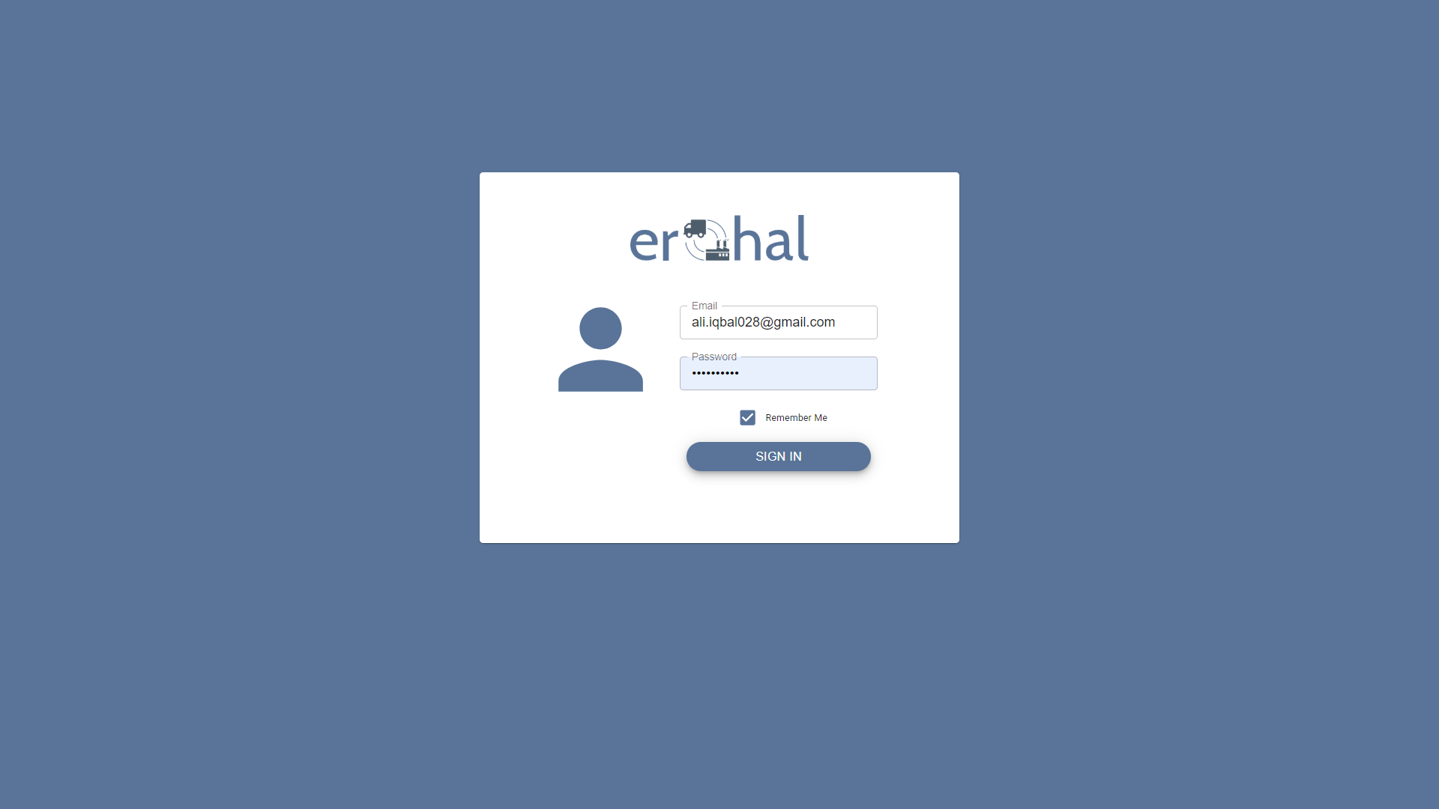

Figure 6: Login

This GUI shows LOGIN page for an admin

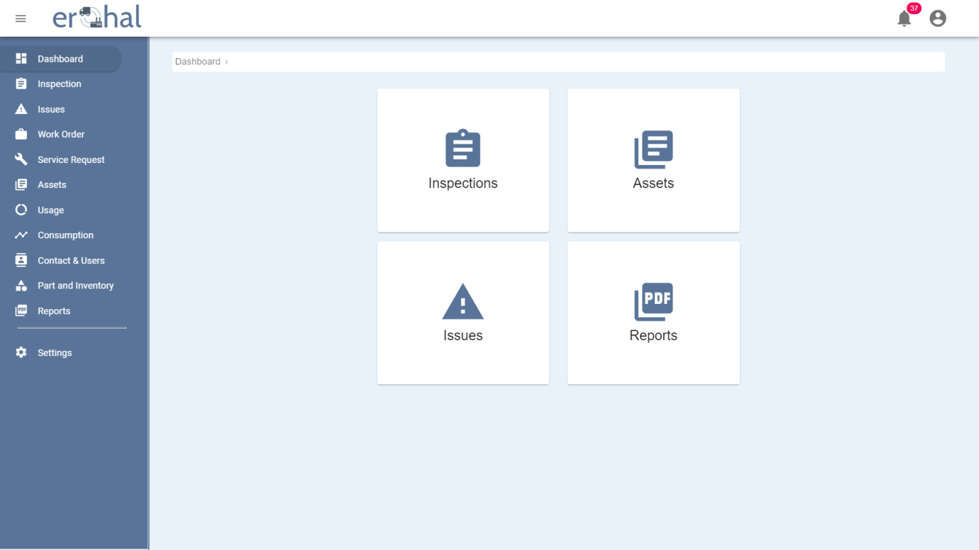

Figure 7: Dashboard

This GUI shows the dashboard of the application.

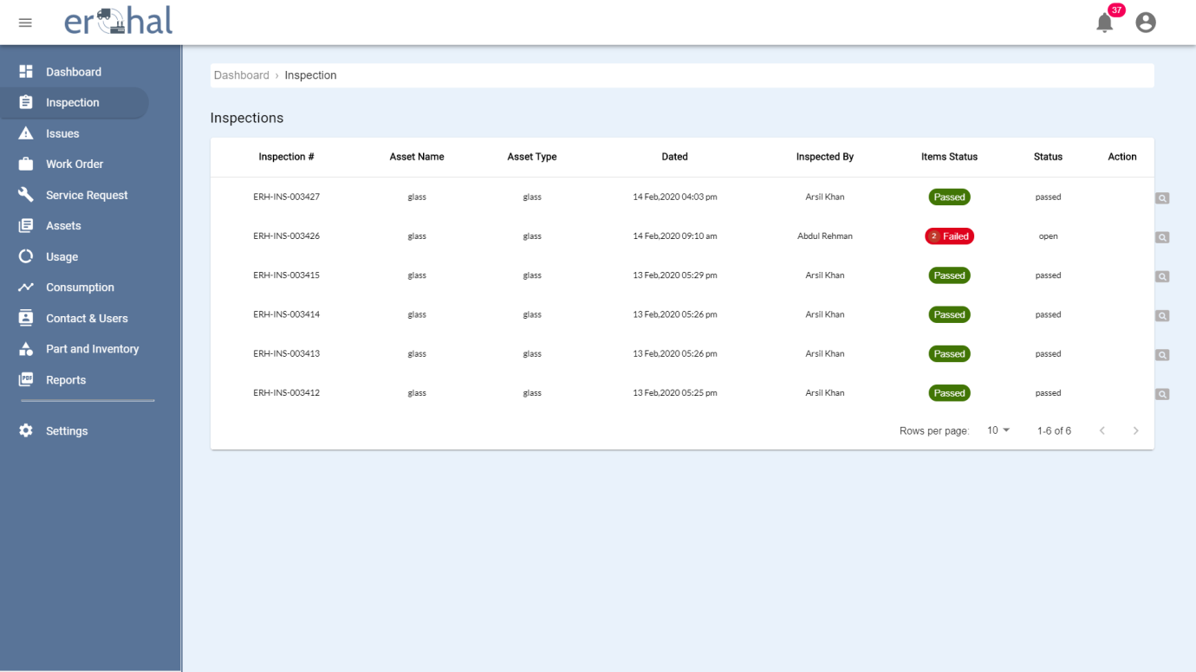

Figure 8: Inspections List

This GUI shows list of all inspections done by users.

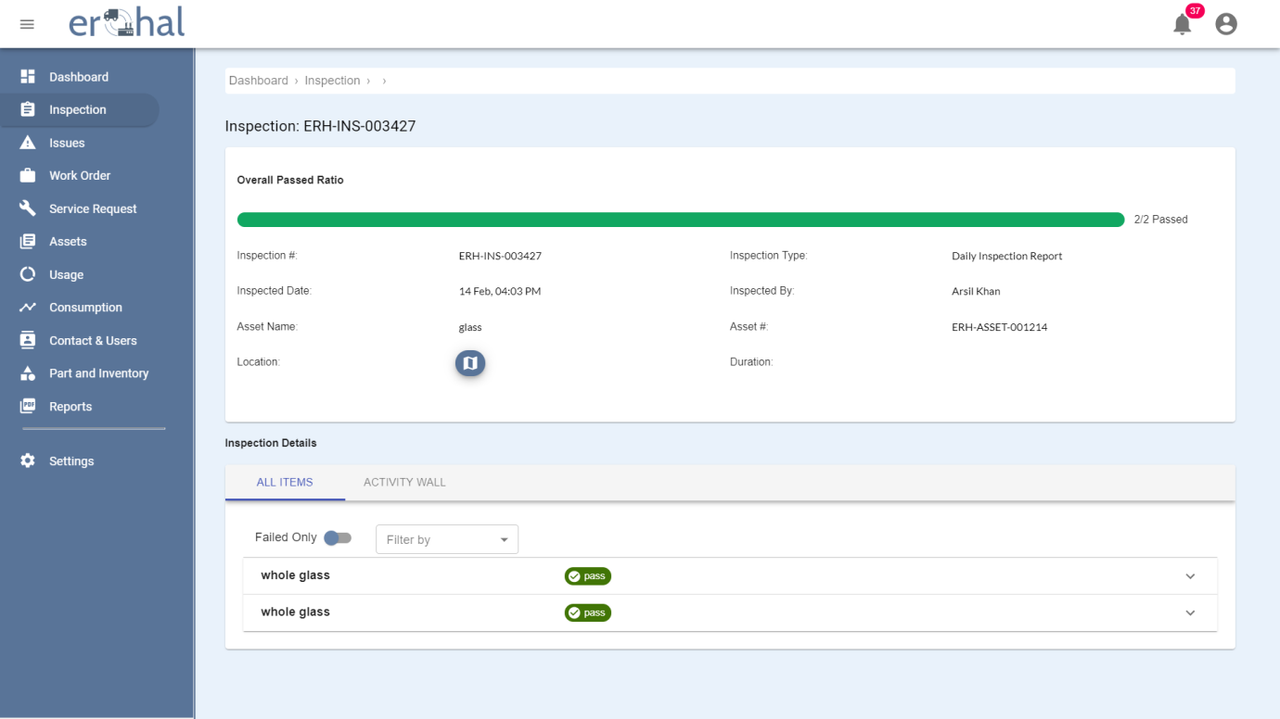

Figure 9: Inspection Details

This GUI shows the details of an inspection.

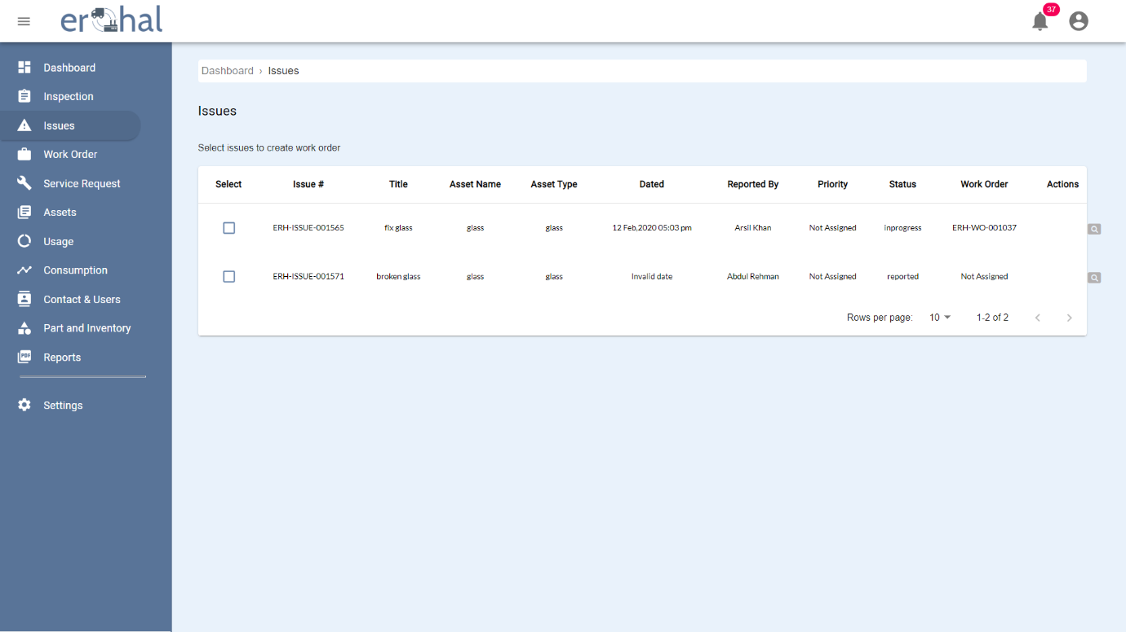

Figure 10: Issues List

This GUI shows the list of all the issues appeared in assets.

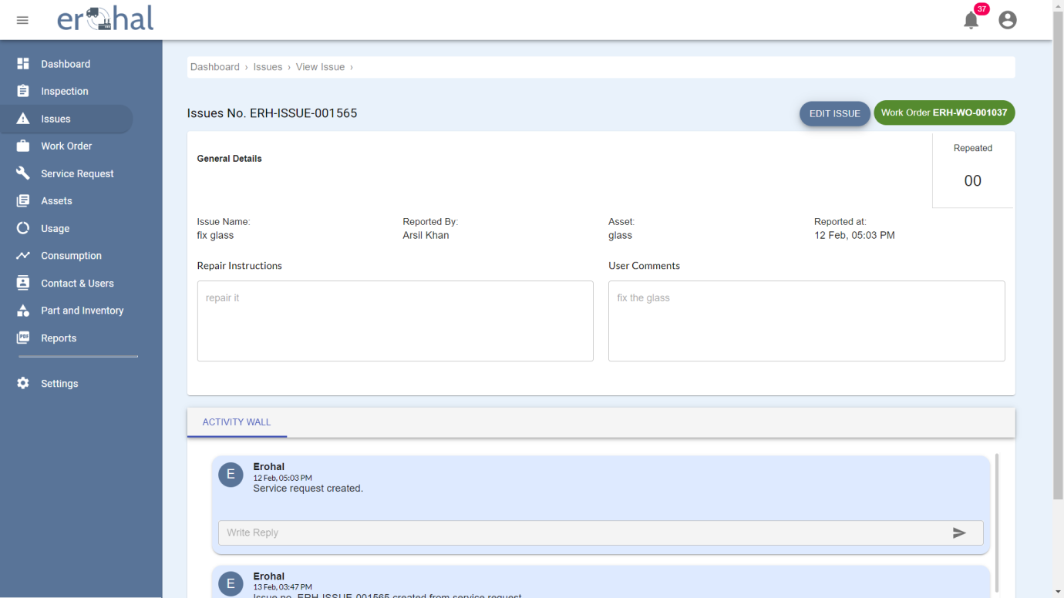

Figure 11: Issue Details 1

This GUI shows the details of an issue and allows to edit that issue.

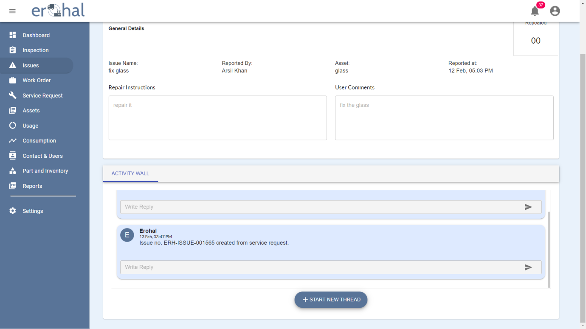

Figure 12: Issue Details 2

This GUI is the remaining part of issue details which shows the activity wall for that issue.

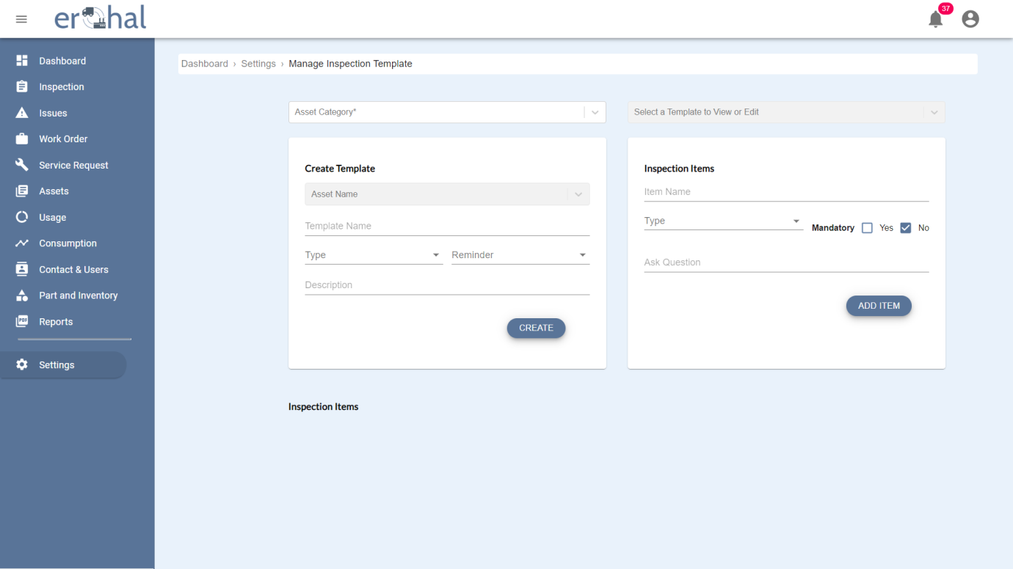

Figure 13: Inspection Template Creation

This GUI shows the view of creation of an inspection template and add an item in that template.

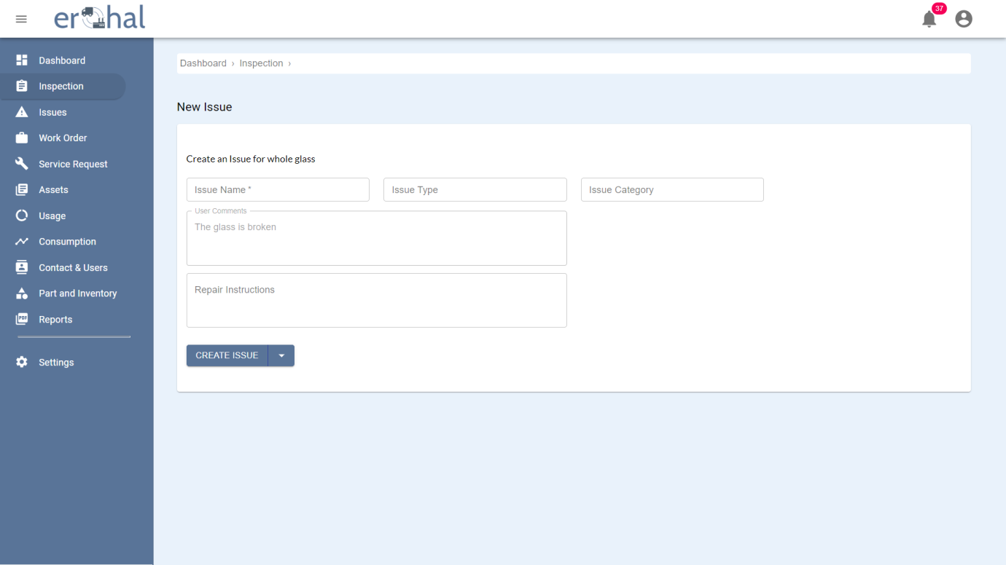

Figure 14: Issue Creation

This GUI shows the form used to create an issue.

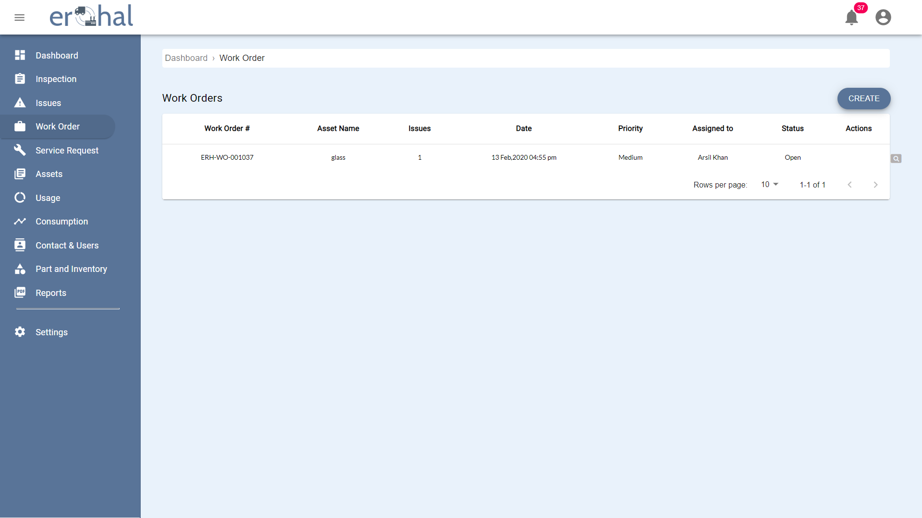

Figure 15: Work Orders

This GUI shows the list of all service requests.

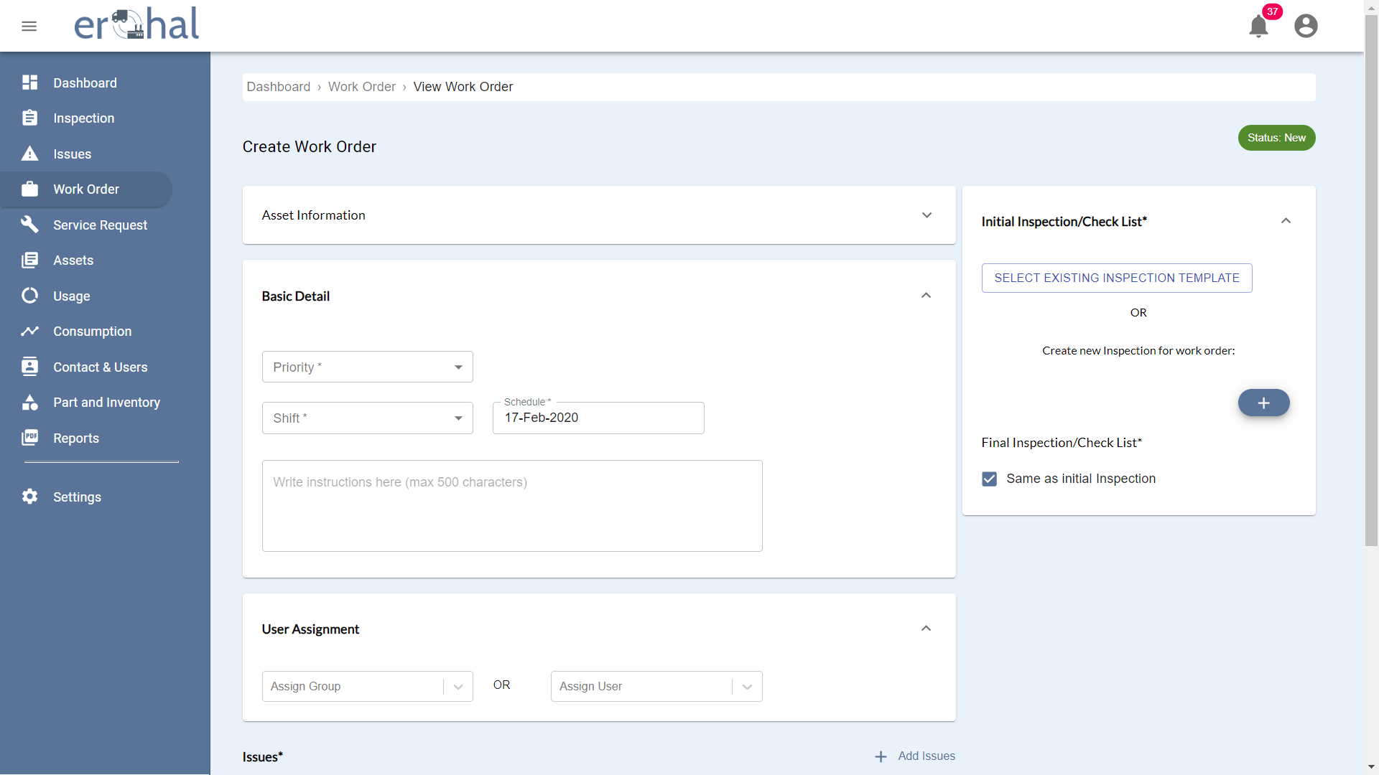

Figure 16: Creating Work Order 1

This GUI shows the requirements of creating work order.

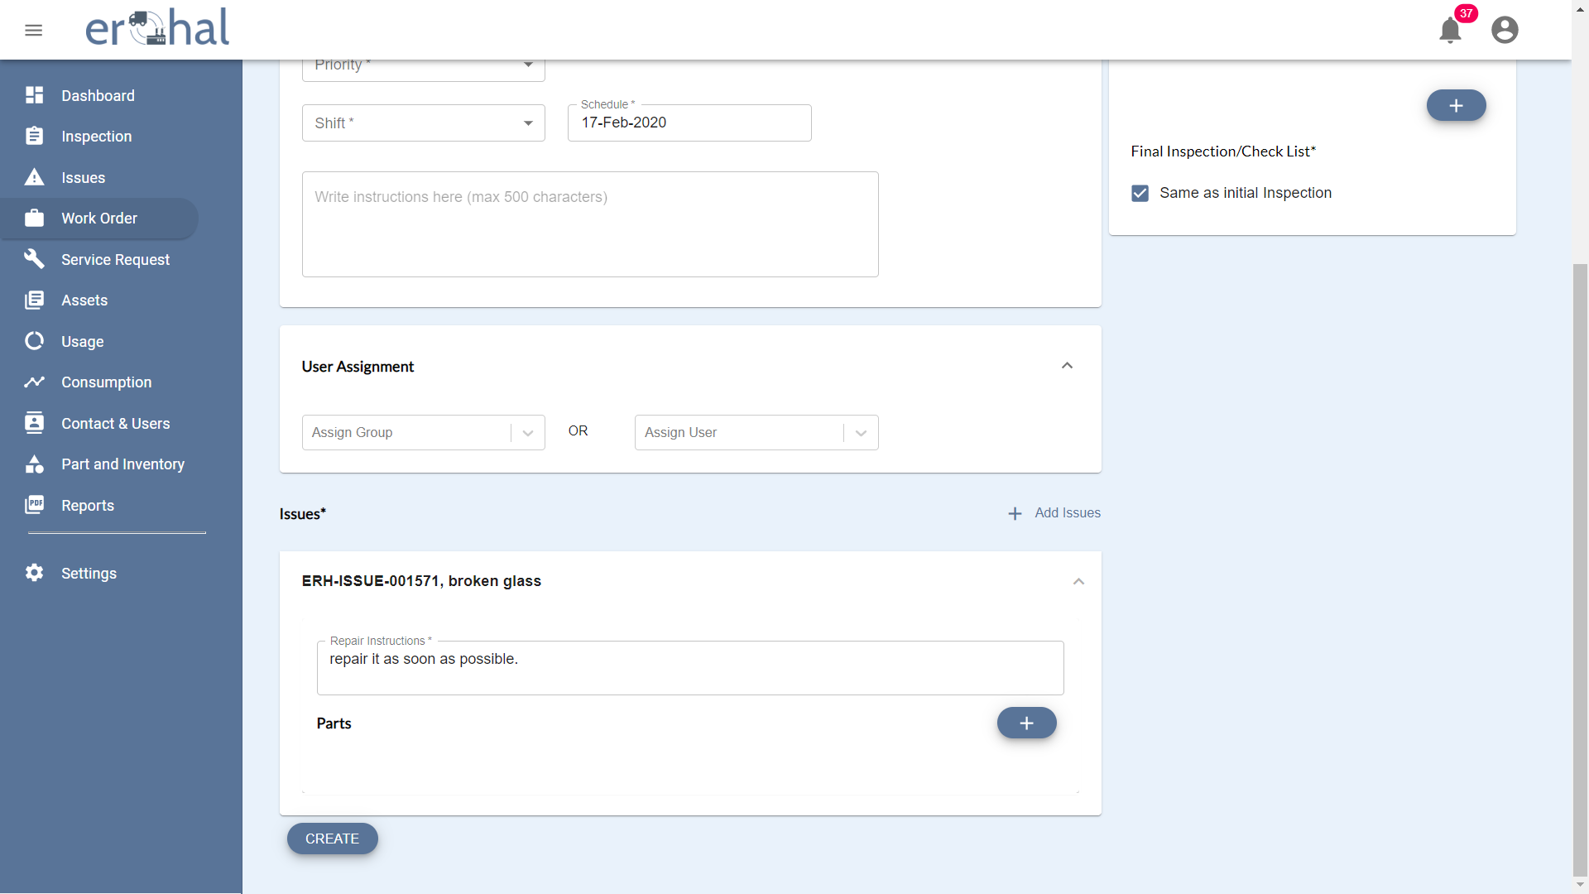

Figure 17: Creating Work Order 2

This GUI shows the requirements of creating work order.

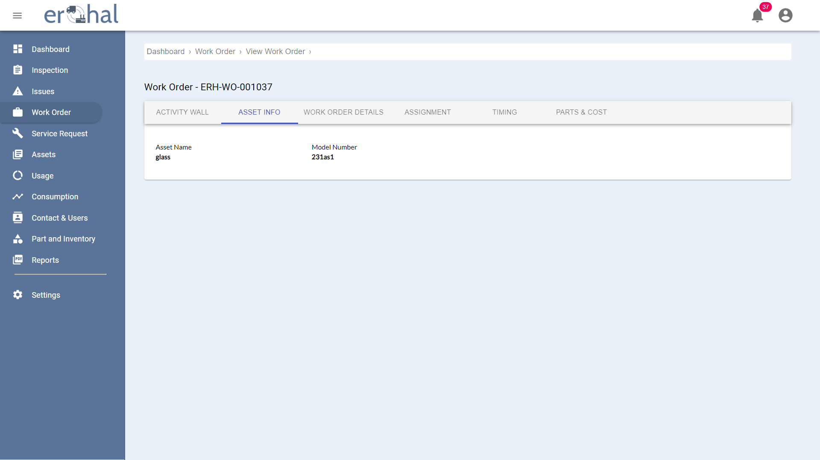

Figure 18: View Work Orders

This GUI shows the asset info of work orders.

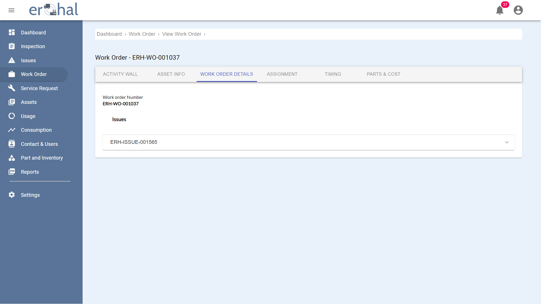

Figure 19: Work Order Details

This GUI shows work order details of work order.

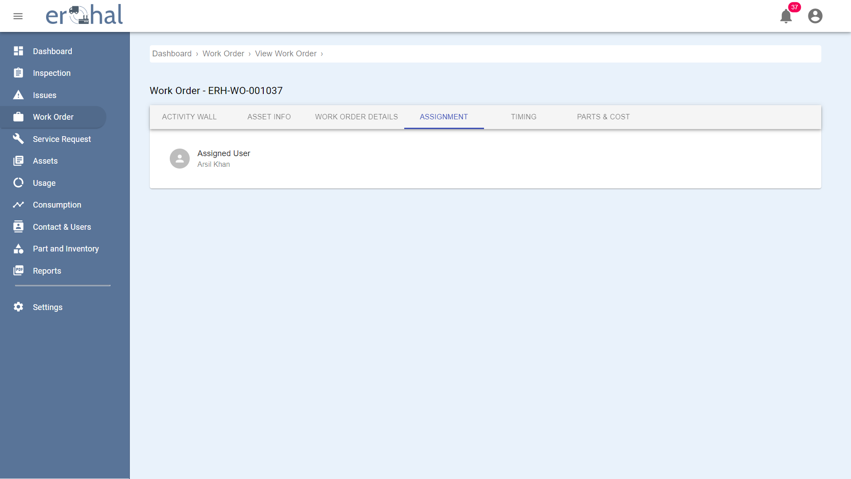

Figure 20: Assigning Work Orders

This GUI shows assigned user of a work order.

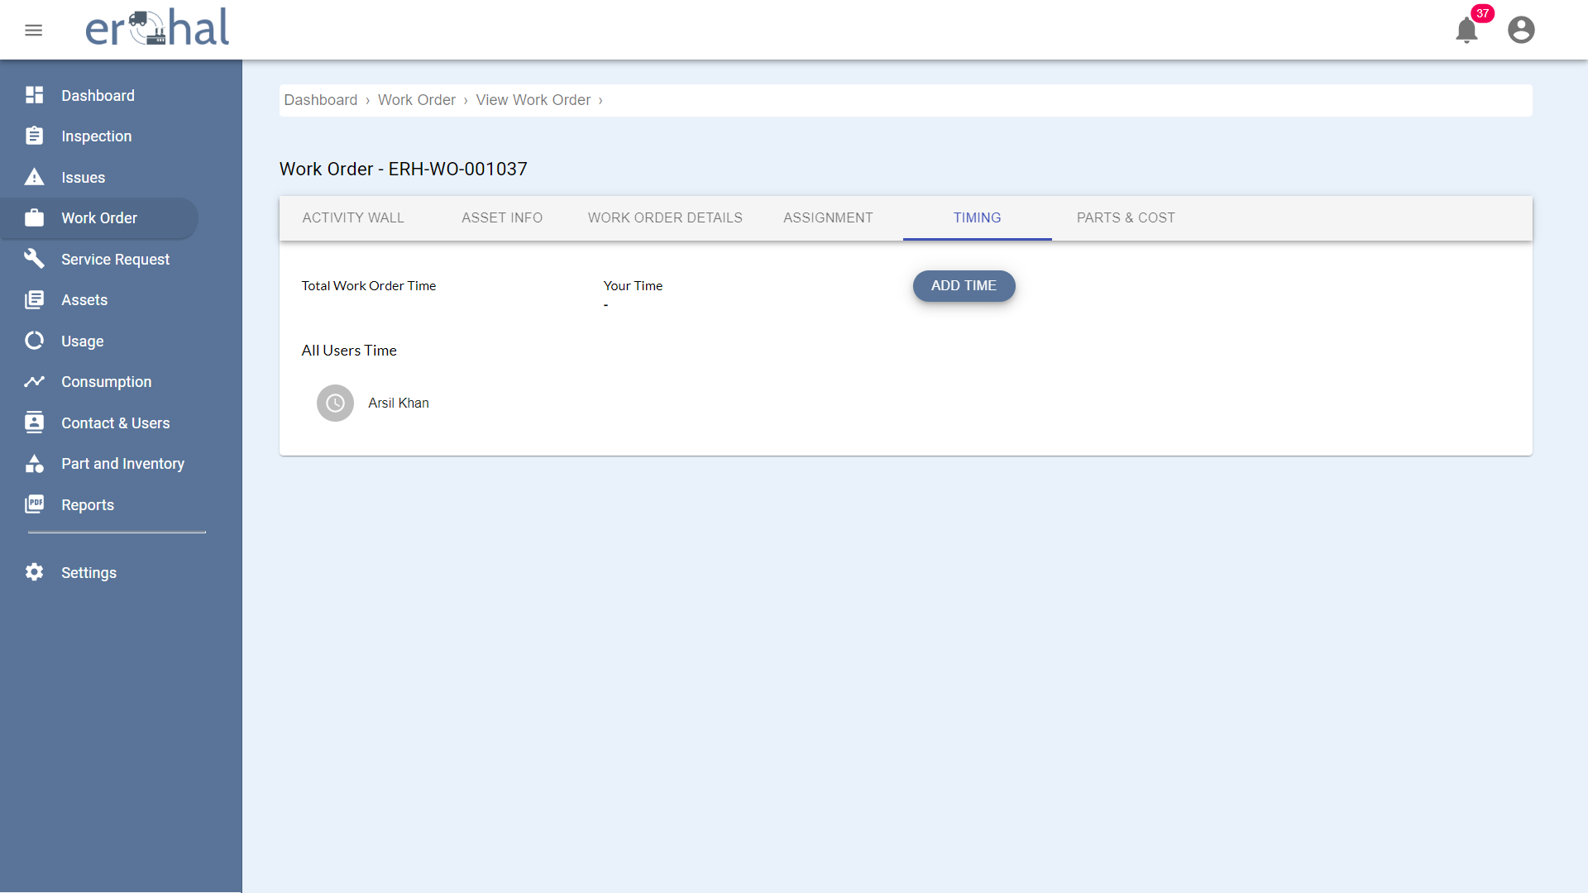

Figure 21: Work Orders Timing

This GUI shows the timing of work order.

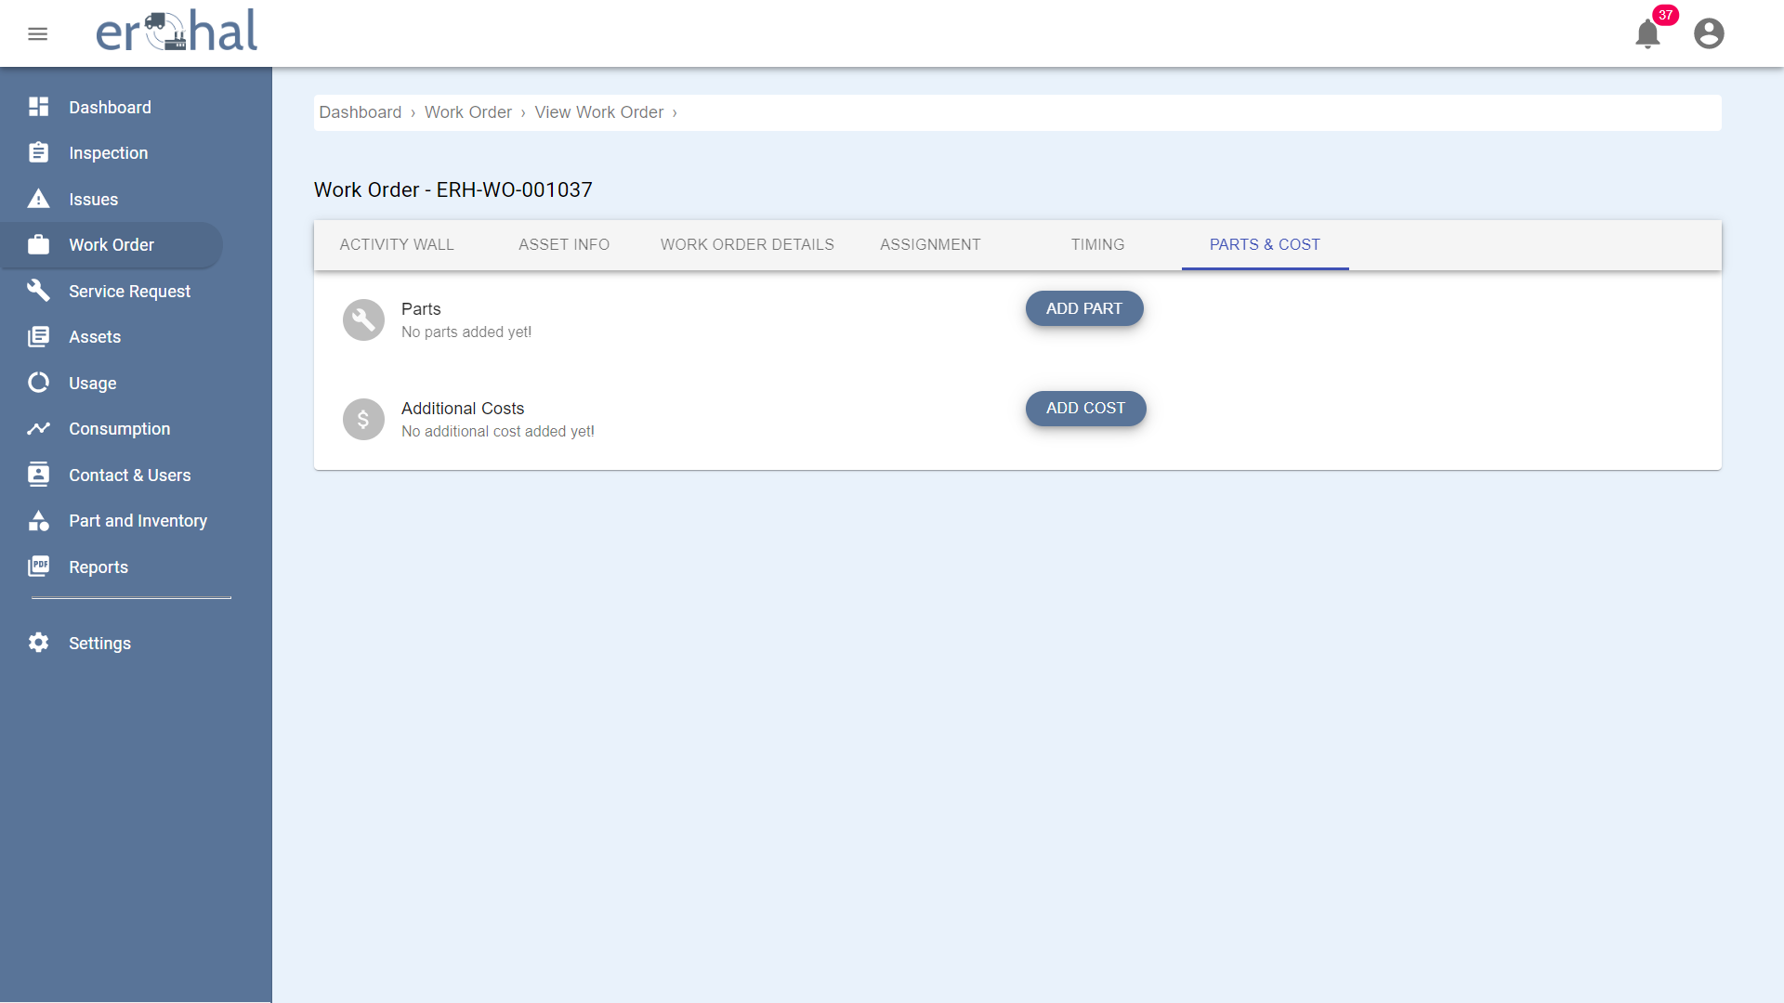

Figure 22: Parts and Cost

This GUI shows the parts and their costs of work order.

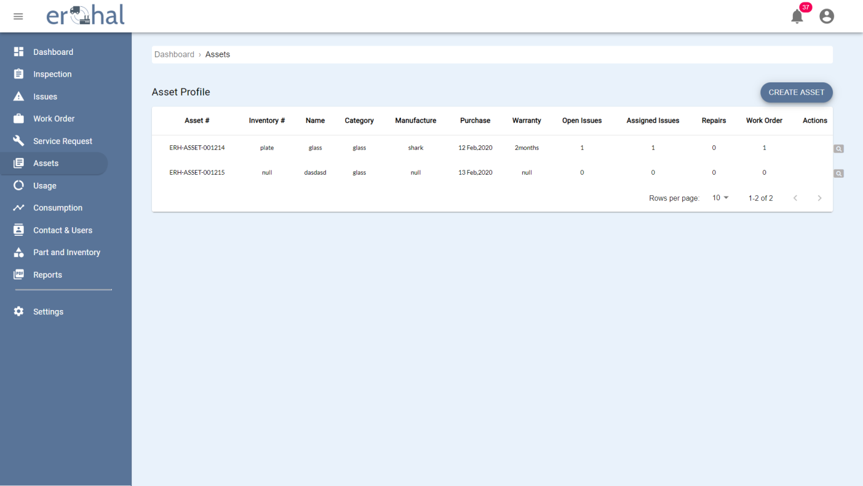

Figure 23: Assets

This GUI shows list of all assets of user which can be further viewed in detail. User can also create an asset from this page.

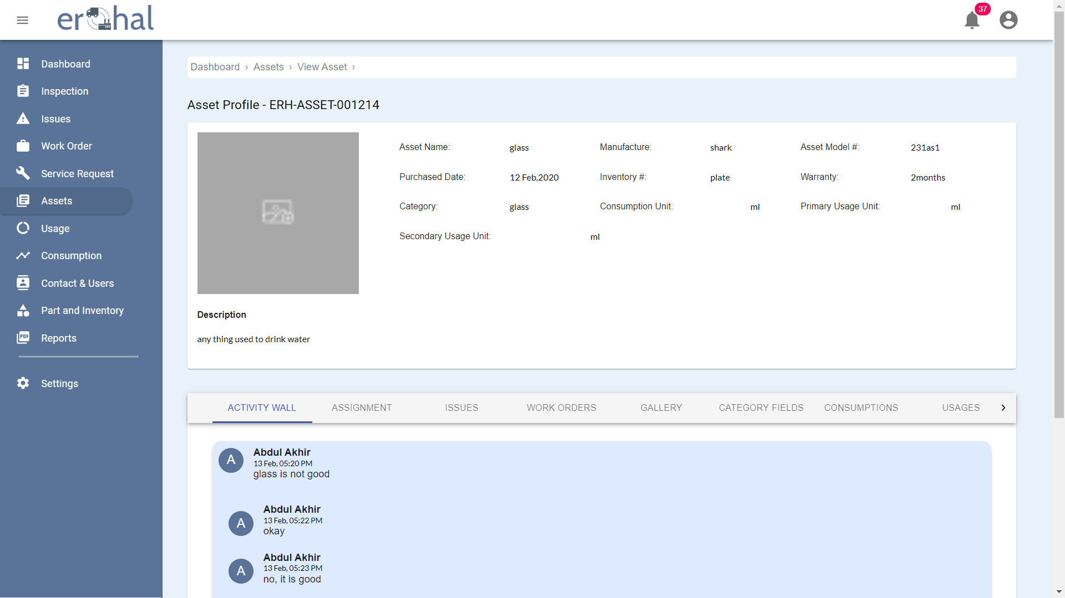

Figure 24: View Asset 1

This GUI shows details of an asset.

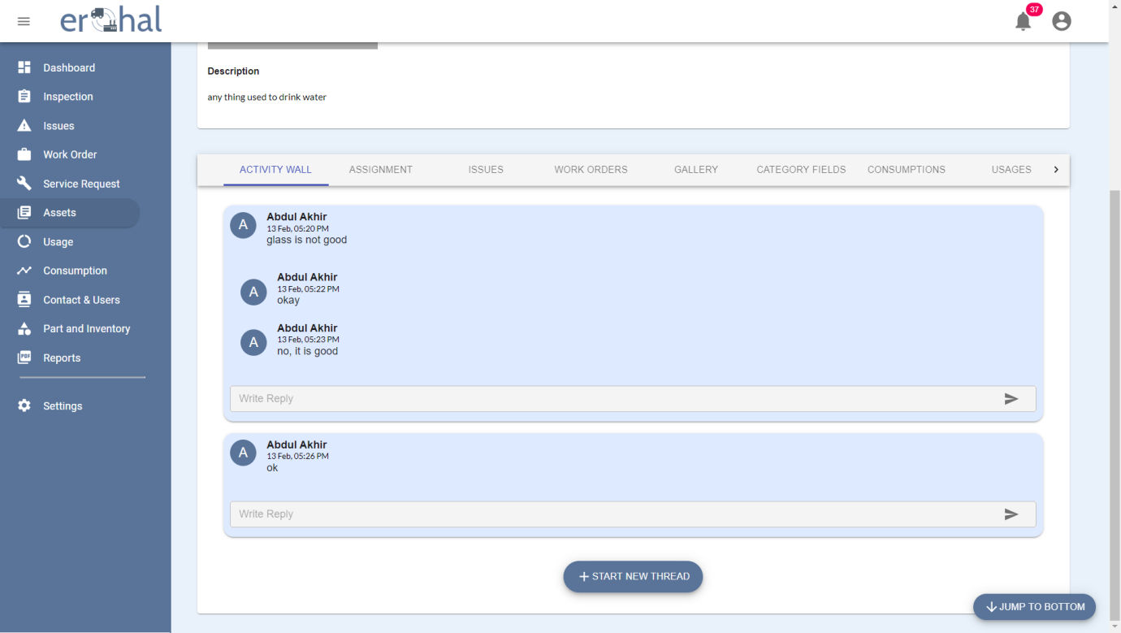

Figure 25: View Asset 2

This GUI shows the message threads of an asset.

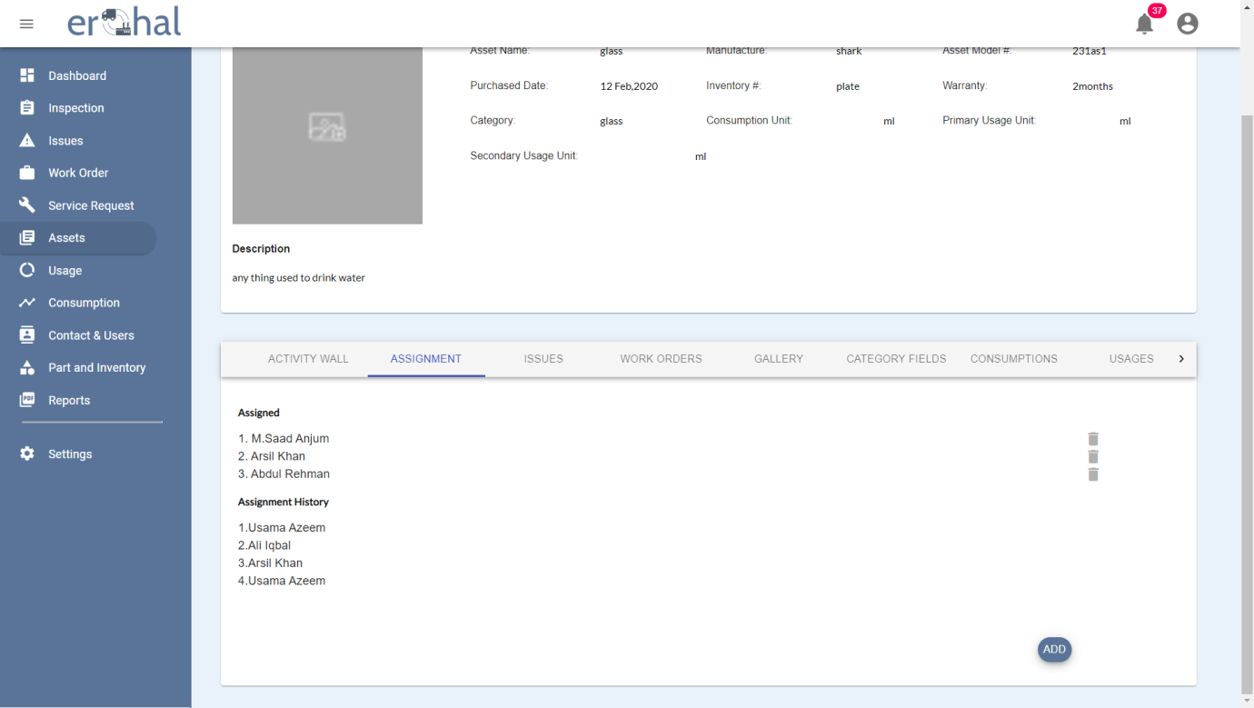

Figure 26: View Asset 3

This GUI shows all assignments of an asset.

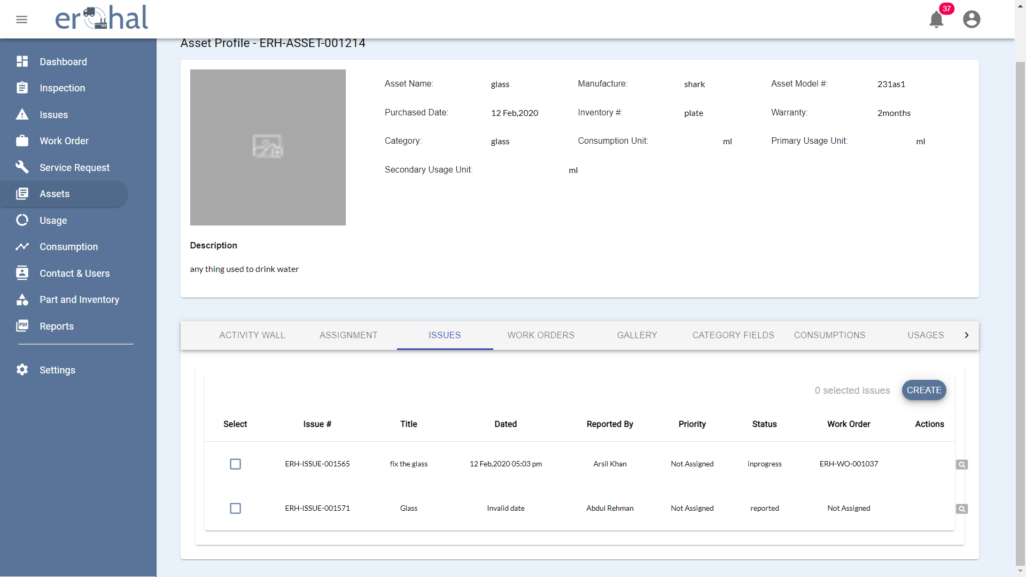

Figure 27: View Asset 4

This GUI shows list of all issues of an asset.

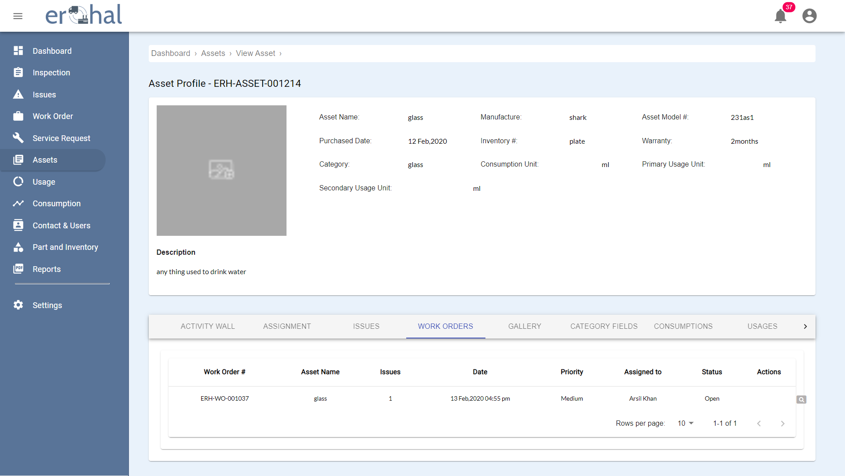

Figure 28: View Asset 5

This GUI shows all work orders of an asset.

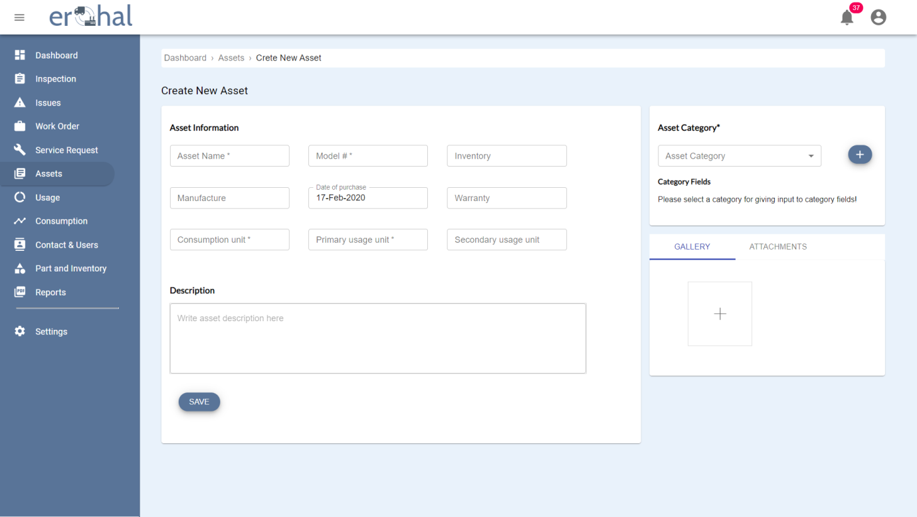

Figure 29: Create New Asset

User can create new asset on this GUI.

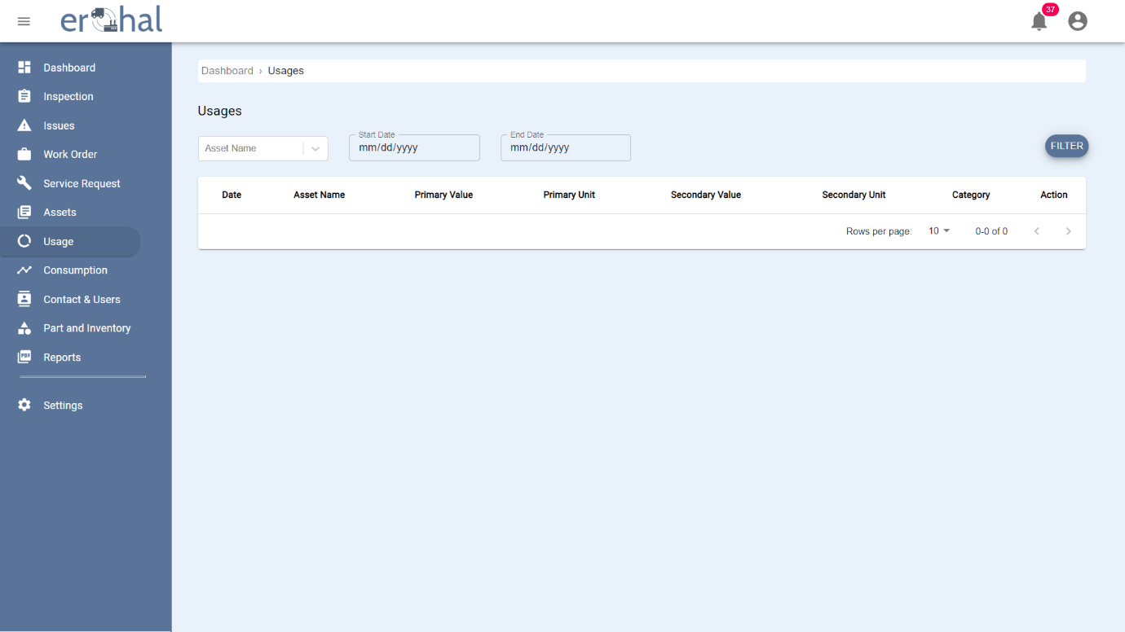

Figure 30: View Usage

This GUI shows all usages of an asset.

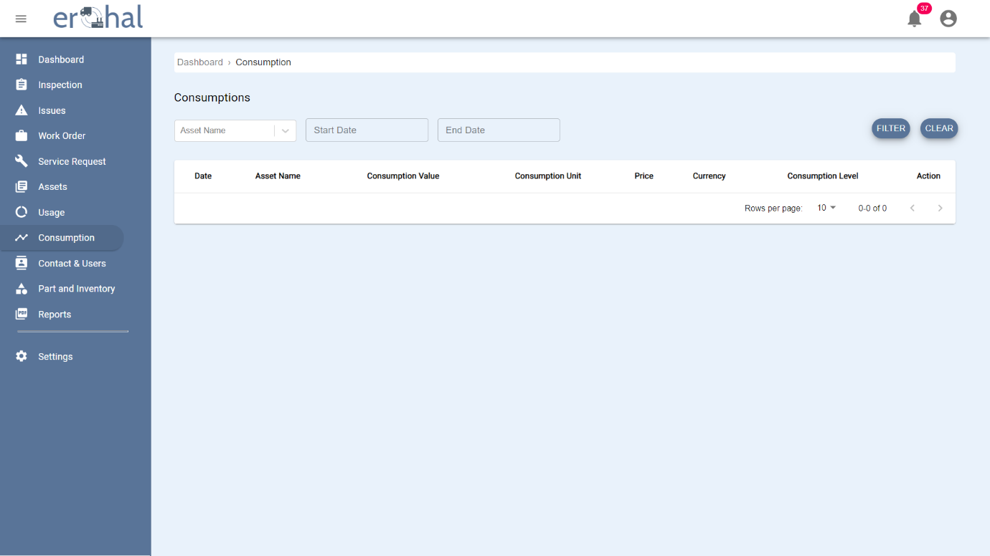

Figure 31: View Consumption

This GUI shows all consumptions of an asset.

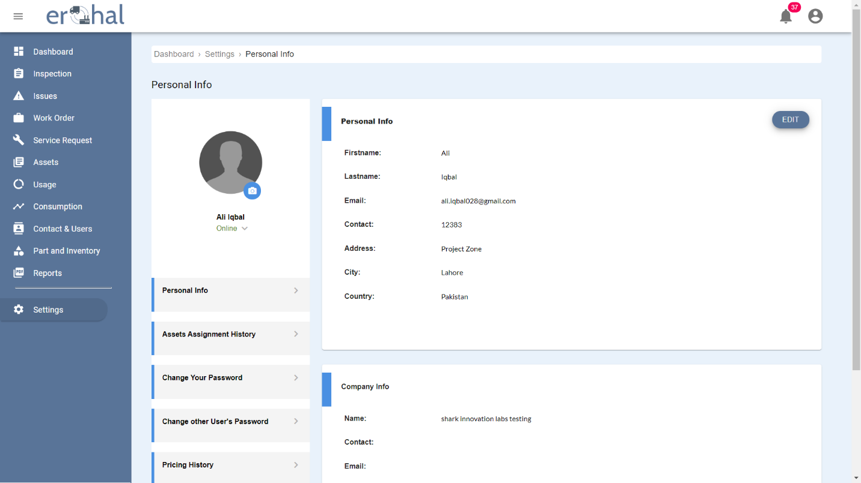

Figure 32: Profile Overview

This GUI show personal and company’s information of a profile.

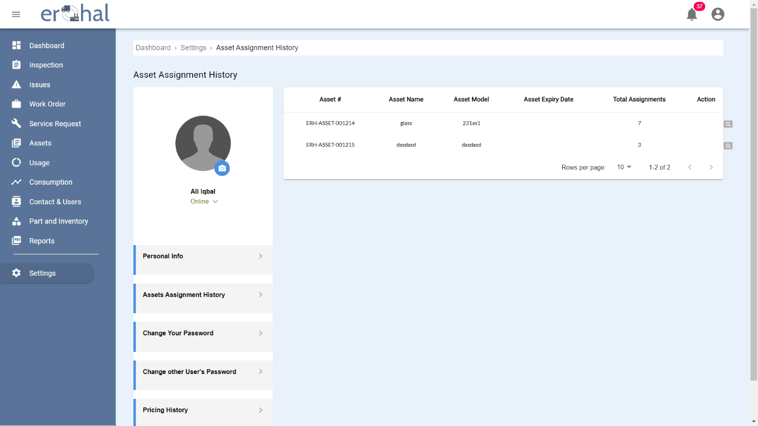

Figure 33: Asset Assignment History

This GUI shows the history of assets assignment.

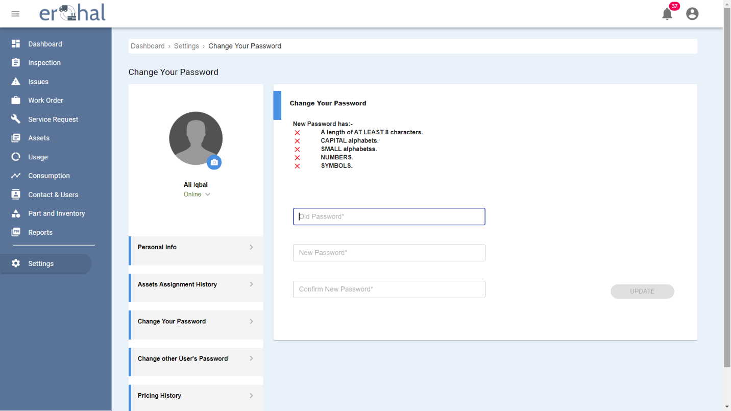

Figure 34: Change Password

This GUI shows how to change your password.

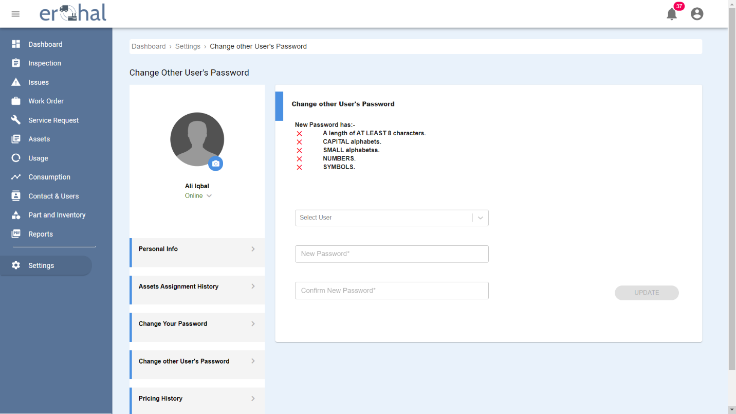

Figure 35: Change Other's Password

This GUI shows how to change another user’s password

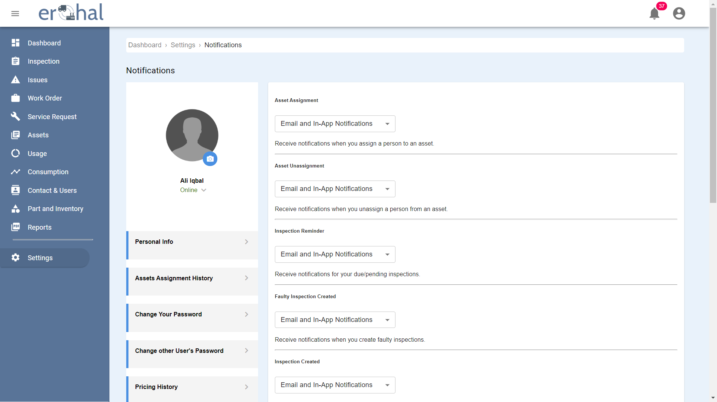

Figure 36: Notifications 1

This GUI shows categories for notifications.

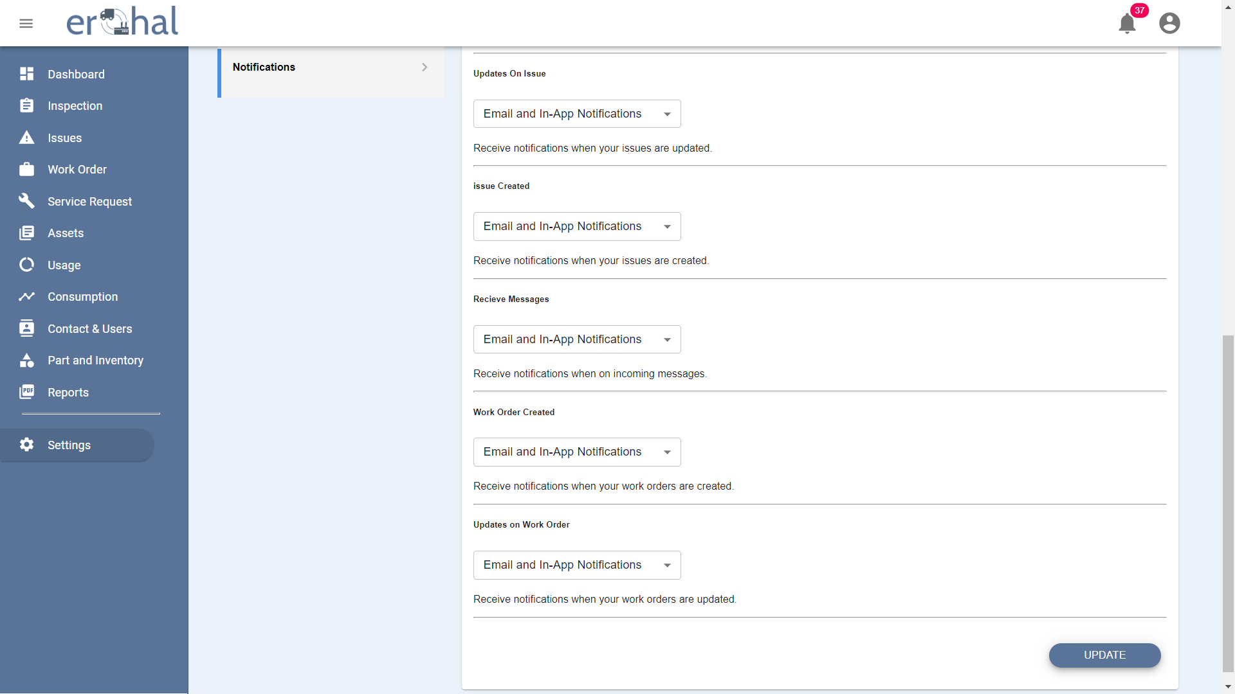

Figure 37: Notifications 2

This GUI shows categories for notifications with options to update their type.

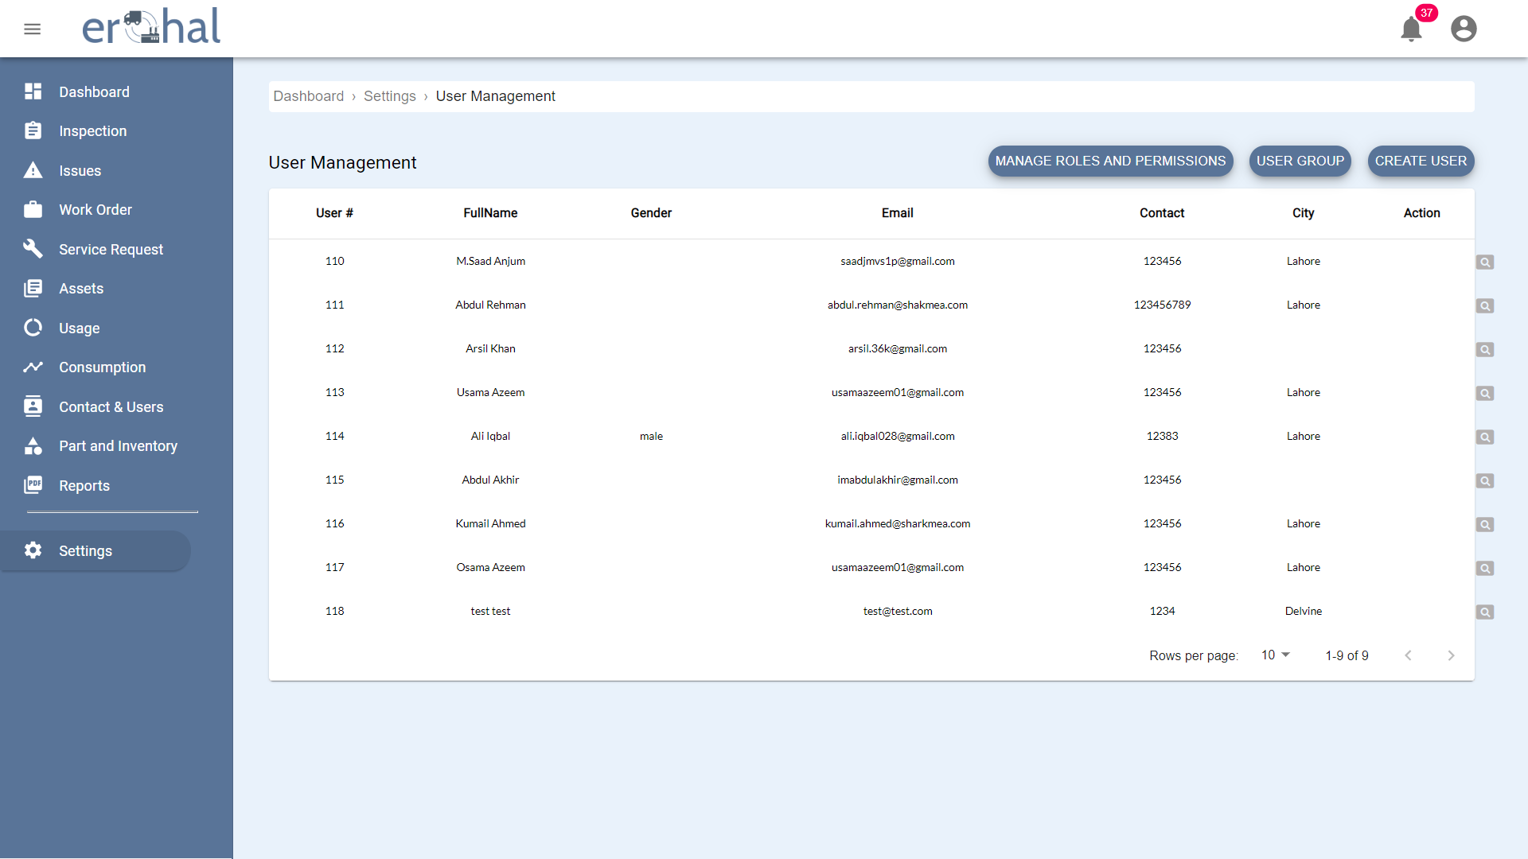

Figure 38: User Management

This GUI shows user management page with all the users.

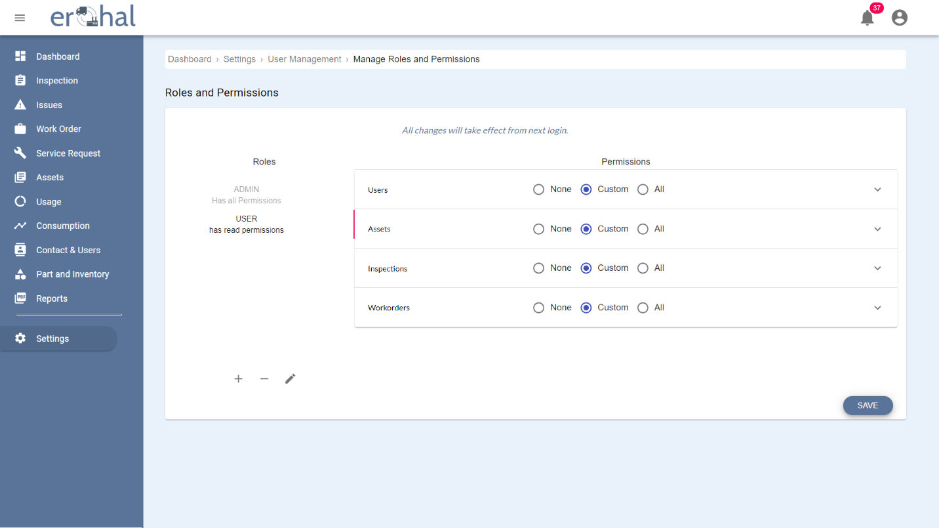

Figure 39: Roles and Permissions

This GUI shows the page to manage roles and permissions of a user.

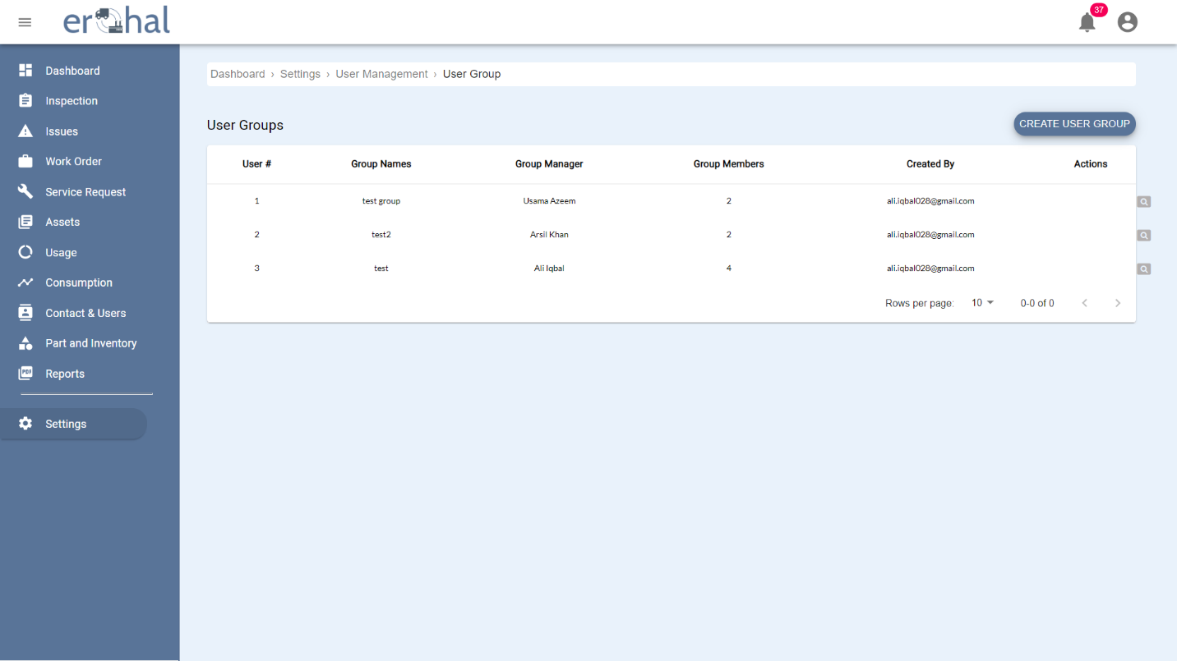

Figure 40: User Groups

This GUI shows all user groups.

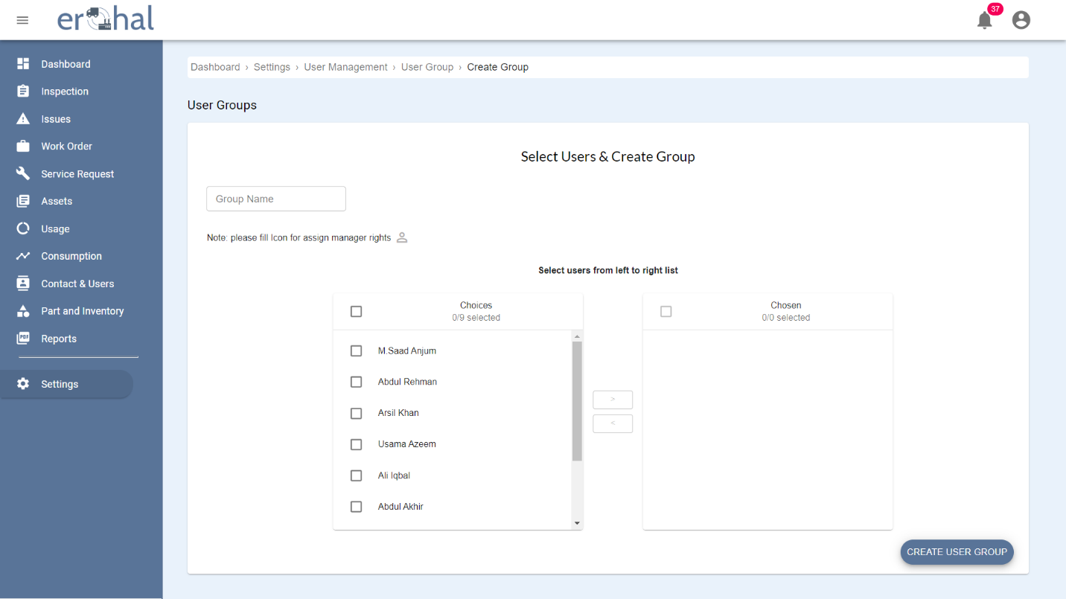

Figure 41: Create User Group

This GUI is for creating a new user group.

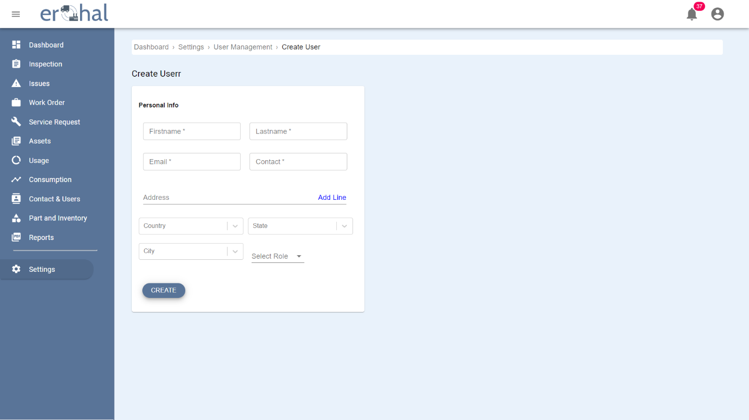

Figure 42: Create User

This GUI is for creating a new user.

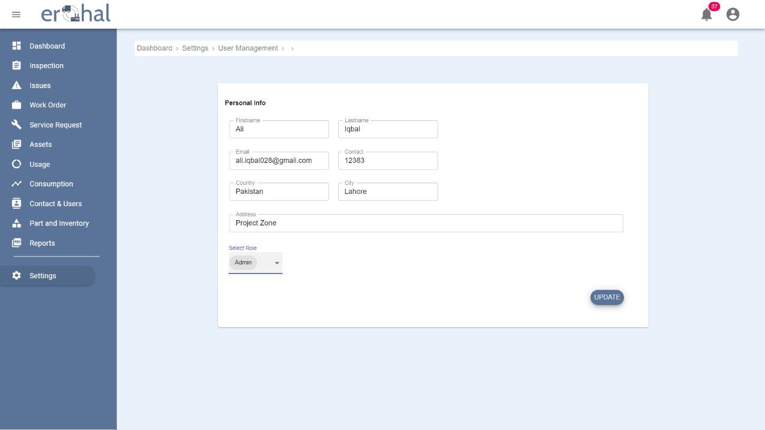

Figure 43: Personal Information

This GUI shows the personal information and the role of a user with an option to update the details.

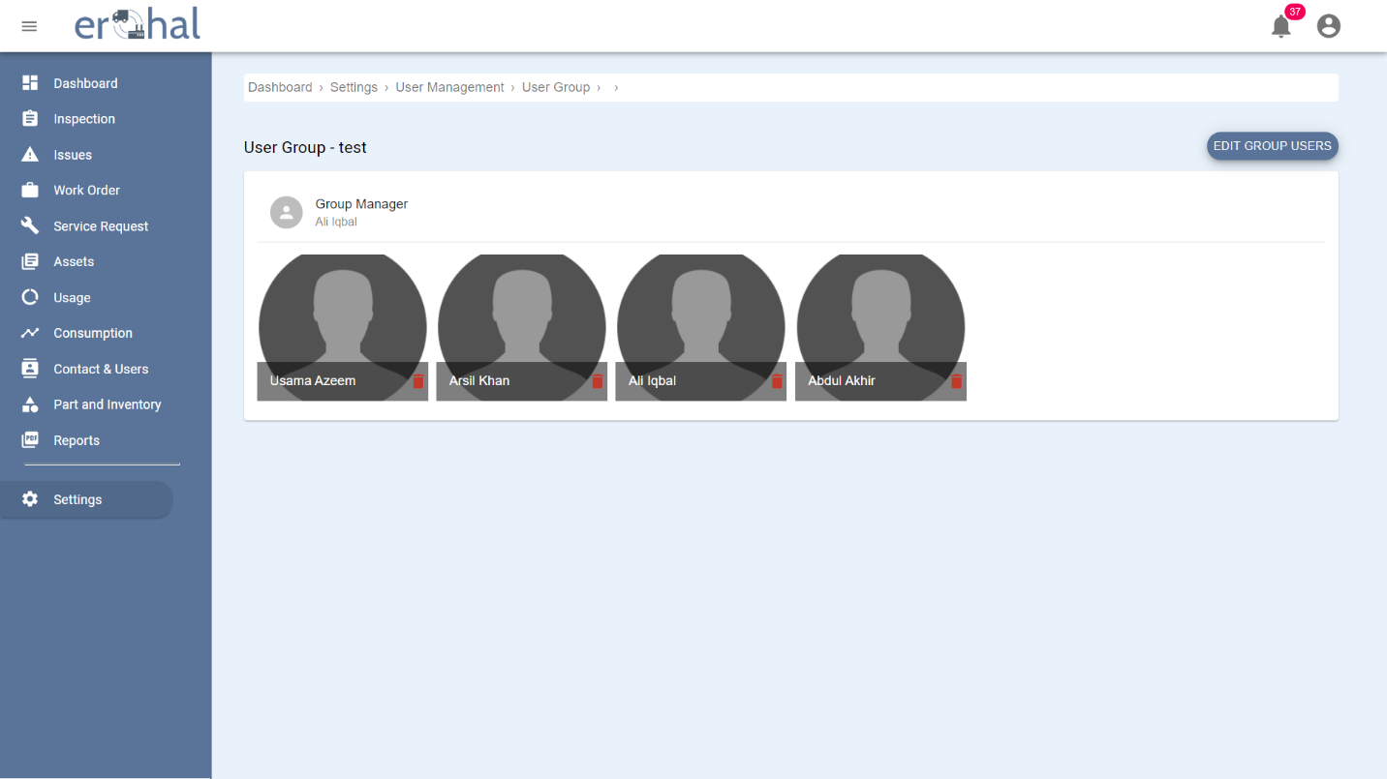

Figure 44: User Group Profile

This GUI shows the details of a single user group.

## Database Design

### ER Diagram

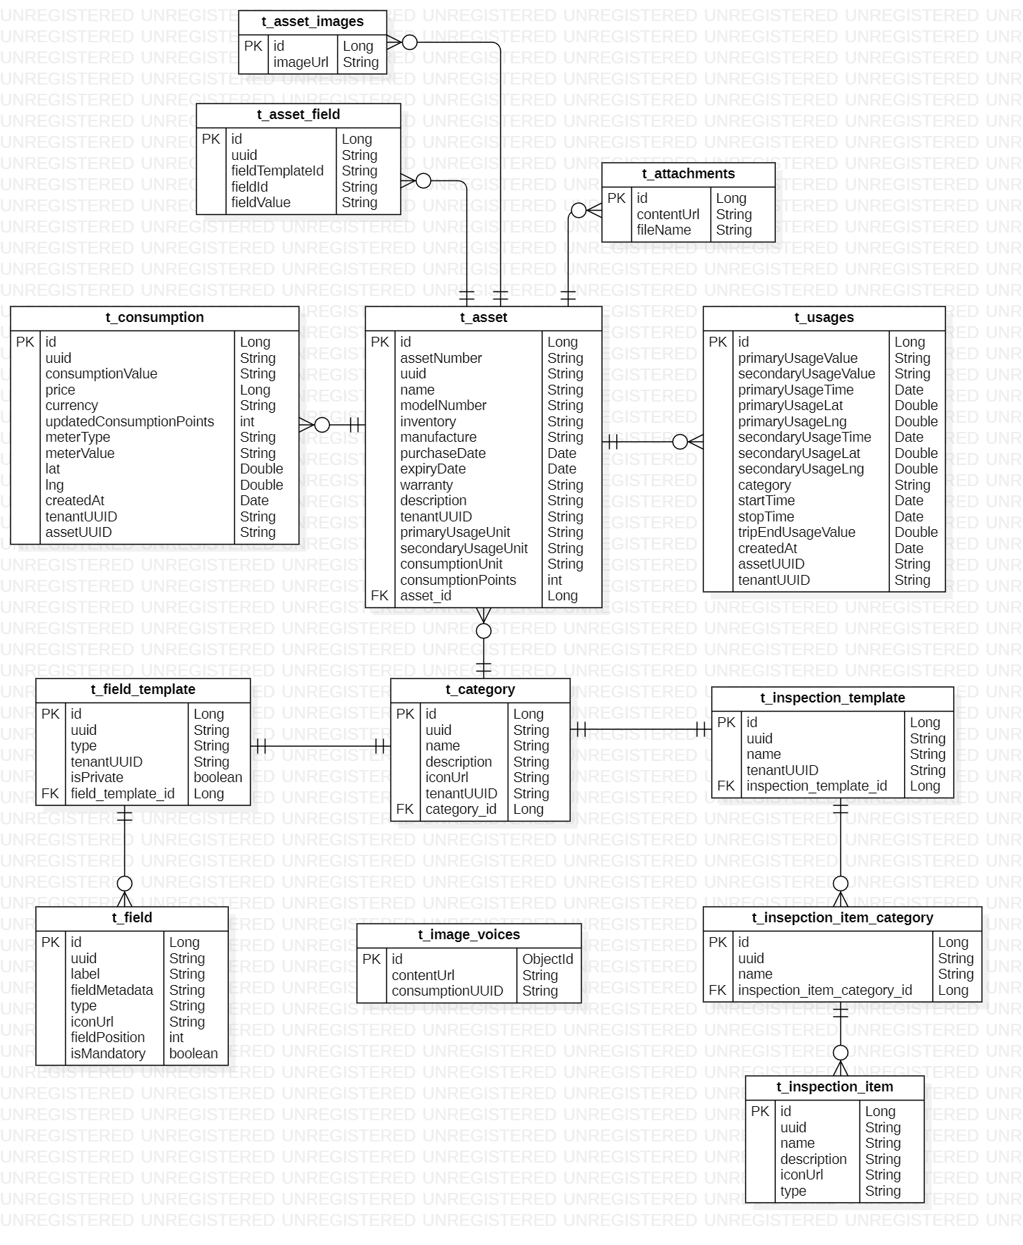

Figure 45: ER Diagram 1

This shows the ER Diagram of Asset Management Service

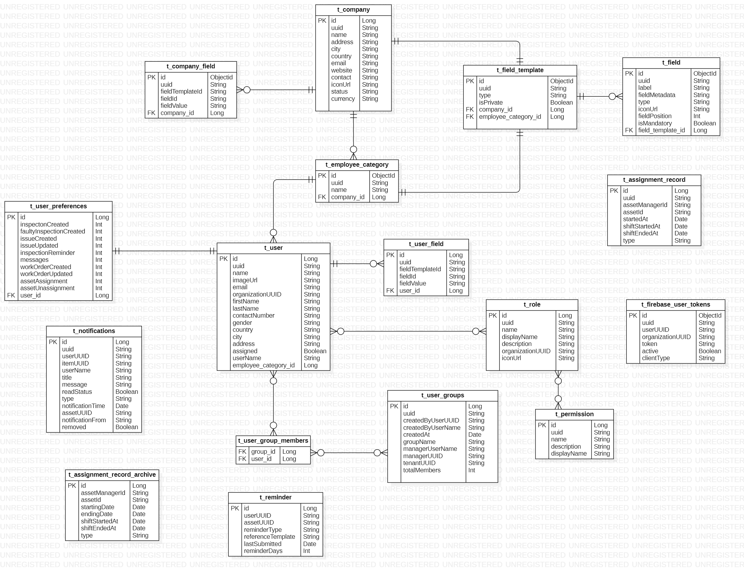

Figure 46: ER Diagram 2

This shows the ER Diagram of Asset Personnel Service

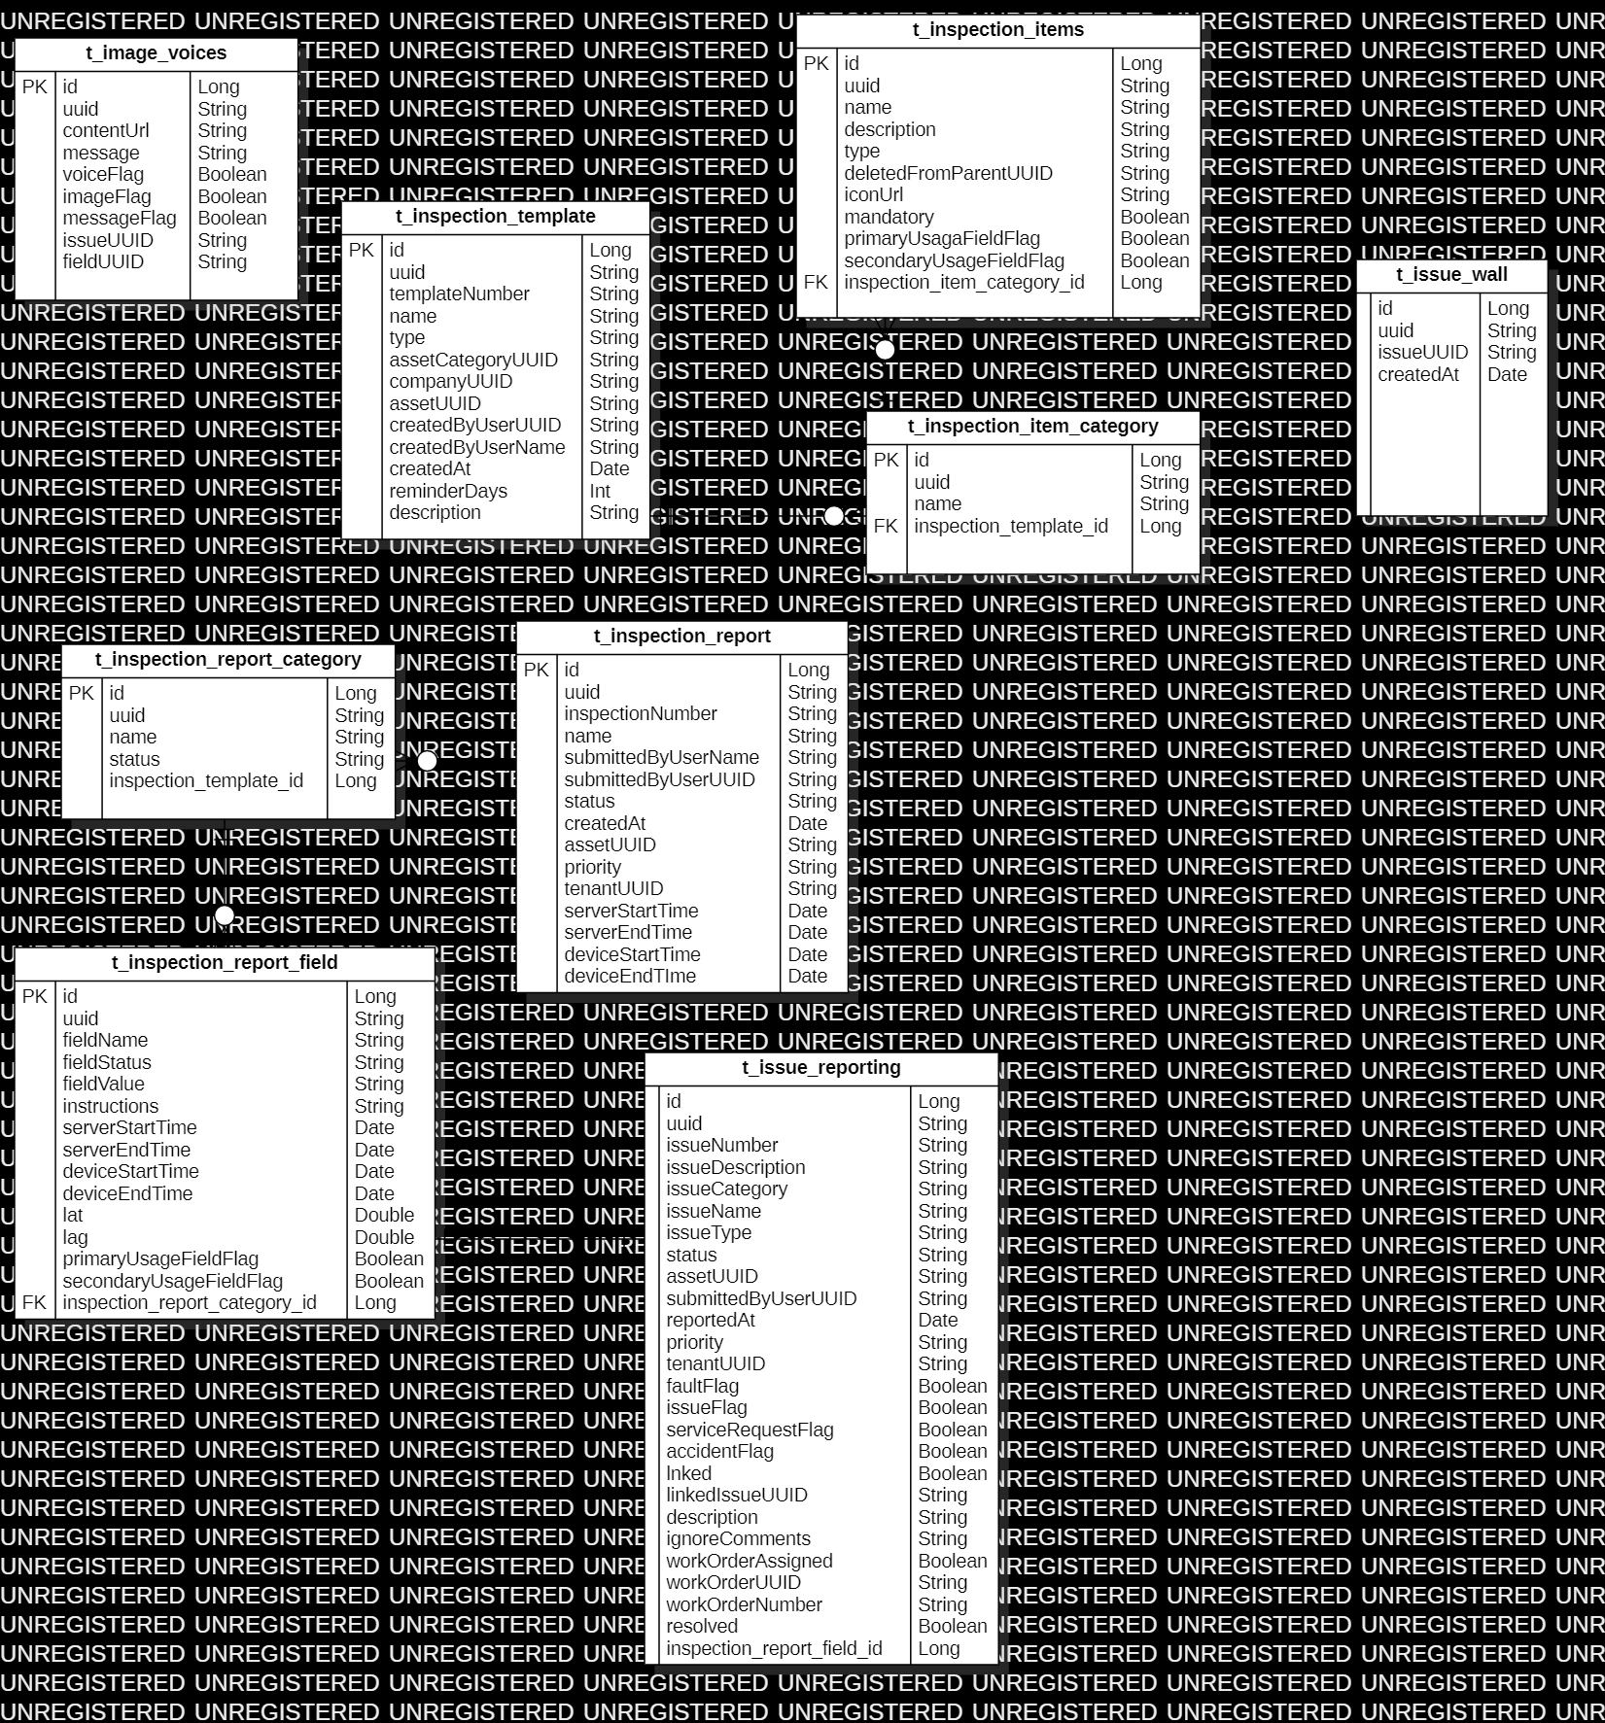

Figure 47: ER Diagram 3

This shows the ER Diagram of Inspection Service

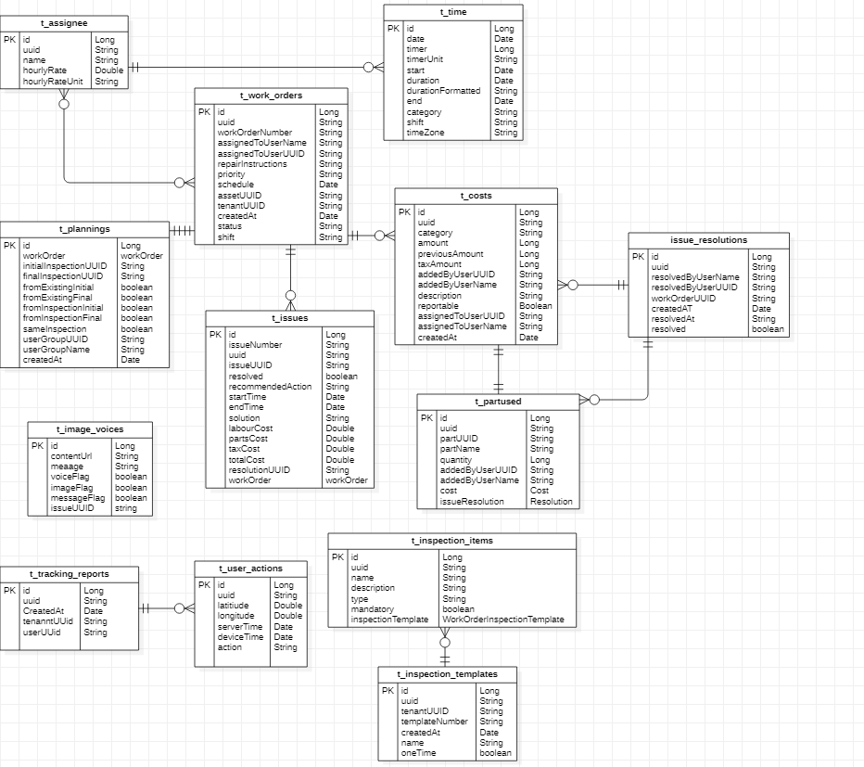

Figure 48: ER Diagram 4

This is the ER Diagram of Work Order Service

### Data Dictionary

#### Image Voices

Table 55: Image Voices Data Dictionary

This is the data dictionary of image voices.

|  |  |  |
| --- | --- | --- |
| **Fields** | **Data Types** | **Examples** |
| Id | Long | 123 |
| Uuid | String | 1a2b31231wso |
| ContentUrl | String | [https://somename.com](https://somename.com/) |
| Message | String | Some message |
| VoiceFlag | Boolean | True |
| ImageFlag | Boolean | False |
| MessageFlag | Boolean | True |
| IssueUUID | String | 1a2b31231wso |
| FieldUUID | String | 1a2b31231wso |

#### Inspection Template

Table 56: Inspection Template Data Dictionary

This is the data dictionary of inspection template.

|  |  |  |
| --- | --- | --- |
| **Fields** | **Data Types** | **Examples** |
| Id | Long | 3231 |
| Uuid | String | 1a2b31231wso |
| TemplateNumber | String | ERH-INS-003378 |
| Name | String | AC inspection template |
| Type | String | Daily inspection |
| AssetCategoryUUID | String | 1a2b31231wso |
| CompanyUUID | String | 1a2b31231wso-2 |
| AssetUUID | String | 1a2b3%1231wso |
| CreatedByUserUUID | String | 1a2b3123#2@1wso |
| CreatedByUserName | String | someusername |
| CreatedAt | Date | 12-03-2020 12:35:12 |
| ReminderDays | Int | 4 |
| Description | String | Any description can fit in |

#### Inspection Items

Table 57: Inspection Items Data Dictionary

This is the data dictionary of inspection items.

|  |  |  |
| --- | --- | --- |
| **Fields** | **Data Types** | **Examples** |
| Id | Long | 23 |
| Uuid | String | 1a2b31231wso |
| Name | String | Car |
| Description | String | Any description |
| Type | String | Car |
| DeletedFromParentUUID | String | 1a2b3123#2@1wso |
| IconUrl | String | [https://somename.com](https://somename.com/) |
| Mandatory | Boolean | False |
| PrimaryUsageFieldFlag | Boolean | True |
| SecondaryUsageFieldFlag | Boolean | True |
| inspection_item_category_id | Long | 3 |

#### Inspection Item Category

Table 58: Inspection Item Category Data Dictionary

This is the data dictionary of inspection item category

|  |  |  |
| --- | --- | --- |
| **Field** | **Data Types** | **Examples** |
| Id | Long | 23 |
| Uuid | String | 1a2b3123#2@1wso |
| Name | String | Car |
| Inspection_template_id | Long | 5 |

#### Inspection Report

Table 59: Inspection Report Data Dictionary

This is the data dictionary of inspection report.

|  |  |  |
| --- | --- | --- |
| **Field** | **Data Types** | **Examples** |
| Id | Long | 7 |
| Uuid | String | 1a2b3123#2@1wso |
| InspectionNumber | String | ERH-INS-003378 |
| Name | String | Daily inspection report |
| SubmittedByUserName | String | someusername |
| SubmittedByUserUUID | String | 1a2b3123#2@1wso |
| Status | String | passed |
| CreatedAt | Date | 12-03-2020 12:35:12 |
| AssetUUID | String | 1a2b3123#2@1wso |
| Priority | String | medium |
| TenantUUID | String | 1a2b3123#2@1wso |
| ServerStartTime | Date | 12-03-2020 12:35:12 |
| ServerEndTime | Date | 12-03-2020 12:35:12 |
| DeviceStartTime | Date | 12-03-2020 12:35:12 |
| DeviceEndTime | Date | 12-03-2020 12:35:12 |

#### Inspection Report Category

Table 60: Inspection Report Category

This is the data dictionary of inspection report category.

|  |  |  |
| --- | --- | --- |
| **Fields** | **Data Types** | **Examples** |
| Id | Long | 23 |
| Uuid | String | 1a2b3123#2@1wso |
| Name | String | Daily inspection report |
| Status | String | pending |
| inspection_template_id | Long | 12 |

#### Inspection Report Field

Table 61: Inspection Report Field

This is the data dictionary of inspection report field.

|  |  |  |
| --- | --- | --- |
| **Field** | **Data Types** | **Examples** |
| Id | Long | 3 |
| Uuid | String | 1a2b3123#2@1wso |
| FieldName | String | Bike inspection report |
| FieldStatus | String | Pass |
| FieldValue | String | Any measured value |
| Instructions | String | Some instructions |
| ServerStartTime | Date | 12-03-2020 12:35:12 |
| ServerEndTime | Date | 12-03-2020 12:35:12 |
| DeviceStartTime | Date | 12-03-2020 12:35:12 |
| DeviceEndTime | Date | 12-03-2020 12:35:12 |
| Lat | Double | 233.232321 |
| Lag | Double | 0.23123131 |
| PrimaryUsageFieldFlag | Boolean | True |
| SecondaryUsageFieldFlag | Boolean | False |
| Inspection_report_category_id | Long | 6 |

#### Issue Reporting

Table 62: Issue Reporting

This is the data dictionary of issue reporting.

|  |  |  |
| --- | --- | --- |
| **Fields** | **Data Types** | **Examples** |
| Id | Long | 12 |
| Uuid | String | 1a2b3123#2@1wso |
| IssueNumber | String | ERH-ISSUE-001555 |
| IssueDescription | String | Some description about issue |
| IssueName | String | cleanliness |
| IssueType | String | cleanliness |
| Status | String | new |
| AssetUUID | String | 1a2b3123#2@1wso |
| SubmittedByUserUUID | String | 1a2b3123#2@1wso |
| ReportedAt | Date | 12-03-2020 12:35:12 |
| Priority | String | High |
| TenantUUID | String | 1a2b3123#2@1wso |
| FaultFlag | Boolean | False |
| IssueFlag | Boolean | False |
| ServiceRequestFlag | Boolean | True |
| AccidentFlag | Boolean | False |
| Linked | Boolean | True |
| LinkedIssueUUID | String | 1a2b3123#2@1wso |
| Description | String | Any description |
| IgnoreComments | String | Ignore comments |
| WorkOrderAssigned | Boolean | True |
| WorkOrderUUID | String | 1a2b3123#2@1wso |
| WorkOrderNumber | String | ERH-WO-001036 |
| Resolved | Boolean | True |
| inspection_report_field_id | Long | 1 |

#### Assign

Table 63: Assign Data Dictionary

This is the data dictionary of the assign table.

|  |  |  |
| --- | --- | --- |
| **Fields** | **DataType** | **Example** |
| id (PK) | Long | 12 |
| uuid | String | 1a2b3123#2@1wso |
| name | String | someusername |
| hourlyRate | Double | 2123442 |
| chourlRateUnit | Date | 02/11/2020 |
| totalWorkedTime | String | 12 hours |
| totalWorkedTimeFormatted | String | 12 hours |

#### Time

Table 64: Time Data Dictionary

This is the data dictionary of the time table.

|  |  |  |
| --- | --- | --- |
| **Fields** | **Datatype** | **Example** |
| id (Pk) | Long | 12 |
| date | Date | 02/11/2020 |
| timer | Long | 233 |
| timerUnit | String | second |
| start | Date | 02/11/2020 |
| duration | Date | 02/11/2020 |
| durationFormmated | String | 23 hours |
| end | Date | 02/11/2020 |
| category | String | GPS |
| shift | String | 23 hours |

#### Work Order

Table 65: Work Order Data Dictionary

This is the work order data dictionary table.

|  |  |  |
| --- | --- | --- |
| **Fields** | **DataType** | **Example** |
| id (Pk) | Long | 12 |
| uuid | String | 1a2b3123#2@1wso |
| workOrderNumber | String | 1a2b3123#2@1wso |
| assignedToUserName | String | someusername |
| assignedToUserUUID | String | 1a2b3123#2@1wso |
| repairInstruction | String | Some instructions |
| Priority | String | high |
| Schedule | Date | 02/11/2020 |
| assetUUID | String | 1a2b3123#2@1wso |
| tenantUUID | String | 1a2b3123#2@1wso |
| createdAt | Date | 02/11/2020 |
| Status | String | pending |
| Shift | String | day |
| estimatedTime | Date | 02/11/2020 |
| elapsedTime | Date | 02/11/2020 |
| slapsedTimeFormatted | String | 23 hours |
| startTime | Date | 02/11/2020 |
| endTime | Date | 02/11/2020 |
| startUsageType | String | type |
| startUsageValue | String | 23 km |
| startUsageAdded | boolean | true |
| endUsageType | String | type |
| endUsageValue | String | 24 km |
| endUsageAdded | boolean | False/true |

#### Plannings

Table 66: Plannings Data Dictionary

This is the data dictionary of the plannings table.

|  |  |  |
| --- | --- | --- |
| **Fields** | **DataType** | **Example** |
| id (Pk) | Long | 12 |
| initialInspectionUUID | String | 1a2b3123#2@1wso |
| finalInspectionUUID | String | 1a2b3123#2@1wso |
| fromExistingInitial | Boolean | false |
| fromExistingFinal | Boolean | salse |
| fromInspectionInitial | Boolean | true |
| fromInspecionFinal | Boolean | false |
| sameInspection | Boolean | true |
| userGroupUUID | String | 1a2b3123#2@1wso |
| userGroupName | String | 1a2b3123#2@1wso |

#### Costs

Table 67: Costs Data Dictionary

This is the data dictionary of the costs table.

|  |  |  |
| --- | --- | --- |
| **Fields** | **DataType** | **Example** |
| id (Pk) | Long | 12 |
| uuid | String | 1a2b3123#2@1wso |
| Category | String | Glass |
| Amount | Long | 320000 |
| previousAmount | Long | 233 |
| taxAmount | Long | 323323 |
| addedByUserUUID | String | 1a2b3123#2@1wso |
| addedByUserName | String | someusername |
| Description | String | something |
| Reportable | Boolean | true |
| assignedToUserUUID | String | 1a2b3123#2@1wso |
| aasignedToUserName | String | someusername |
| createdAt | Date | 2 am |

#### Issue Resolutions

Table 68: Issue Resolutions Data Dictionary

This is the data dictionary of the issue resolutions table.

|  |  |  |
| --- | --- | --- |
| **Fields** | **DataType** | **Example** |
| id (Pk) | Long | 12 |
| uuid | String | 1a2b3123#2@1wso |
| resolvedByUserName | String | someusername |
| resolvedByUserUUID | String | 1a2b3123#2@1wso |
| workOrderUUID | String | 1a2b3123#2@1wso |
| createdAt | Date | Date and time |
| resolvedAt | String | date |
| Resolved | boolean | True/False |

#### Part Used

Table 69: Part Used Data Dictionary

This is the data dictionary of the part used table.

|  |  |  |
| --- | --- | --- |
| **Fields** | **DataType** | **Example** |
| id (Pk) | Long | 12 |
| uuid | String | 1a2b3123#2@1wso |
| partUUID | String | 1a2b3123#2@1wso |
| partName | String | shaft |
| Quantity | Long | 232332 |
| addedByUserUUID | String | 1a2b3123#2@1wso |
| addedByUserName | String | someusername |

#### Tracking Report

Table 70: Tracking Report Data Dictionary

This is the data dictionary of tracking report.

|  |  |  |
| --- | --- | --- |
| **Fields** | **Data Type** | **Example** |
| id(PK) | Long | 12 |
| uuid | String | 1a2b3123#2@1wso |
| createdAt | Date | Date and time |
| tenantUUID | String | 1a2b3123#2@1wso |
| userUUID | String | 1a2b3123#2@1wso |

#### User Action

Table 71: User Action Data Dictionary

This is the data dictionary of user action.

|  |  |  |
| --- | --- | --- |
| **Fields** | **Data Type** | **Example** |
| id(PK) | Long | 12 |
| uuid | String | 1a2b3123#2@1wso |
| latitude | Double | 7732873283723 |
| longitude | Double | 326732238 |
| serverTime | Date | 02/11/2020 |
| deviceTime | Date | 02/11/2020 |
| action | String | Something to say |

#### Asset

Table 72: Asset Data Dictionary

This is the data dictionary of the asset.

|  |  |  |
| --- | --- | --- |
| **Fields** | **Data Type** | **Example** |
| id (PK) | Long | Long(“578f6fa2df35c7fbdbaed8d3”) |
| assetNumber | String | 13A76t |
| uuid | String | 1a2b31231wso |
| name | String | Akhir |
| modelNumber | String | 2008 |
| inventory | String | cars |
| manufacture | String | Honda |
| purchaseDate | Date | 02/11/2020 |
| expiryDate | Date | 05/11/2020 |
| warranty | String | 3 months |
| description | String | Asset detail |
| tenantUUID | String | 1a2b31231wso |
| primaryUsageUnit | String | kilometer |
| secondaryUsageUnit | String | mile |
| consumptionUnit | String | meter |
| consumptionPoints | int | 12 |
| asset_id (FK) | Long | Long(“578f6fa2df35c7fbdbaed8d3”) |

#### Consumption

Table 73: Consumption Data Dictionary

This is the data dictionary of the consumption.

|  |  |  |
| --- | --- | --- |
| **Fields** | **Data Type** | **Example** |
| id (PK) | Long | Long(“578f6fa2df35c7fbdbaed8d3”) |
| uuid | String | 1a2b31231wso |
| consumptionValue | String | 128316 |
| price | Long | 32999 |
| currency | String | Dollars |
| updatedConsumptionPoints | Int | 13981 |
| meterType | String | mileage |
| meterValue | String | 12890 |
| lat | Double | 13.899348883 |
| lng | Double | 13.899348883 |
| createdAt | Date | 02/11/2020 |
| tenantUUID | String | 1a2b31231wso |
| assetUUID | String | 1a2b31231wso |

#### Usage

Table 74: Usage Data Dictionary

This is the data dictionary of the usage.

|  |  |  |
| --- | --- | --- |
| **Fields** | **Data Type** | **Example** |
| id (PK) | Long | Long(“578f6fa2df35c7fbdbaed8d3”) |
| primaryUsageValue | String | “19231242535” |
| secondaryUsageValue | String | “19231242535” |
| primaryUsageTime | Date | 14:00 |
| primaryUsageLat | Double | 13.899348883 |
| primaryUsageLng | Double | 13.918836542 |
| secondaryUsageTime | Date | 15:00 |
| secondaryUsageLat | Double | 13.899348883 |
| secondaryUsageLng | Double | 13.918836542 |
| category | String | “category name” |
| startTime | Date | 12:00 |
| stopTime | Date | 13:00 |
| tripEndUsageValue | Double | 3000 |
| createdAt | Date | 02/11/2020 |
| assetUUID | String | 1a2b31231wso |
| tenantUUID | String | 1a2b31231wso |

#### Asset Field

Table 75: Asset Field Data Dictionary

This is the data dictionary of the asset field.

|  |  |  |
| --- | --- | --- |
| **Fields** | **Data Type** | **Example** |
| id (Pk) | Long | Long(“578f6fa2df35c7fbdbaed8d3”) |
| uuid | String | 1a2b31231wso |
| fieldTemplateId | String | 1a2b31231wso |
| fieldId | String | 1a2b31231wso |
| fieldValue | String | “2000” |

#### Asset Images

Table 76: Asset Images Data Dictionary

This is the data dictionary of the asset images.

|  |  |  |
| --- | --- | --- |
| **Fields** | **Data Type** | **Example** |
| id (Pk) | Long | Long(“578f6fa2df35c7fbdbaed8d3”) |
| imageUrl | String | [https://imageurl.com](https://imageurl.com/) |

#### Attachments

Table 77: Attachments Data Dictionary

This is the data dictionary of the attachments.

|  |  |  |
| --- | --- | --- |
| **Fields** | **Data Type** | **Example** |
| id (Pk) | Long | Long(“578f6fa2df35c7fbdbaed8d3”) |
| contentUrl | String | [https://attachments.com](https://attachments.com/) |
| fileName | String | Erohal |

#### Category

Table 78: Category Data Dictionary

This is the data dictionary of the category.

|  |  |  |
| --- | --- | --- |
| **Fields** | **Data Type** | **Example** |
| id (PK) | Long | Long(“578f6fa2df35c7fbdbaed8d3”) |
| uuid | String | 1a2b31231wso |
| name | String | category1 |
| description | String | “category of the asset” |
| iconUrl | String | [https://iconurl.com](https://iconurl.com/) |
| tenantUUID | String | 1a2b31231wso |
| category_id (FK) | Long | Long(“578f6fa2df35c7fbdbaed8d3”) |

#### Field Template

Table 79: Field Template Data Dictionary

This is the data dictionary of the field template.

|  |  |  |
| --- | --- | --- |
| **Fields** | **Data Type** | **Example** |
| id (PK) | Long | Long(“578f6fa2df35c7fbdbaed8d3”) |
| uuid | String | 1a2b31231wso |
| type | String | Primary |
| tenantUUID | String | 1a2b31231wso |
| isPrivate | Boolean | True |
| field_template_id (FK) | Long | Long(“578f6fa2df35c7fbdbaed8d3”) |

#### Field

Table 80: Field Data Dictionary

This is the data dictionary of the field.

|  |  |  |
| --- | --- | --- |
| **Fields** | **Data Type** | **Example** |
| id (PK) | Long | Long(“578f6fa2df35c7fbdbaed8d3”) |
| uuid | String | 1a2b31231wso |
| label | String | vehicles |
| fieldMetadata | String | “type, name, model” |
| type | String | secondary |
| iconUrl | String | [https://iconurl.com](https://iconurl.com/) |
| fieldPosition | Int | 1 |
| isMandatory | Boolean | True |

#### Company

Table 81: Company Data Dictionary

This is the data dictionary of the company table.

|  |  |  |
| --- | --- | --- |
| **Fields** | **DataType** | **Example** |
| id (PK) | Long | 123 |
| uuid | String | 1a287dcsjh7 |
| name | String | Ali Iqbal |
| address | String | House: 123, Street: 1, Block: D |
| city | String | Lahore |
| country | String | Pakistan |
| email | String | [abc@gmail.com](mailto:abc@gmail.com) |
| website | String | [https://somename.com](https://somename.com/) |
| contact | String | 03001234567 |
| iconUrl | String | [https://somename.com](https://somename.com/) |
| status | String | current |
| currency | String | dollar |

#### Company Field

Table 82: Company Field Data Dictionary

This is the data dictionary of the company field table.

|  |  |  |
| --- | --- | --- |
| **Fields** | **Datatype** | **Example** |
| id (Pk) | Long | 123 |
| uuid | String | 1a287dcsjh7 |
| fieldTemplateId | String | 123 |
| fieldId | String | 123 |
| fieldValue | String | 123 |
| company_id (FK) | Long | 123 |

#### Employee Category

Table 83: Employee Category Data Dictionary

This is the data dictionary of employee category table.

|  |  |  |
| --- | --- | --- |
| **Fields** | **DataType** | **Example** |
| id (Pk) | Long | 123 |
| uuid | String | 1a287dcsjh7 |
| name | String | Ali iqbal |
| company_id (FK) | Long | 123 |

#### User

Table 84: User Data Dictionary

This is the data dictionary of the user table.

|  |  |  |
| --- | --- | --- |
| **Fields** | **DataType** | **Example** |
| id (Pk) | Long | 123 |
| uuid | String | 1a287dcsjh7 |
| name | String | Ali iqbal |
| imageUrl | String | [https://somename.com](https://somename.com/) |
| email | String | ali@gmail.com |
| organizationUUID | String | 129sf42mkn |
| firstName | String | Ali |
| lastName | String | Iqbal |
| contactNumber | String | 03001234567 |
| gender | String | m |
| country | String | Pakistan |
| city | String | Lahore |
| address | String | House: 123, Street: 1, Block: D |
| assigned | Boolean | true |
| userName | String | Ali028 |
| employee_category_id (FK) | Long | 123 |

#### User Field

Table 85: User Field Data Dictionary

This is the data dictionary of the user field table.

|  |  |  |
| --- | --- | --- |
| **Fields** | **DataType** | **Example** |
| id (Pk) | Long | 123 |
| uuid | String | 1a287dcsjh7 |
| fieldTemplateId | String | 123 |
| fieldId | String | 123 |
| fieldValue | String | 123 |
| user_id (FK) | Long | 123 |

#### User Preferences

Table 86: User Preferences Data Dictionary

This is the data dictionary of the user preferences table.

|  |  |  |
| --- | --- | --- |
| **Fields** | **DataType** | **Example** |
| id (Pk) | Long | 123 |
| inspectonCreated | Int | 1 |
| faultyInspectionCreated | Int | 1 |
| issueCreated | Int | 1 |
| issueUpdated | Int | 1 |
| inspectionReminder | Int | 1 |
| Messages | Int | 1 |
| workOrderCreated | Int | 1 |
| workOrderUpdated | Int | 1 |
| assetAssignment | Int | 1 |
| assetUnassignment | Int | 1 |
| user_id (FK) | Long | 123 |

#### User Group Members

Table 87: User Group Members Data Dictionary

This is the data dictionary of the user group members table.

|  |  |  |
| --- | --- | --- |
| **Fields** | **DataType** | **Example** |
| group_id (Fk) | Long | 123 |
| user_id (Fk) | Long | 123 |

#### User Groups

Table 88: User Groups Data Dictionary

This is the data dictionary of the user groups table.

|  |  |  |
| --- | --- | --- |
| **Fields** | **DataType** | **Example** |
| id (Pk) | Long | 123 |
| uuid | String | 1a287dcsjh7 |
| createdByUserUUID | String | 12h4g1375f |
| createdByUserName | String | Ali Iqbal |
| createdAt | Date | 02/02/2020 |
| groupName | String | Innovation labs |
| managerUserName | String | Ali028 |
| managerUUID | String | 91spke84nr |
| tenantUUID | String | 437hfc2oq |
| totalMembers | Int | 5 |

#### Role

Table 89: Role Data Dictionary

This is the data dictionary of the role table.

|  |  |  |
| --- | --- | --- |
| **Fields** | **DataType** | **Example** |
| id (Pk) | Long | 123 |
| uuid | String | 1a287dcsjh7 |
| name | String | Ali iqbal |
| displayName | String | Ali028 |
| description | String | This is a description |
| organizationUUID | String | 18734c02ld |
| iconUrl | String | [https://somename.com](https://somename.com/) |

#### Permission

Table 90: Permission Data Dictionary

This is the data dictionary of the permission table.

|  |  |  |
| --- | --- | --- |
| **Fields** | **DataType** | **Example** |
| id (Pk) | Long | 123 |
| uuid | String | 1a287dcsjh7 |
| name | String | Ali iqbal |
| description | String | This is a description |
| displayName | String | Ali028 |

#### Notifications

Table 91: Notifications Data Dictionary

This is the data dictionary of the notifications table.

|  |  |  |
| --- | --- | --- |
| **Fields** | **DataType** | **Example** |
| id (Pk) | Long | 123 |
| uuid | String | 1a287dcsjh7 |
| userUUID | String | 9834nfxd00 |
| username | String | Ali028 |
| title | String | Issue detected |
| message | String | This is a message |
| readStatus | Boolean | True |
| type | String | primary |
| notificationTime | Date | 02/02/2020 |
| assetUUID | String | N2c93470x08u |
| notificationFrom | String | Shark innovation labs |
| Removed | Boolean | False |

#### Assignment Record

Table 92: Assignment Record Data Dictionary

This is the data dictionary of the assignment record table.

|  |  |  |
| --- | --- | --- |
| **Fields** | **DataType** | **Example** |
| id (Pk) | Long | 123 |
| uuid | String | 1a287dcsjh7 |
| assetManagerId | String | 123 |
| assetId | String | 123 |
| startedAt | Date | 02/02/2020 |
| shiftStartedAt | Date | 02/02/2020 |
| shiftEndedAt | Date | 02/02/2020 |
| type | String | primary |

#### Assignment Record Archive

Table 93: Assignment Record Archive Data Dictionary

This is the data dictionary of the assignment record archive table.

|  |  |  |
| --- | --- | --- |
| **Fields** | **DataType** | **Example** |
| id (Pk) | Long | 123 |
| assetManagerId | String | 123 |
| assetId | String | 123 |
| startingDate | Date | 02/02/2020 |
| endingDate | Date | 02/02/2020 |
| shiftStartedAt | Date | 02/02/2020 |
| shiftEndedAt | Date | 02/02/2020 |
| type | String | primary |

#### Reminder

Table 94: Reminder Data Dictionary

This is the data dictionary of the reminder table.

|  |  |  |
| --- | --- | --- |
| **Fields** | **DataType** | **Example** |
| id (Pk) | Long | 123 |
| userUUID | String | 1394ncxp99u |
| assetUUID | String | 394qvytpp0w |
| reminderType | String | type |
| referenceTemplate | String | reference |
| lastSubmitted | Date | 02/02/2020 |
| reminderDays | Int | 29 |

#### Firebase User Tokens

Table 95: Firebase User Tokens Data Dictionary

This is the data dictionary of the firebase user tokens table.

|  |  |  |
| --- | --- | --- |
| **Fields** | **DataType** | **Example** |
| id (Pk) | Long | 123 |
| userUUID | String | 945nco48cn02 |
| assetUUID | String | 2c948nvp409 |
| reminderType | String | type |
| referenceTemplate | String | reference |
| lastSubmitted | Date | 02/02/2020 |
| reminderDays | Int | 29 |

## System Requirements

### Hardware Requirements

* Internet speed of at least 3Mbps required.

### Software Requirements

* Any browser that supports notification permissions.

## Design Considerations

This section describes many of the issues which need to be addressed or resolved before attempting to devise a complete design solution.



### Assumptions and Dependencies

Following are the assumptions or dependencies regarding the software and its use. These may concern such issues as:

* We assumed the user has a Desktop with 4GB RAM and 64-bit Operating system.
* Users have browsers installed in their desktop which is compatible for JavaScript.
* Users must have internet connection as it is a web-based application.
* Data provided by the user would be cleaned other than a few anomalies.
* User familiars with understanding prediction reports.

### General Constraints

Following are the global limitations or constraints that have a significant impact on the design of the system's software:

#### Hardware or software environment

* We are designing a web application, so targeted systems should have browsers such as Google Chrome installed which supports JavaScript.
* In the case of hardware, web application requires 4 GB RAM, 64 bit Operating System.

#### End-user environment

* Users can use the web application using high speed internet in a browser mentioned in software requirements which supports the concept of web caching and cookies to save data for future use.

#### Availability or volatility of resources

* High speed and continuous internet are required for better performance.

#### Interoperability requirements

* Client and server have to share and store data using common standards.

#### Interface/protocol requirements

* Http protocol will be used for communication between client and server using the internet.
* Interface will be implemented using react and running on browsers which are mentioned in software requirement.

#### Data repository and distribution requirements

* Online Cloud based databases will be used for storage and retrieval of data for web application. Only the admin can change it.

#### Security requirements (or other such regulations)

* System will be performing actions using secure protocols, secure the personal information of users as well as dataset provided by IOT devices.
* System will perform authentication and authorization.

#### Memory and other capacity limitations

* System requires CPU, Memory, I/O capacity, Bandwidth and cache space for better performance.

#### Verification and validation requirements (testing)

* System will allow those users to perform actions that have valid credentials for login.

#### Language Constraints

* This system is useful to those who are familiar with English language.

## Development Methods

When we think about development, agile [10] is the most productive and effective choice. In agile we are using scrum model [11] more specifically. The main reason to follow this method is to deliver working software frequently with a preference to the shorter timescale and provide early and continuous delivery. Developers would have a complete understanding of the project for better outcomes. Daily stand ups are being held to track the pace of group members and their performance. Sprints consist of functionality-based tasks. After the analysis following sequence would be followed for every functionality:

* Requirement gathering
* Product backlog defining and sprint planning
* Design integration
* Development
* Test and release

This helps in dividing the project in small modules and makes development of the product more efficient.

## Class diagram

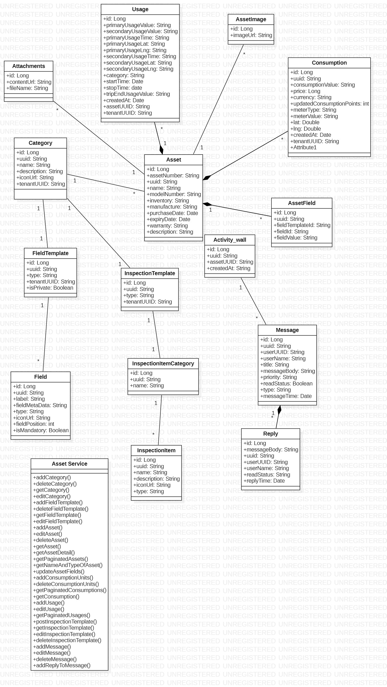

Figure 49: Asset Management Service

This is the class diagram of asset management service.

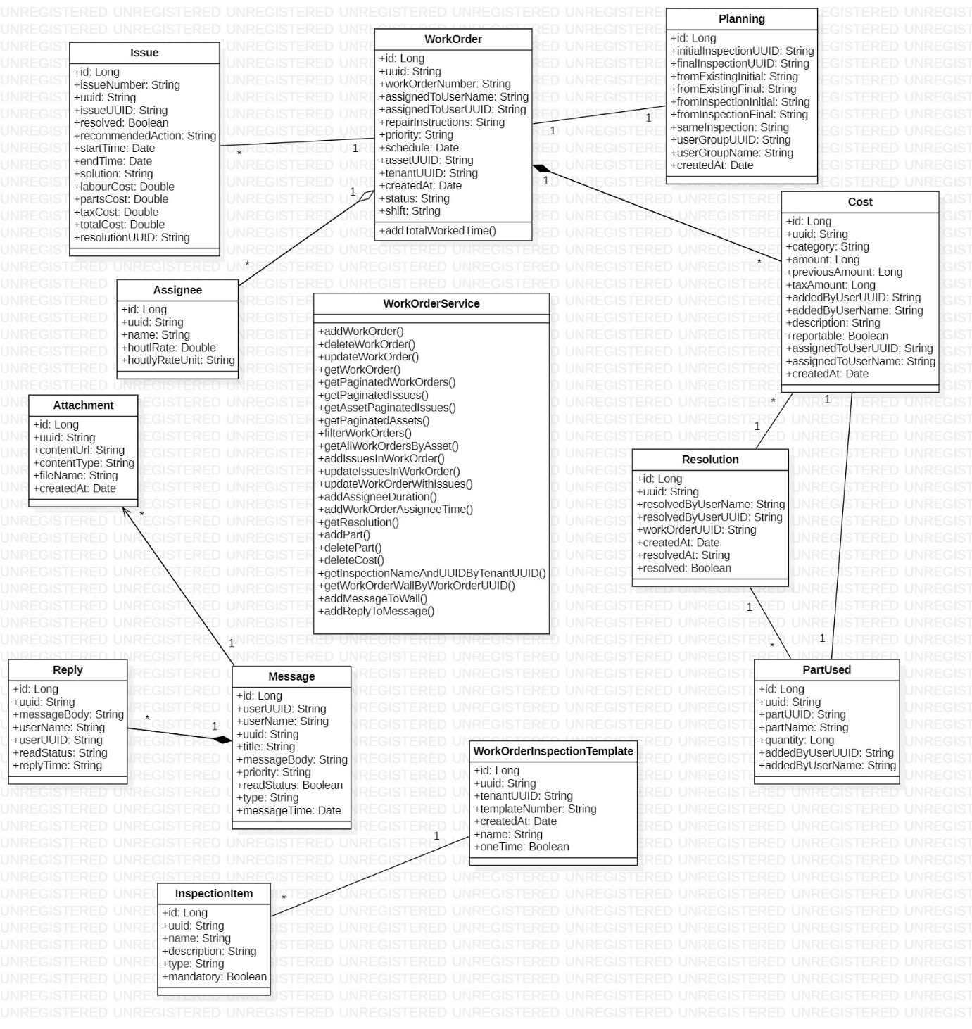

Figure 50: Work Order Service

This is the class diagram of work order service.

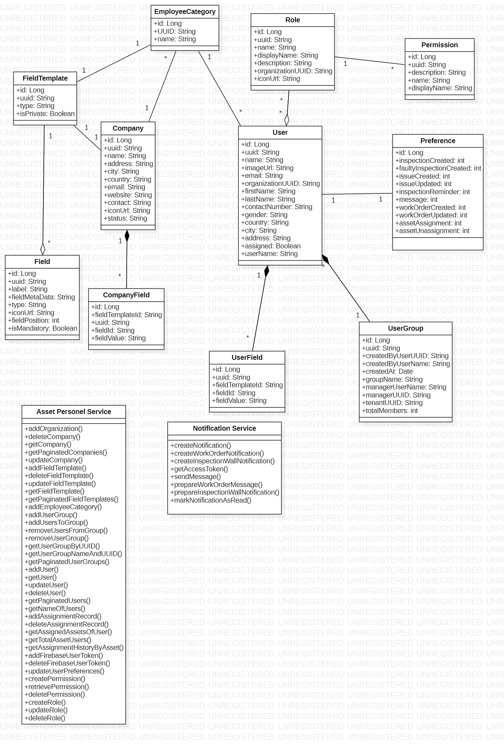

Figure 51: Asset Personnel Service

This is the class diagram of asset personnel service.

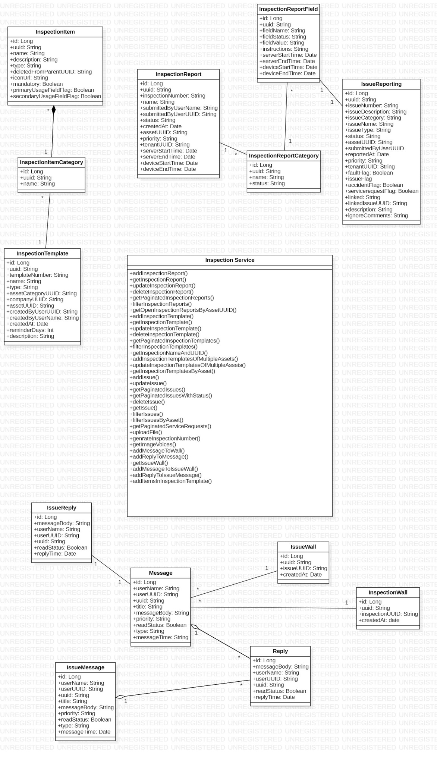

Figure 52: Inspection Service

This is the class diagram of inspection service.

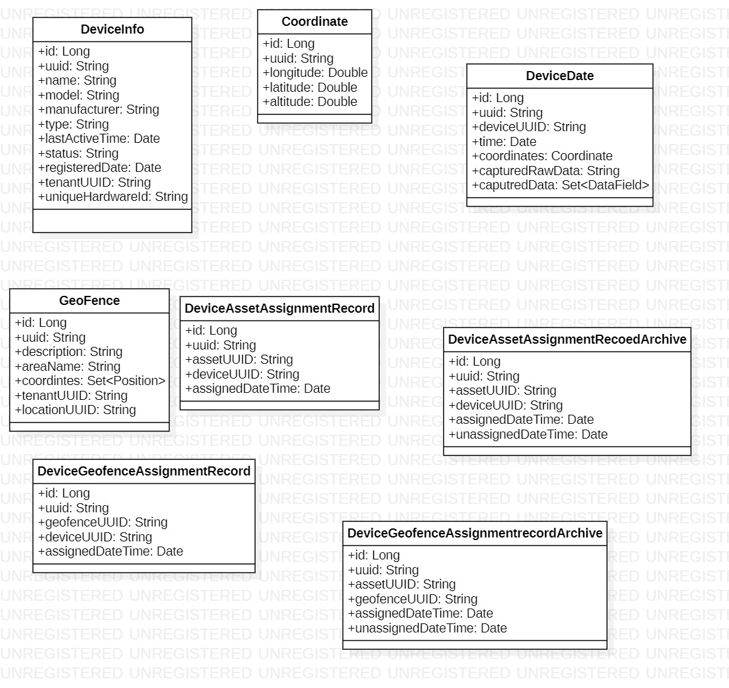

Figure 53: Device Template Service

This is the class diagram of device template service.

## Sequence diagram

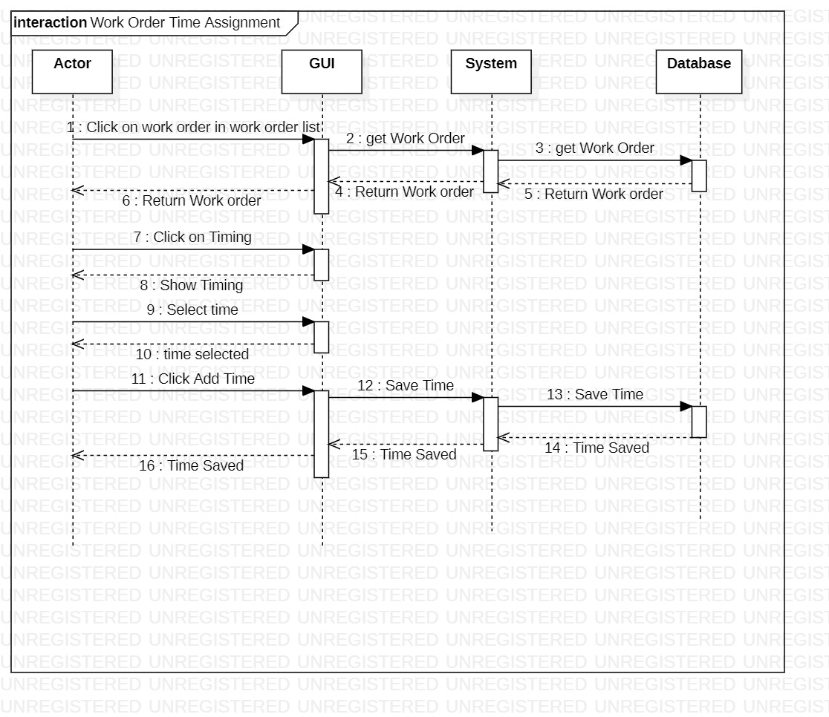

Figure 54: Work Order Time Assignment

This is the sequence diagram of work order time assignment.

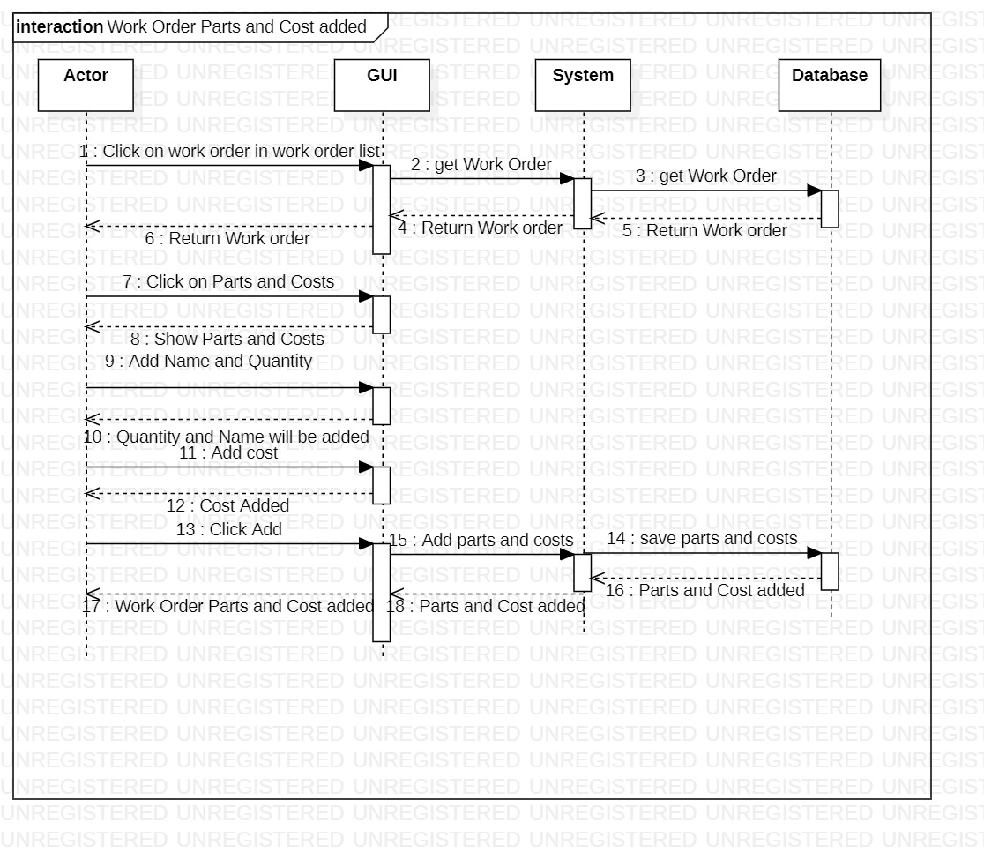

Figure 55: Work Order Parts and Cost added

This is the sequence diagram of work order parts and cost.

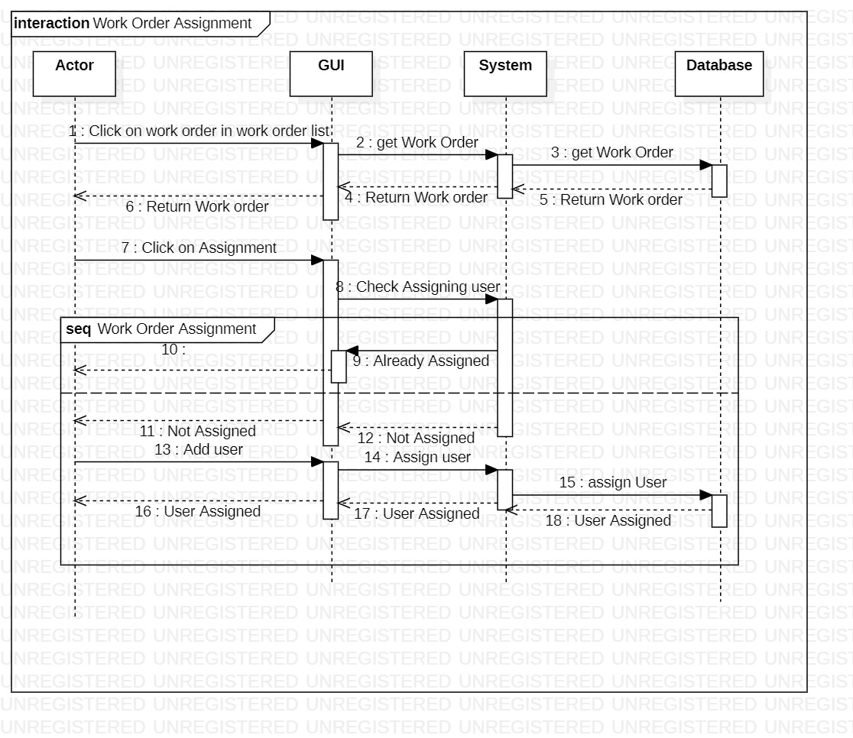

Figure 56: Work Order Assignment

This is the sequence diagram of work order assignment.

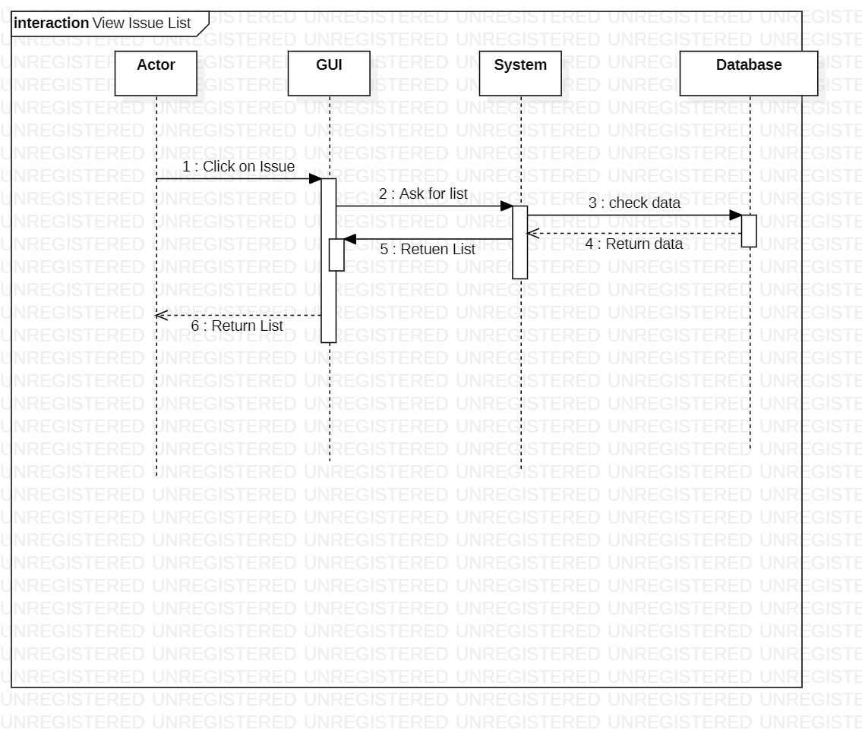

Figure 57: View Issue List

This is the sequence diagram of view issue list.

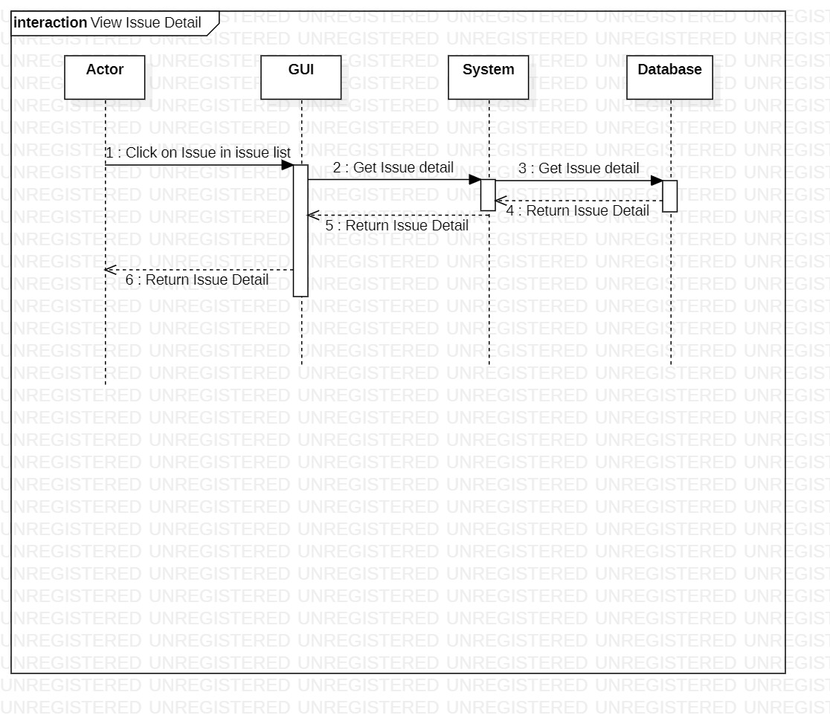

Figure 58: View Issue Detail

This is the sequence diagram of view issue detail.

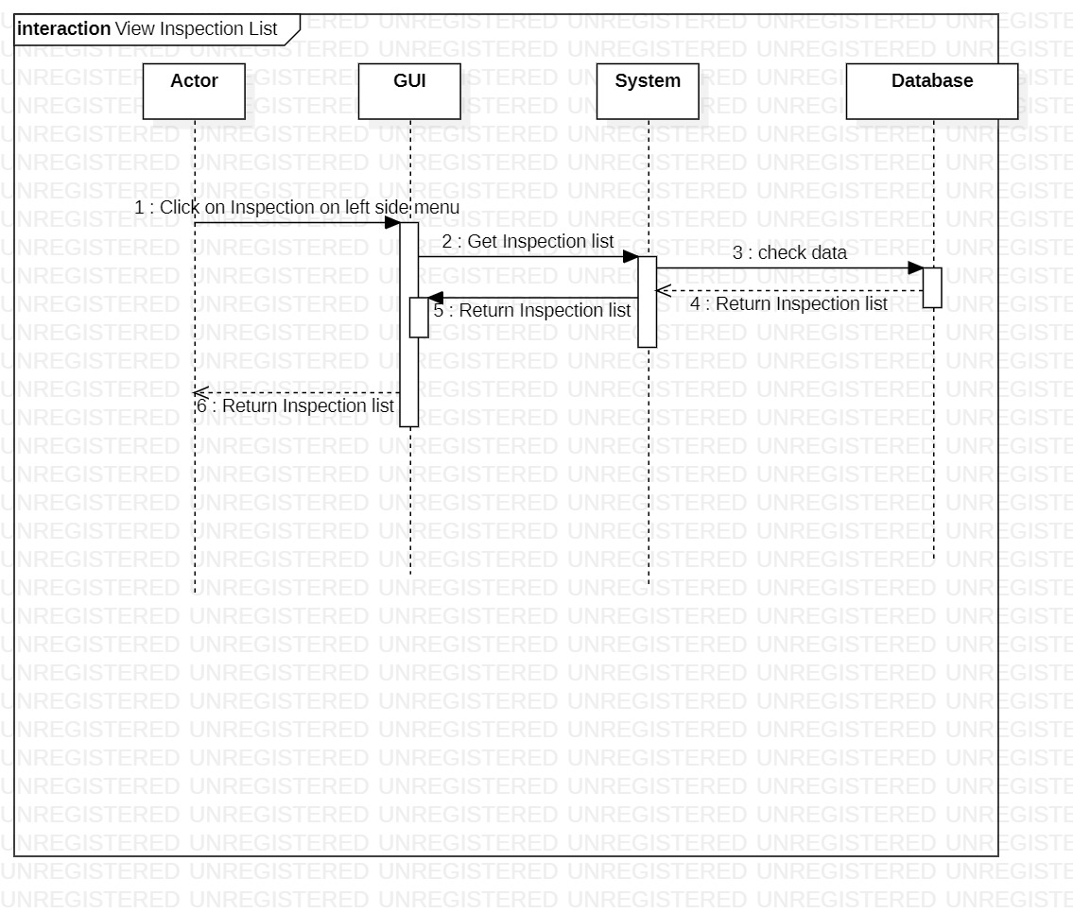

Figure 59: View Inspection List

This is the sequence diagram of view inspection list.

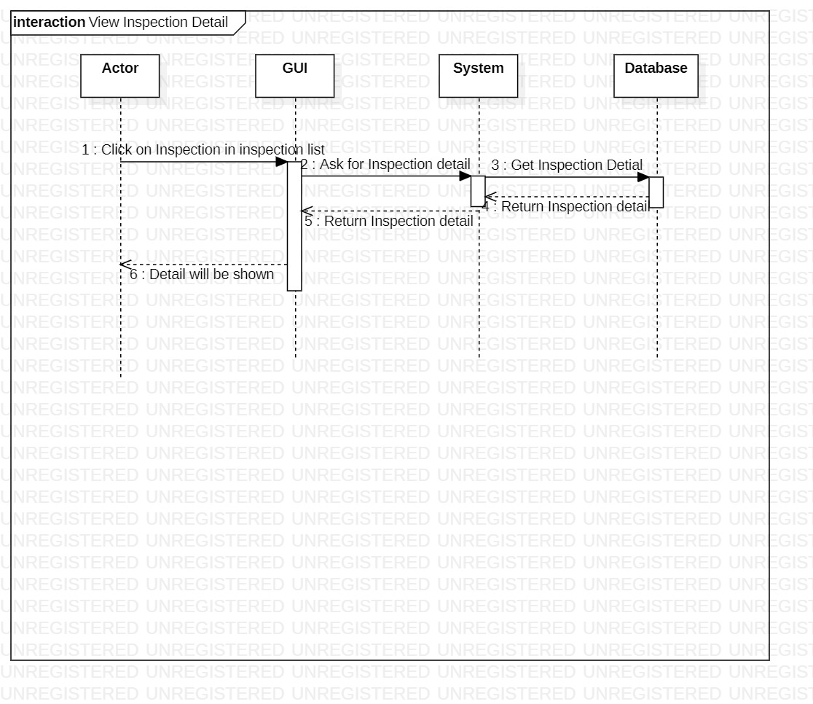

Figure 60: View Inspection Detail

This is the sequence diagram of view inspection detail.

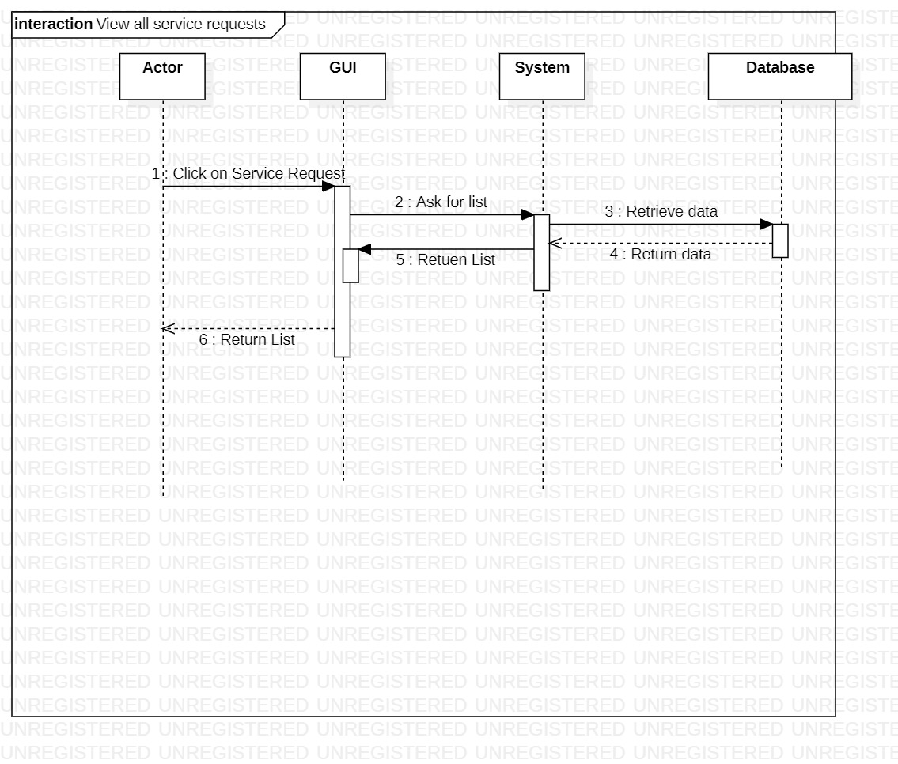

Figure 61: View All Service Requests

This is the sequence diagram of view all service requests.

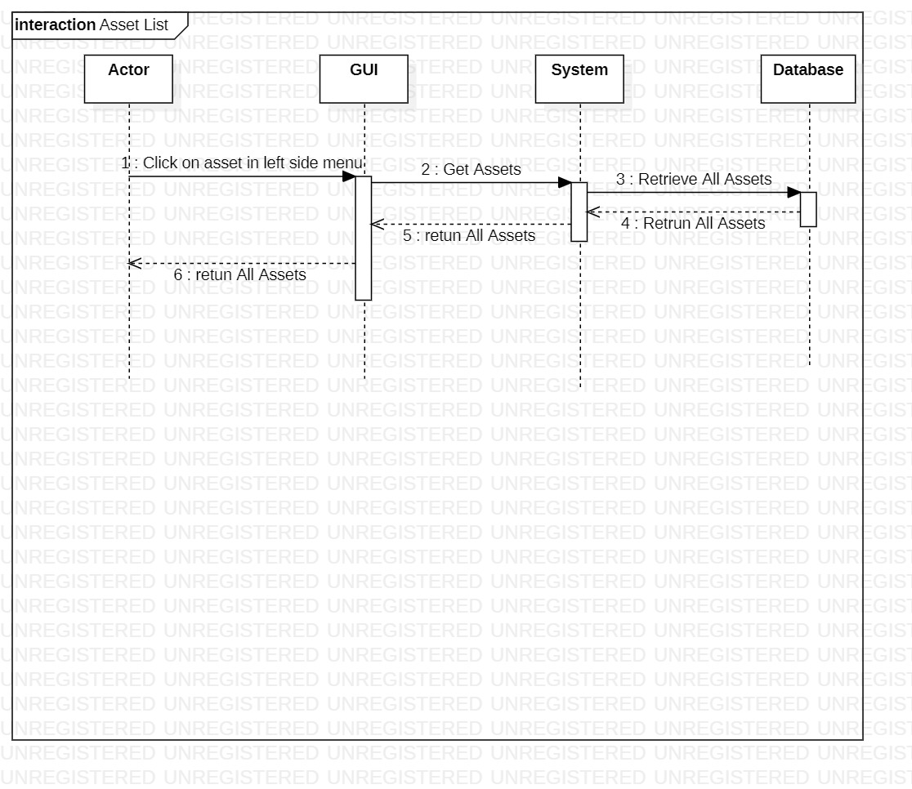

Figure 62: Asset List

This is the sequence diagram of asset list.

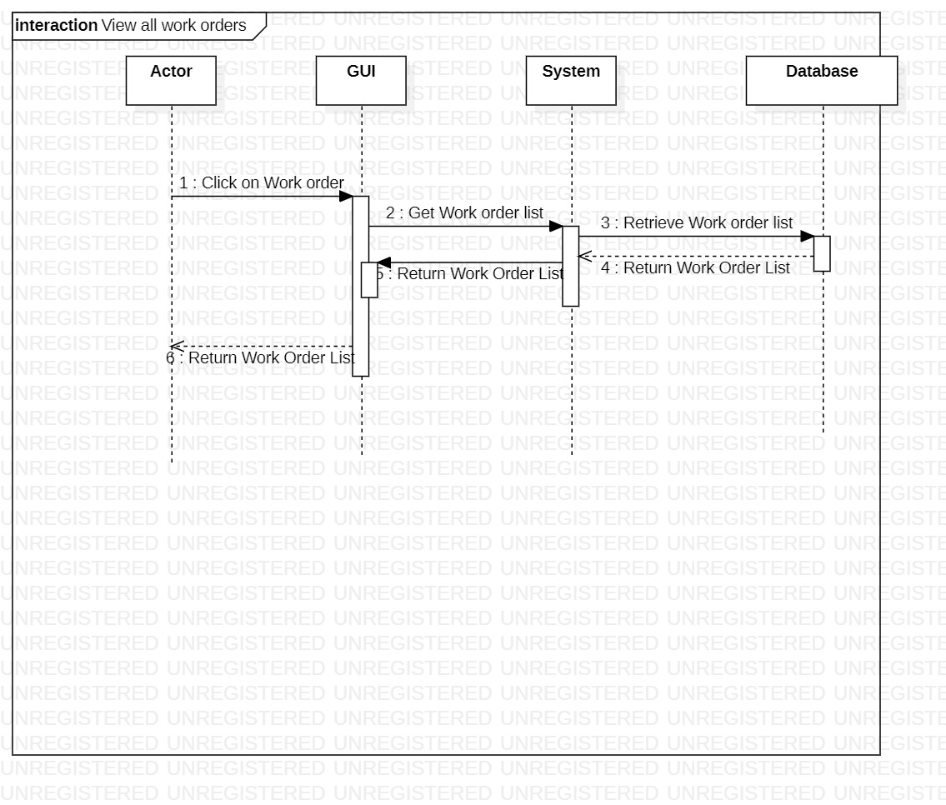

Figure 63: View All Work Orders

This is the sequence diagram of view work orders.

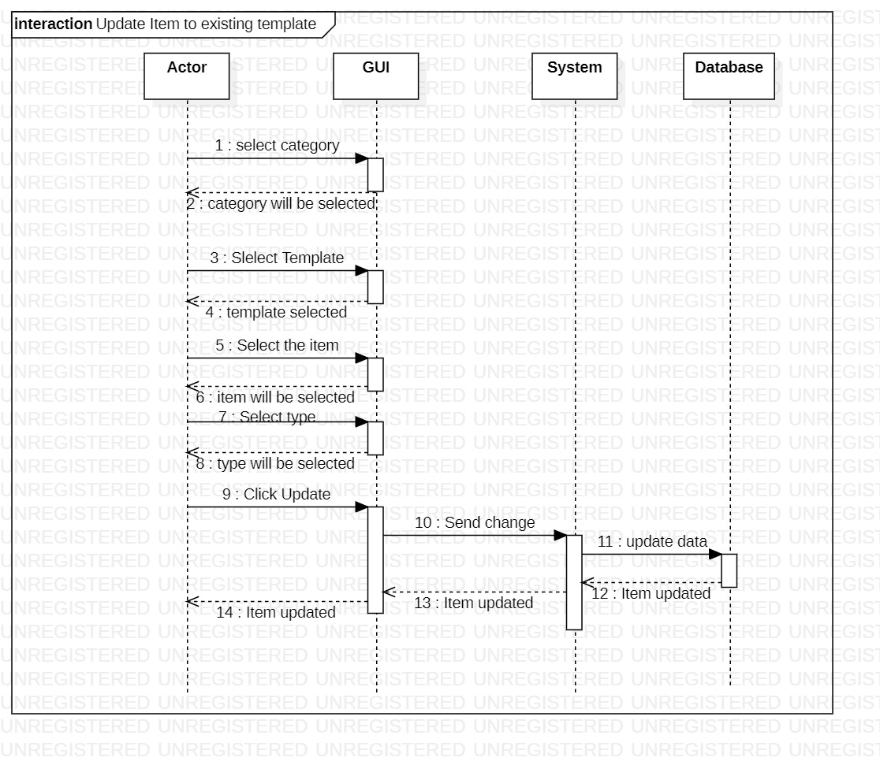

Figure 64: Update Item to Existing Template

This is the sequence diagram of update item to existing template.

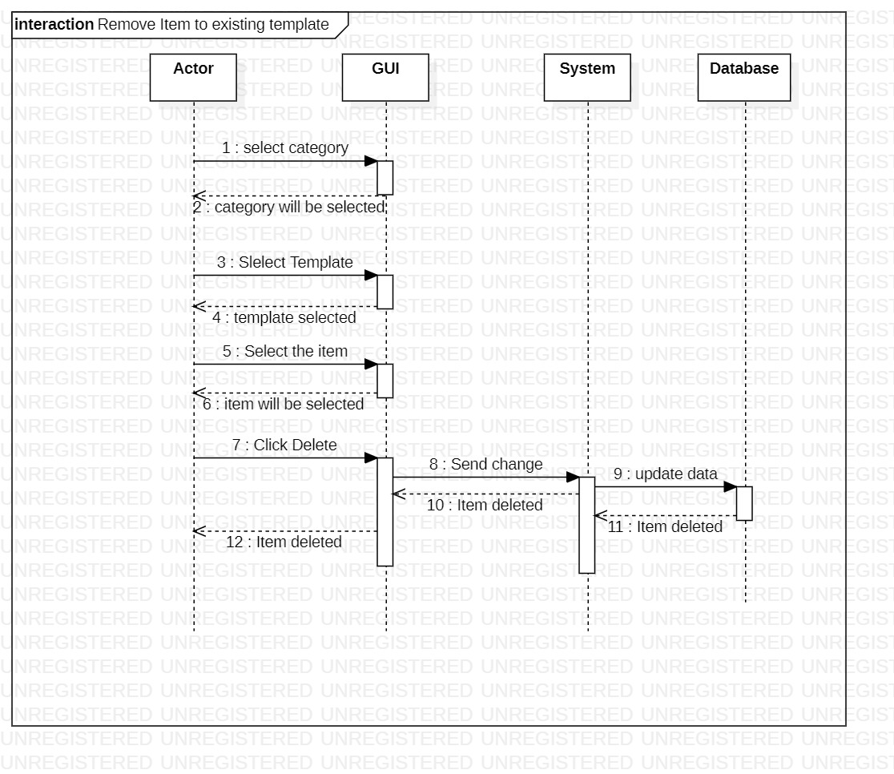

Figure 65: Remove Item to Existing Template

This is the sequence diagram of remove item to existing template.

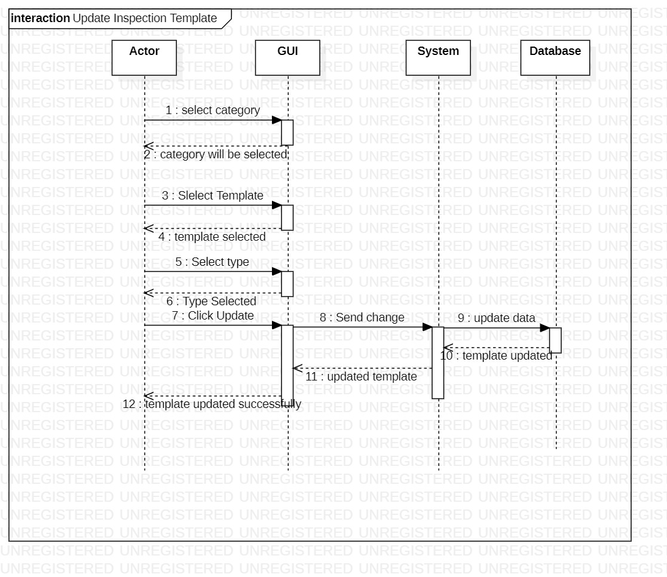

Figure 66: Update Inspection Template

This is the sequence diagram of update inspection template.

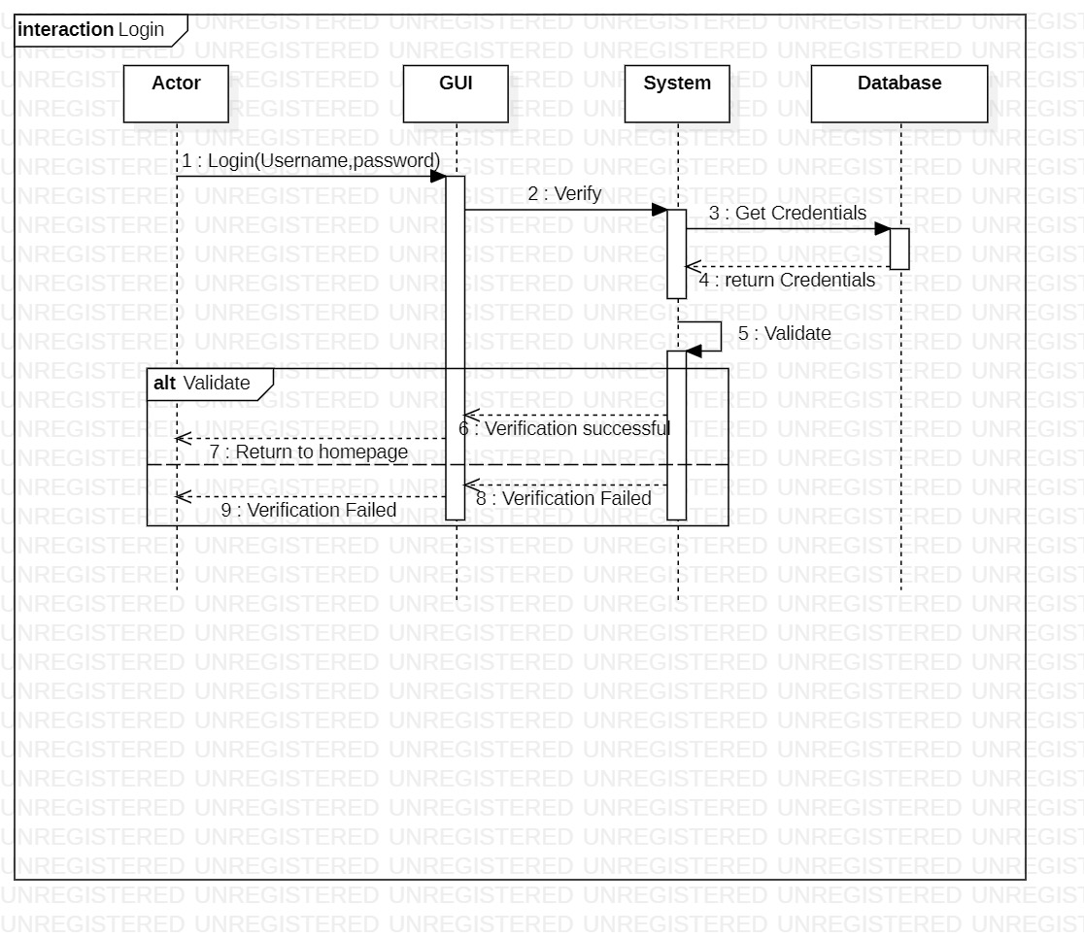

Figure 67: Login

This is the sequence diagram of login.

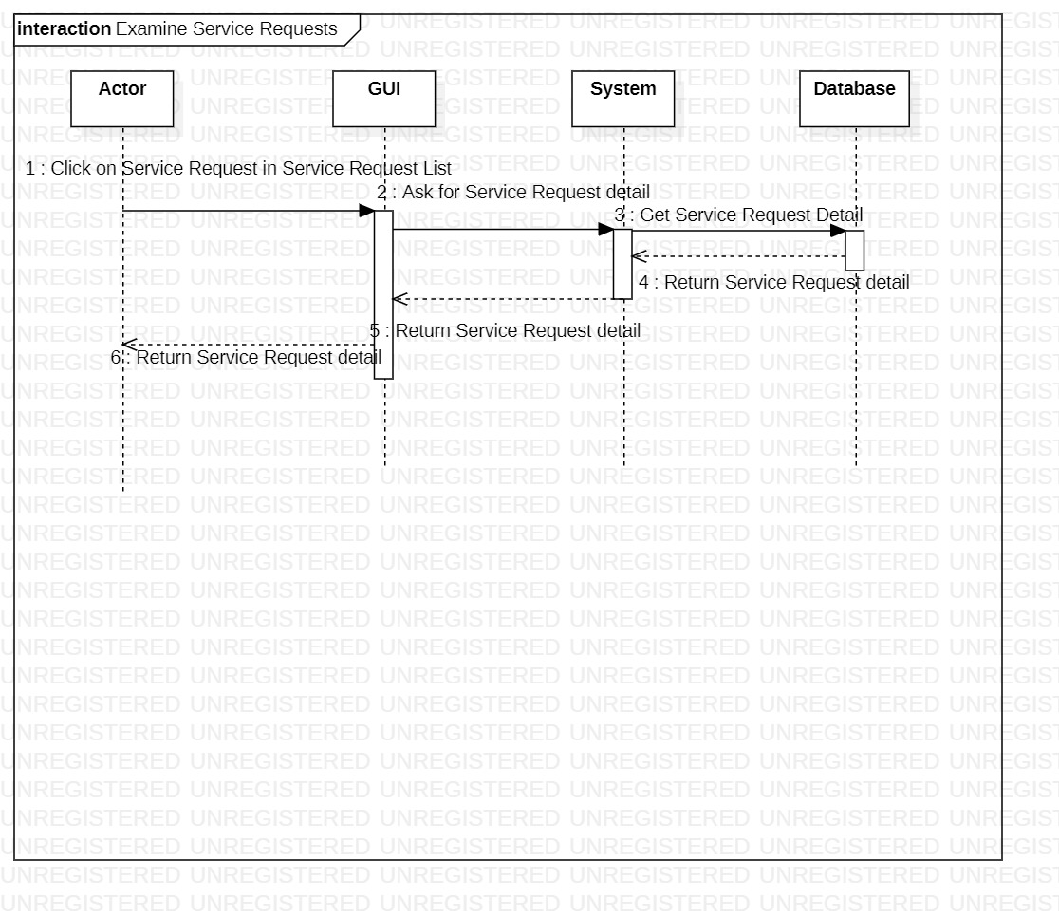

Figure 68: Examine Service Requests

This is the sequence diagram of examine service requests.

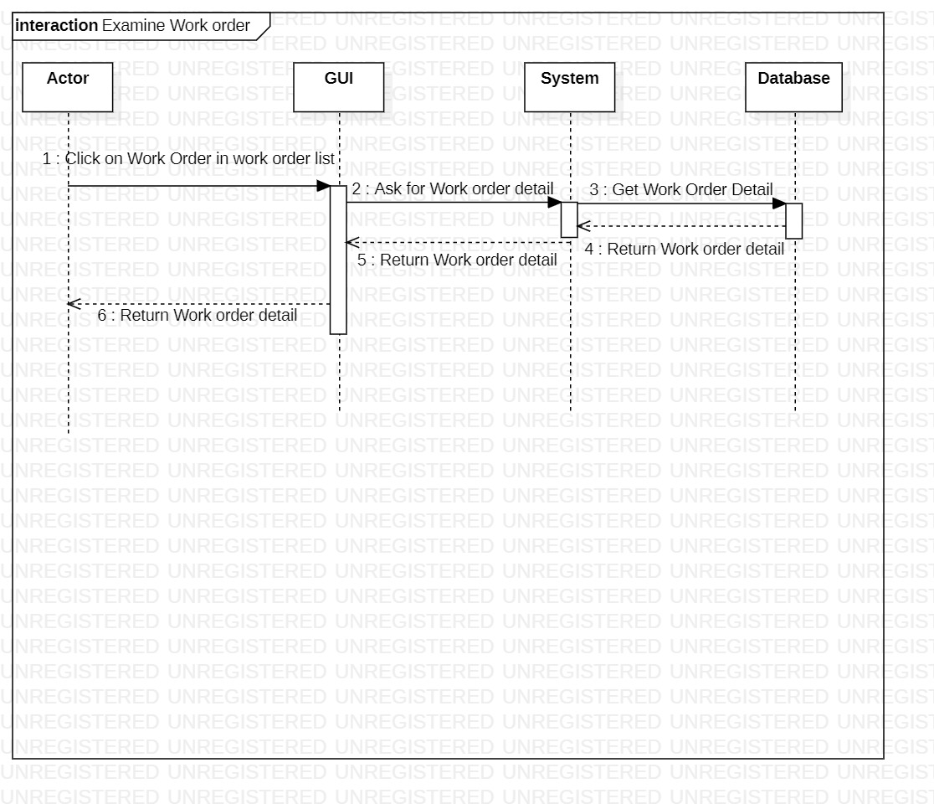

Figure 69: Examine Work Order

This is the sequence diagram of examine work order.

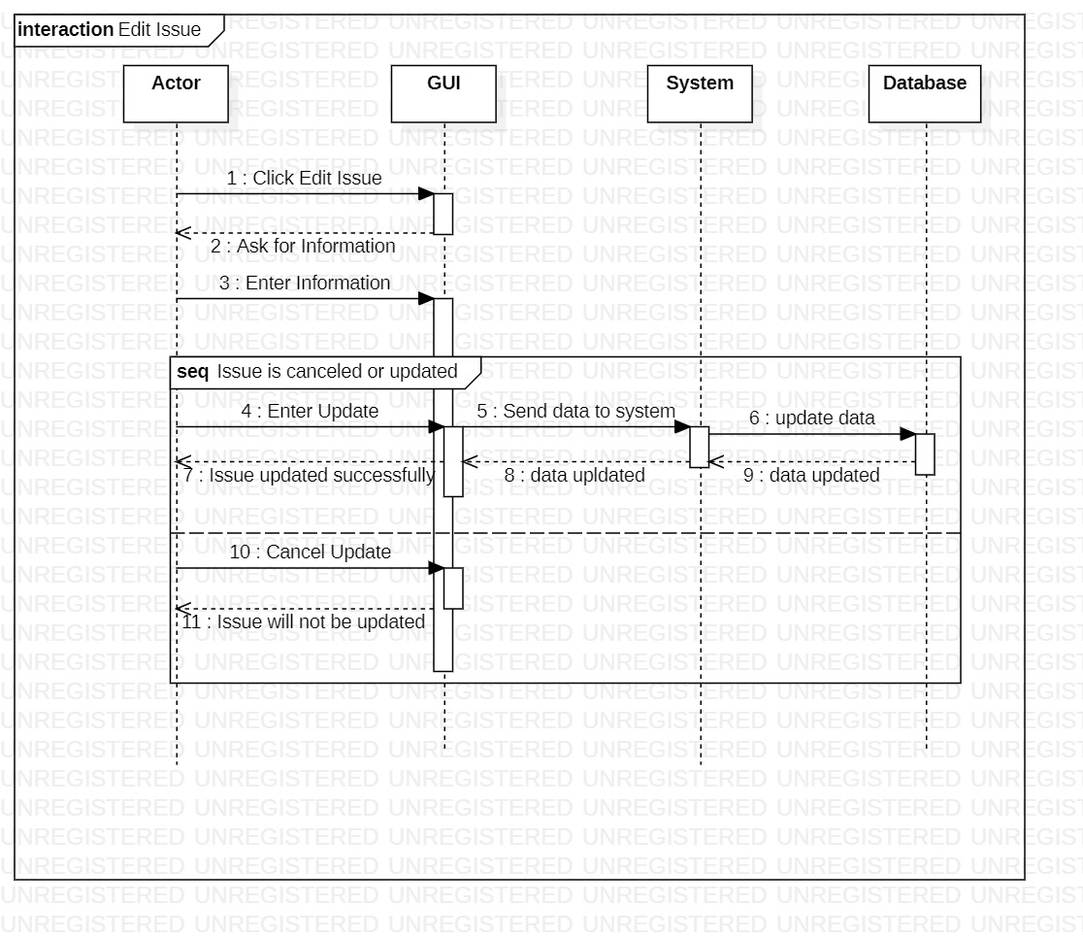

Figure 70: Edit Issue

This is the sequence diagram of edit issue.

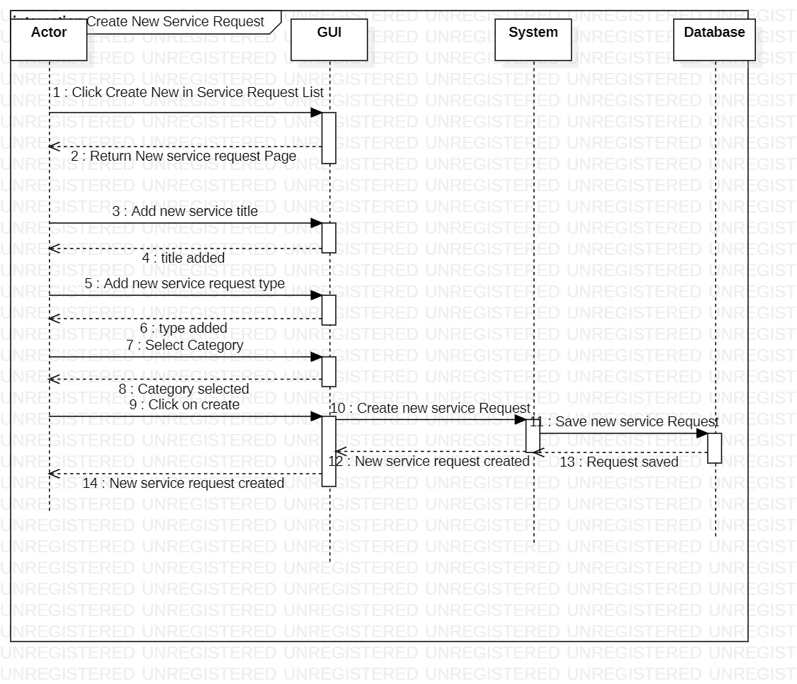

Figure 71: Create New Service Request

This is the sequence diagram of create new service request.

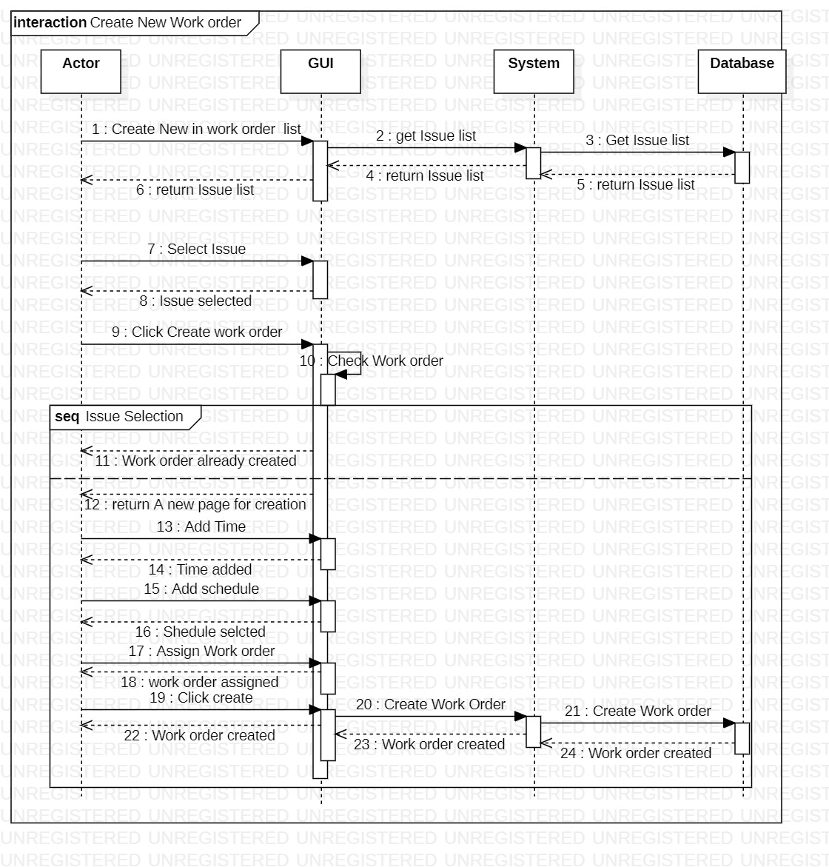

Figure 72: Create New Work Order

This is the sequence diagram of create new work order.

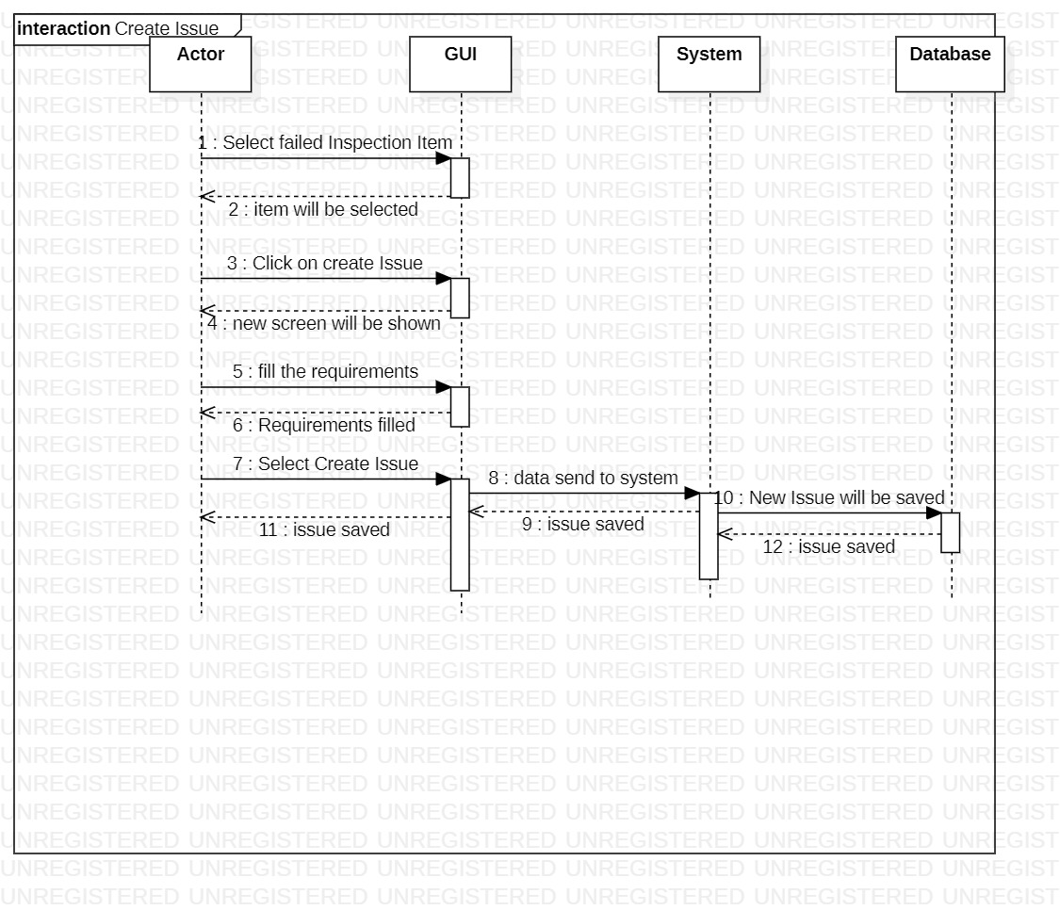

Figure 73: Create Issue

This is the sequence diagram of create issue.

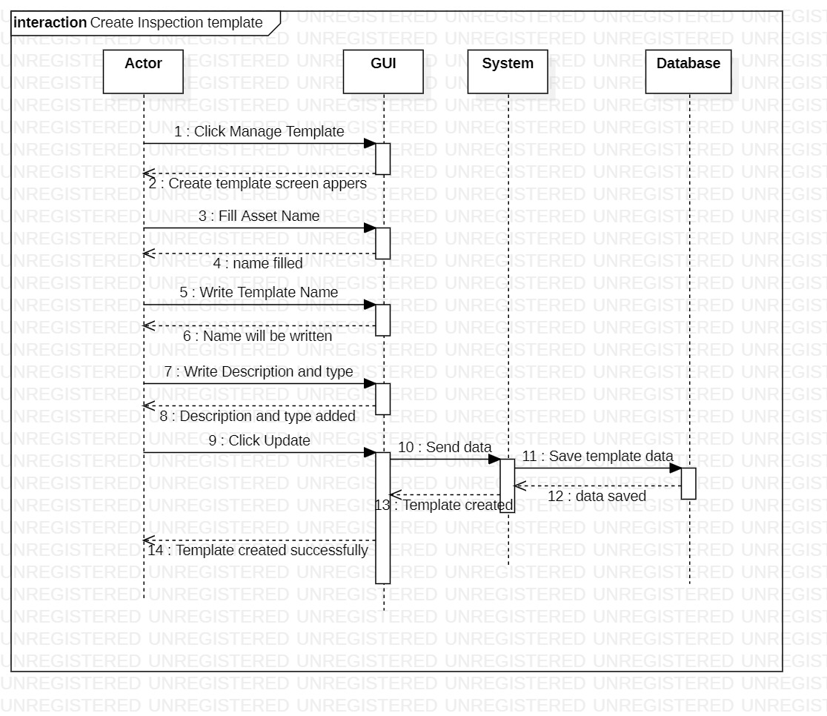

Figure 74: Create Inspection Template

This is the sequence diagram of create inspection template.

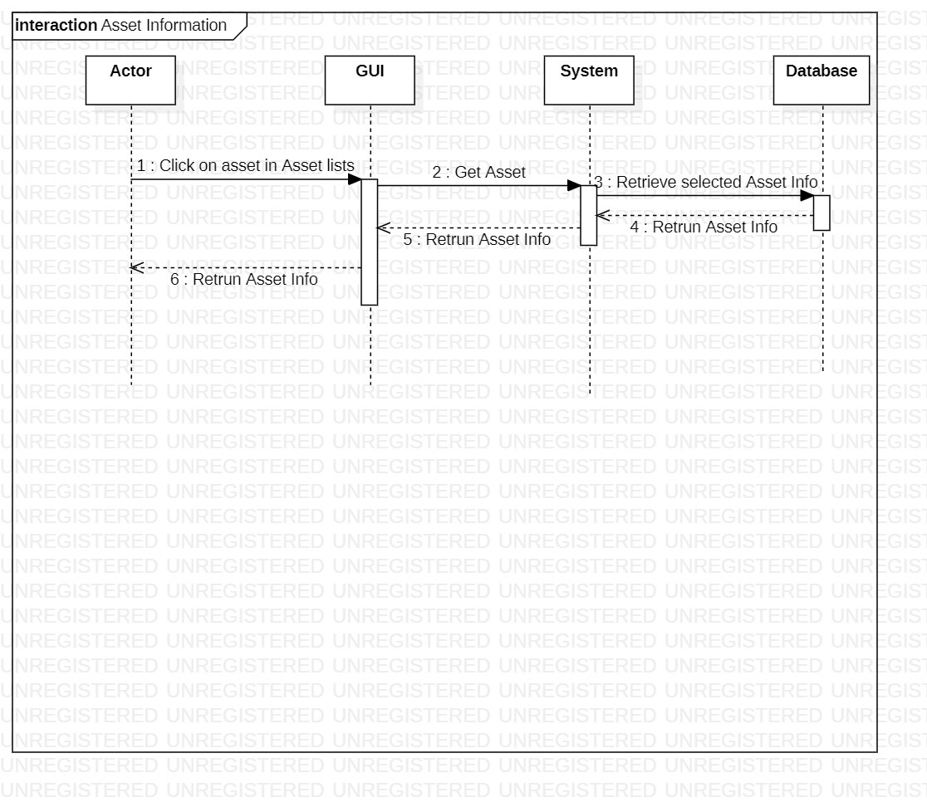

Figure 75: Asset Information

This is the sequence diagram of asset information.

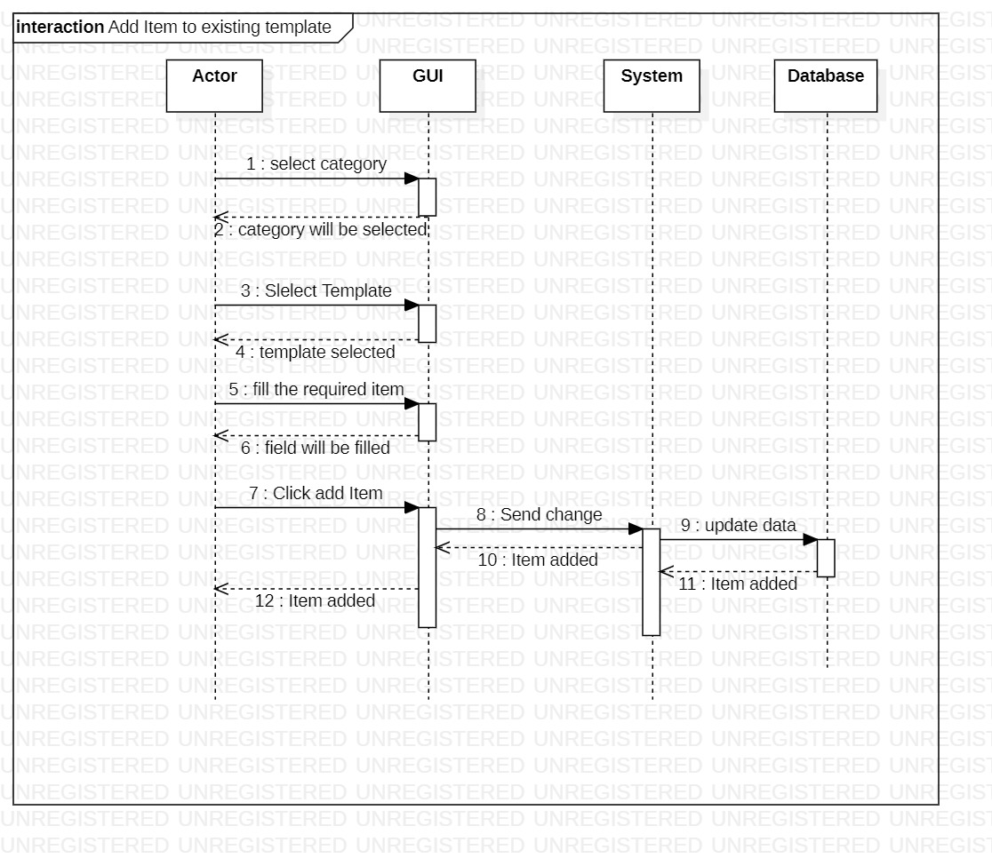

Figure 76: Add Item to Existing Template

This is the sequence diagram of add item to existing template.

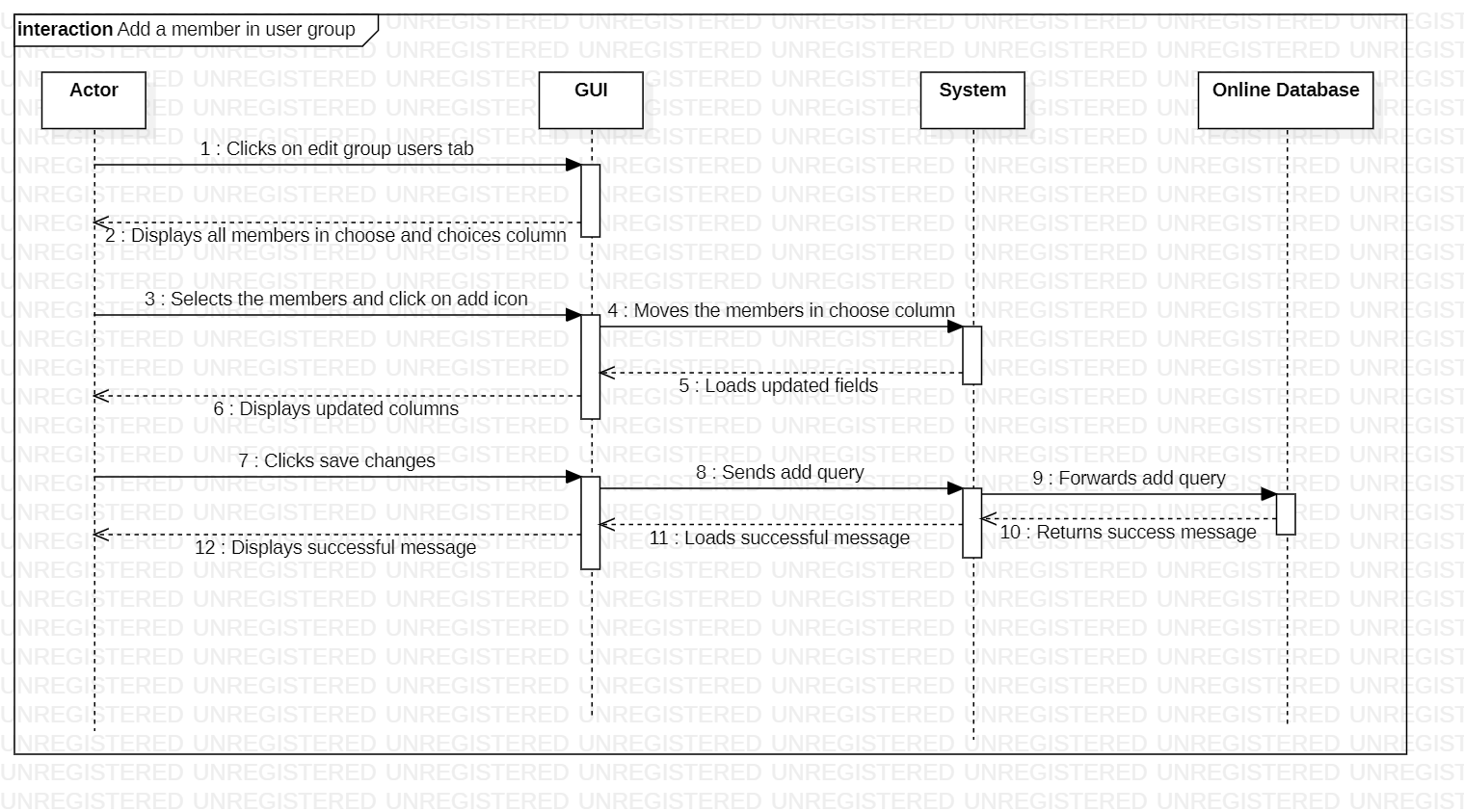

Figure 77: Add a Member in User Group

This is the sequence diagram of add a member in user group.

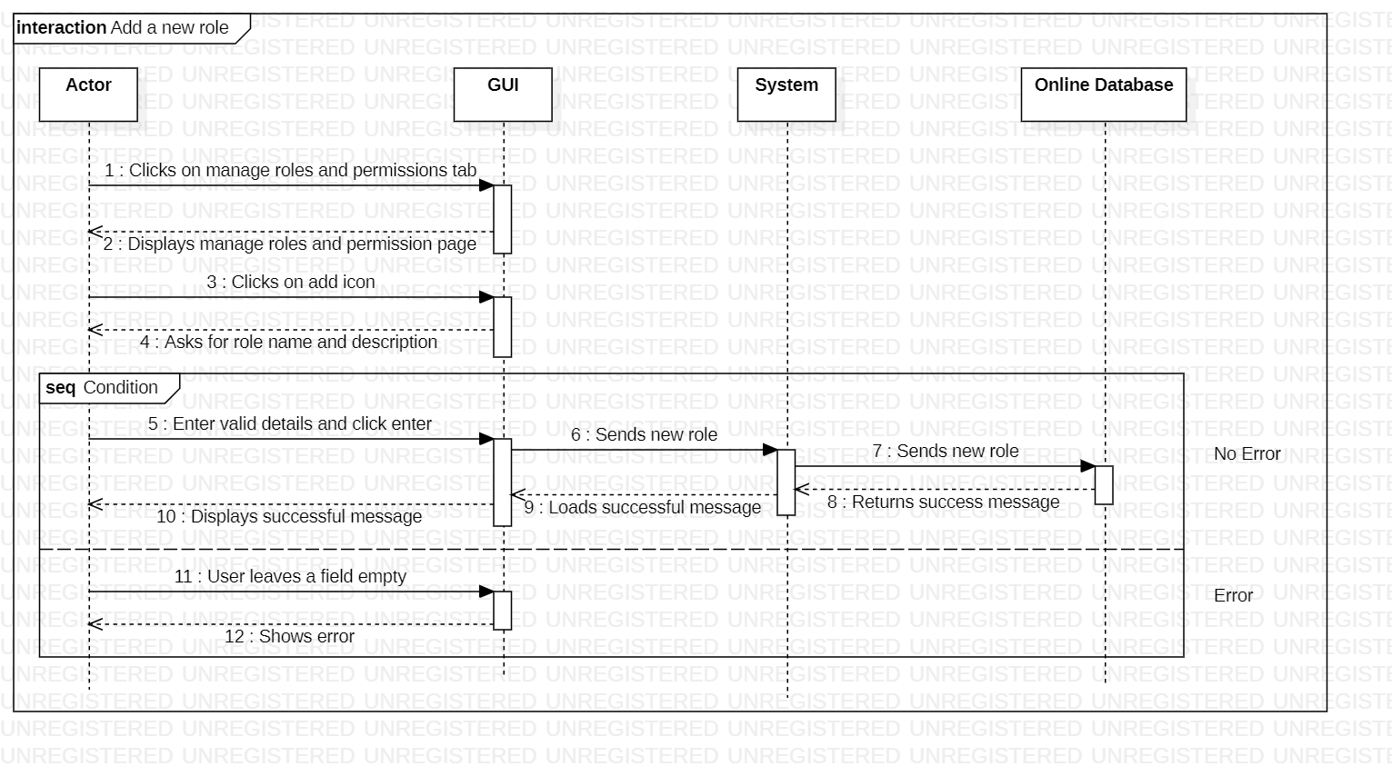

Figure 78: Add a New Role

This is the sequence diagram of add a new role.

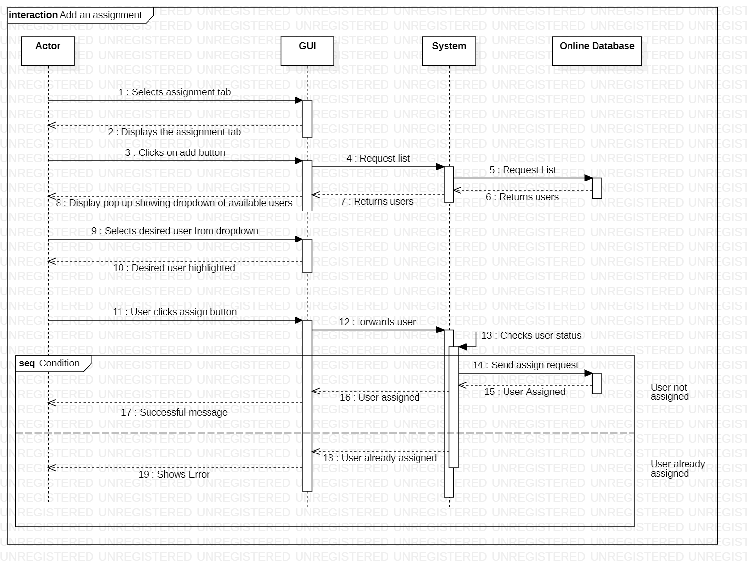

Figure 79: Add an Assignment

This is the sequence diagram of add an assignment.

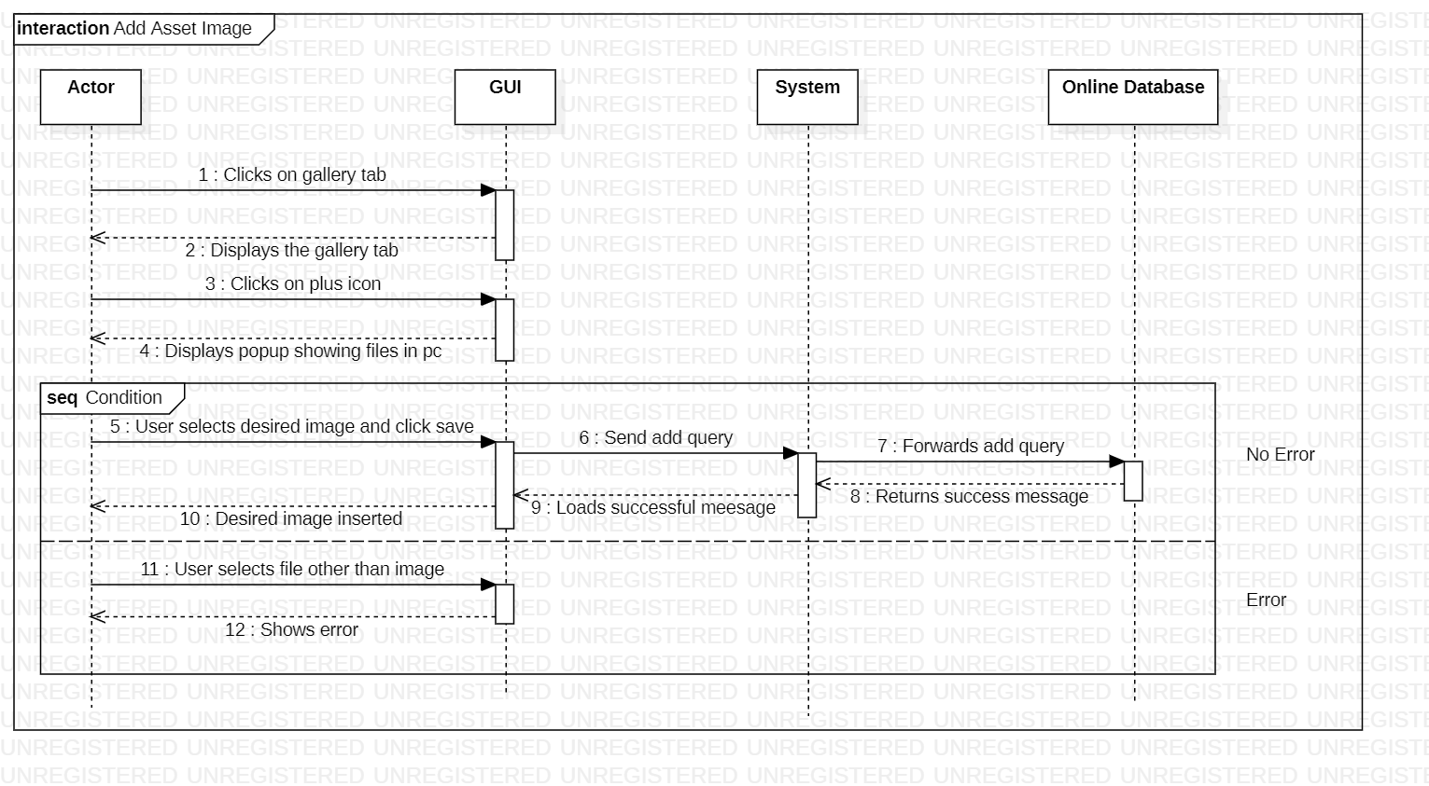

Figure 80: Add an Asset Image

This is the sequence diagram of add an asset image.

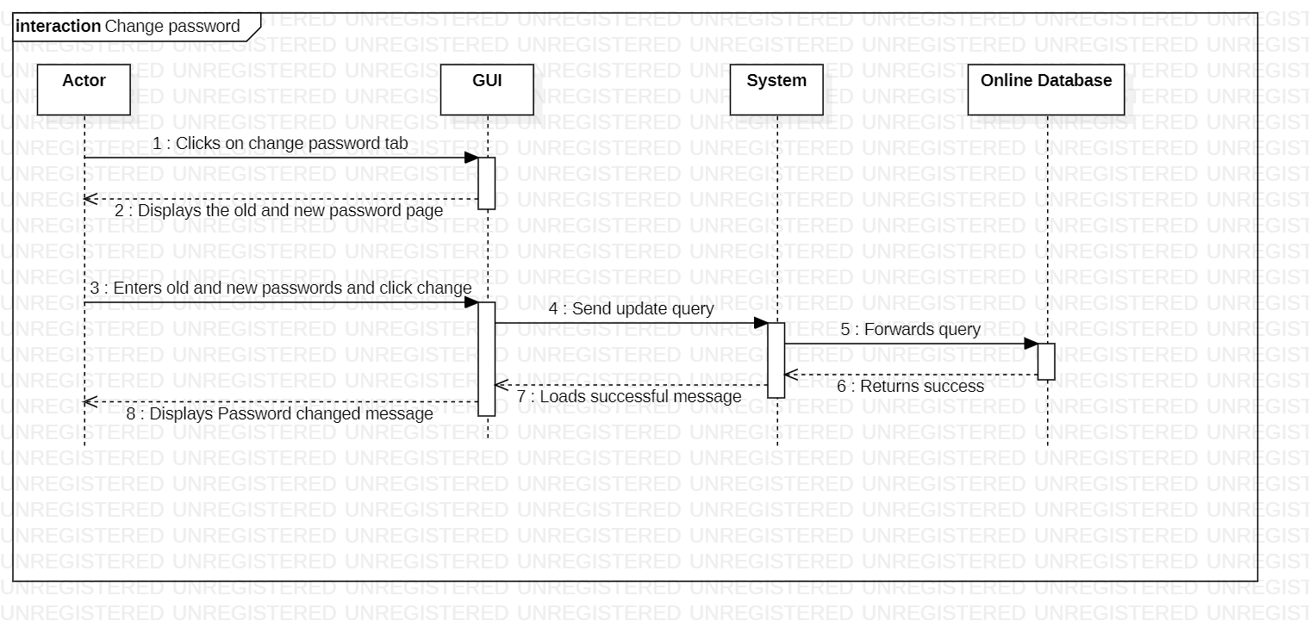

Figure 81: Change Password

This is the sequence diagram of change password.

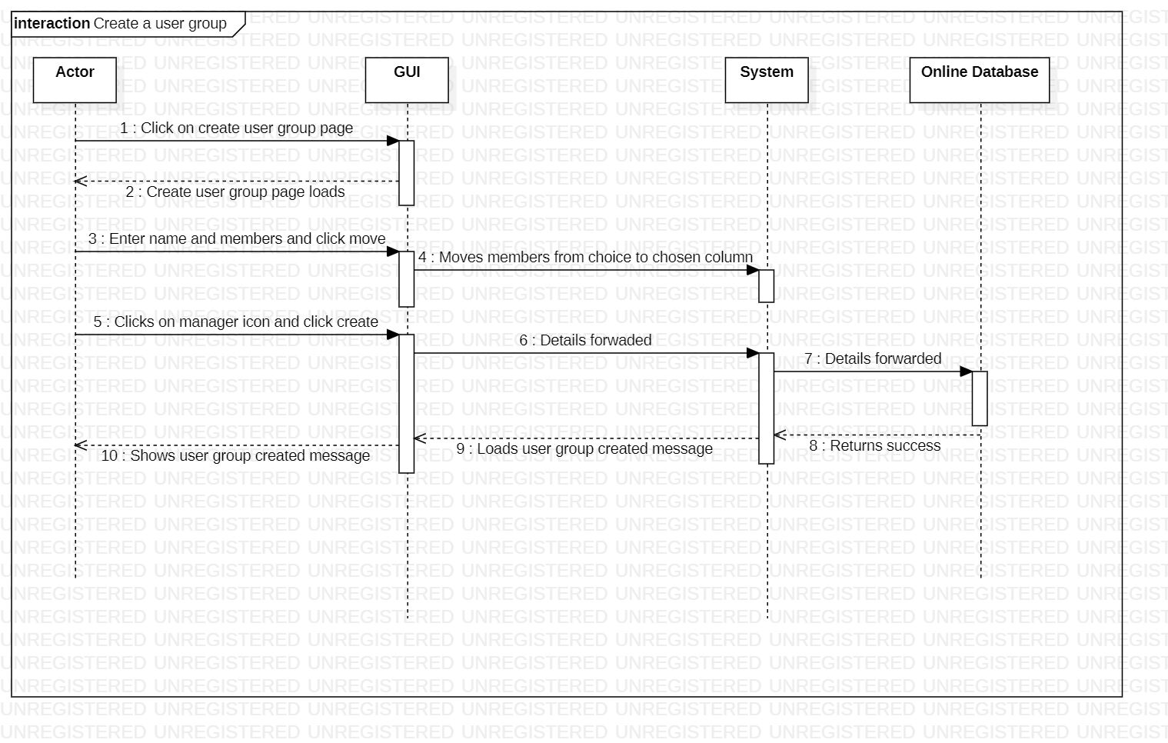

Figure 82: Create a User group

This is the sequence diagram of create a user group.

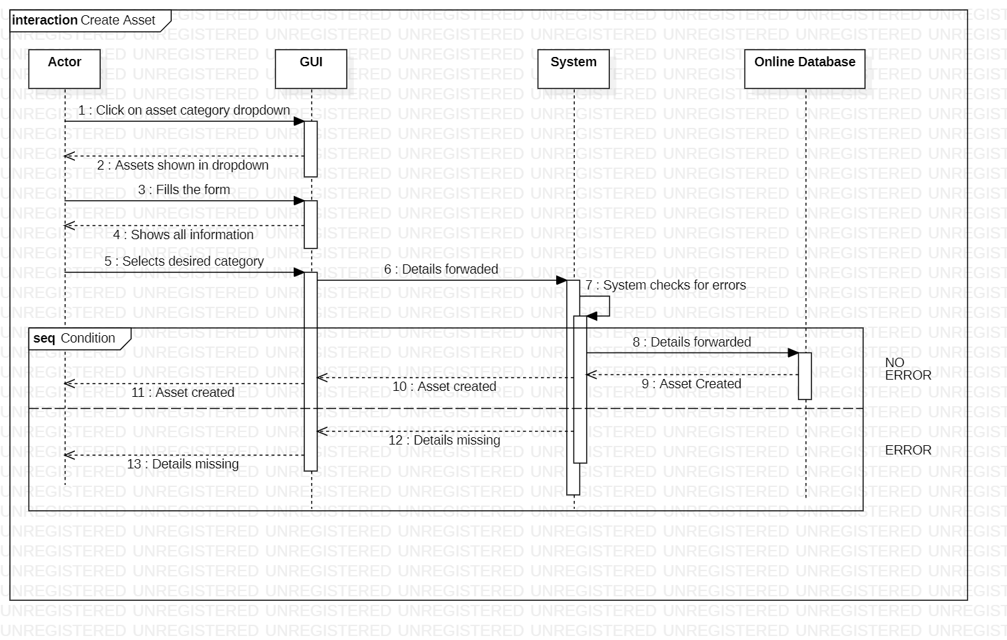

Figure 83: Create Asset

This is the sequence diagram of create asset.

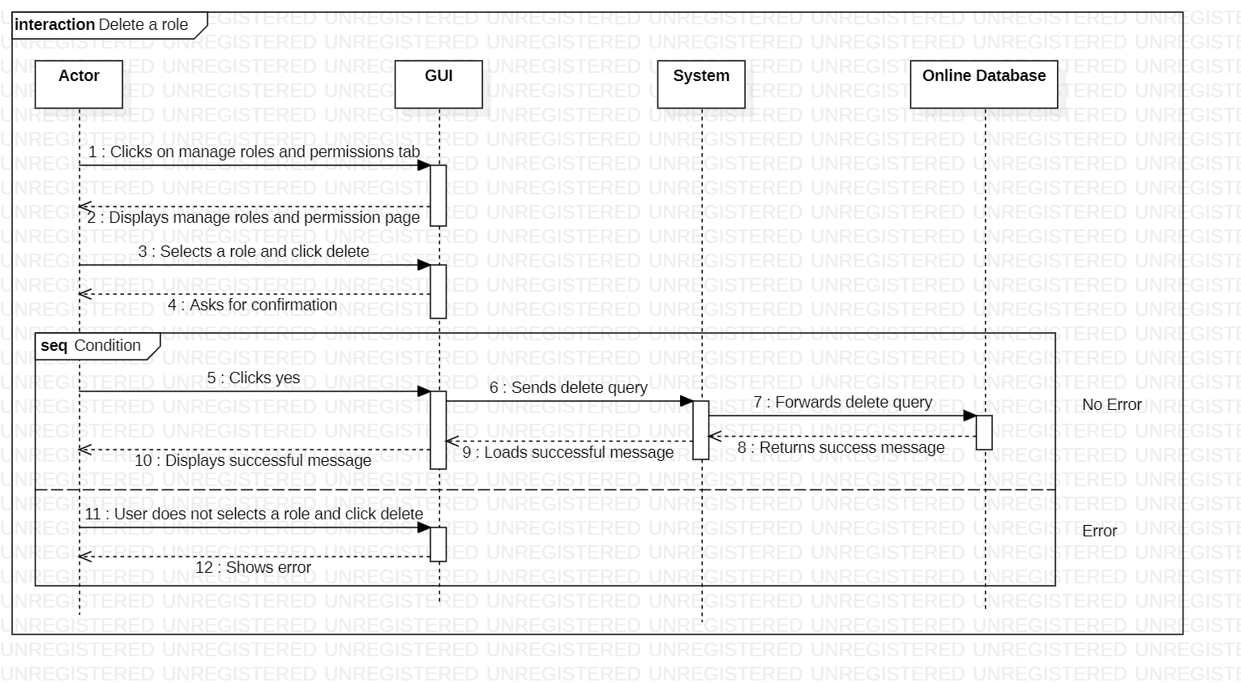

Figure 84: Delete a Role

This is the sequence diagram of delete a role.

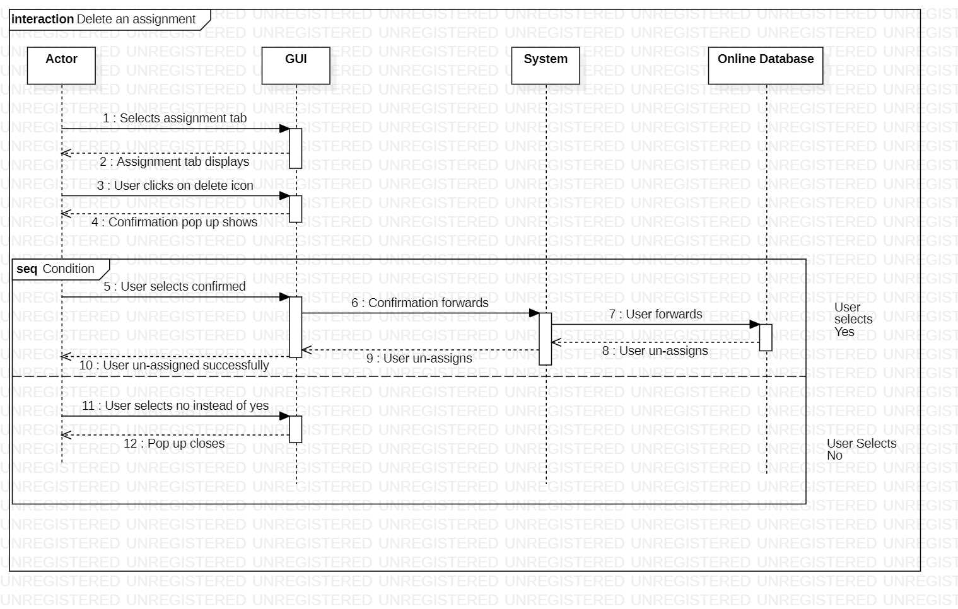

Figure 85: Delete an Assignment

This is the sequence diagram of delete an assignment

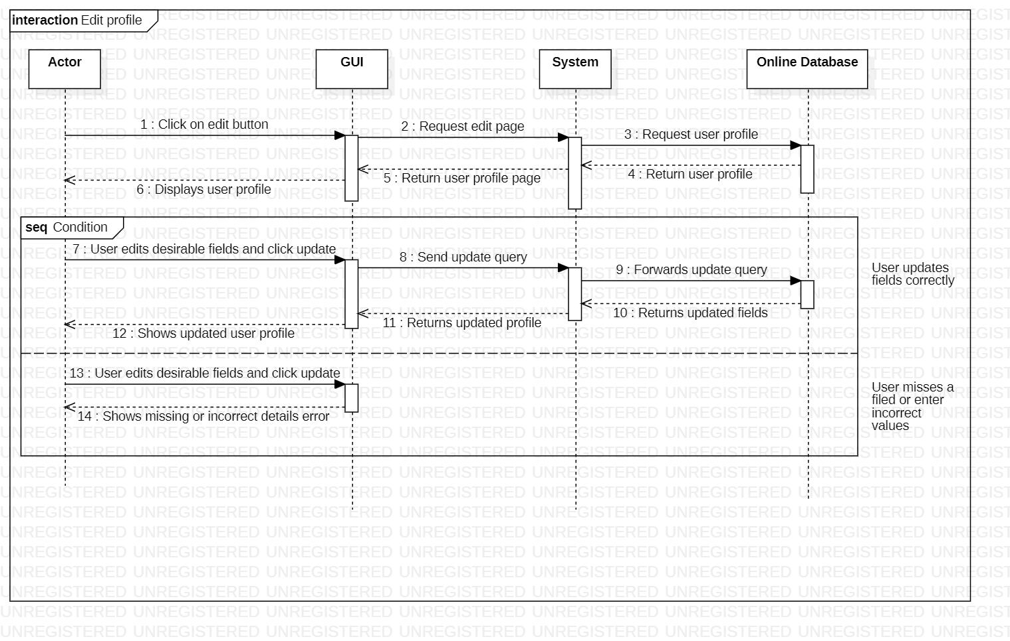

Figure 86: Edit a Profile

This is the sequence diagram of edit a profile.

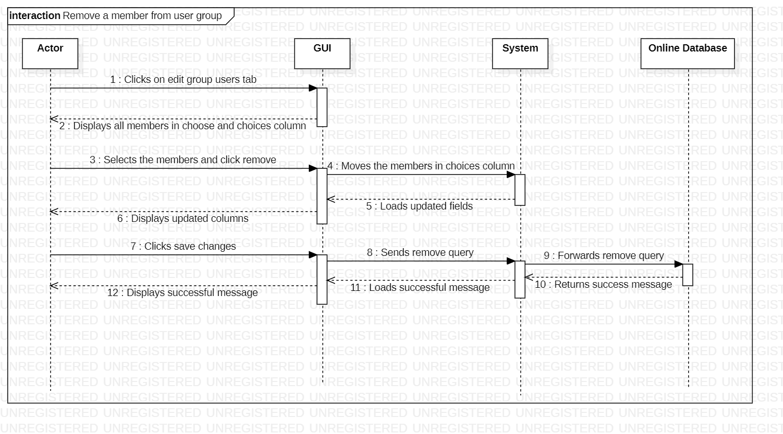

Figure 87: Remove a Member from User Group

This is the sequence diagram of remove a member from user group.

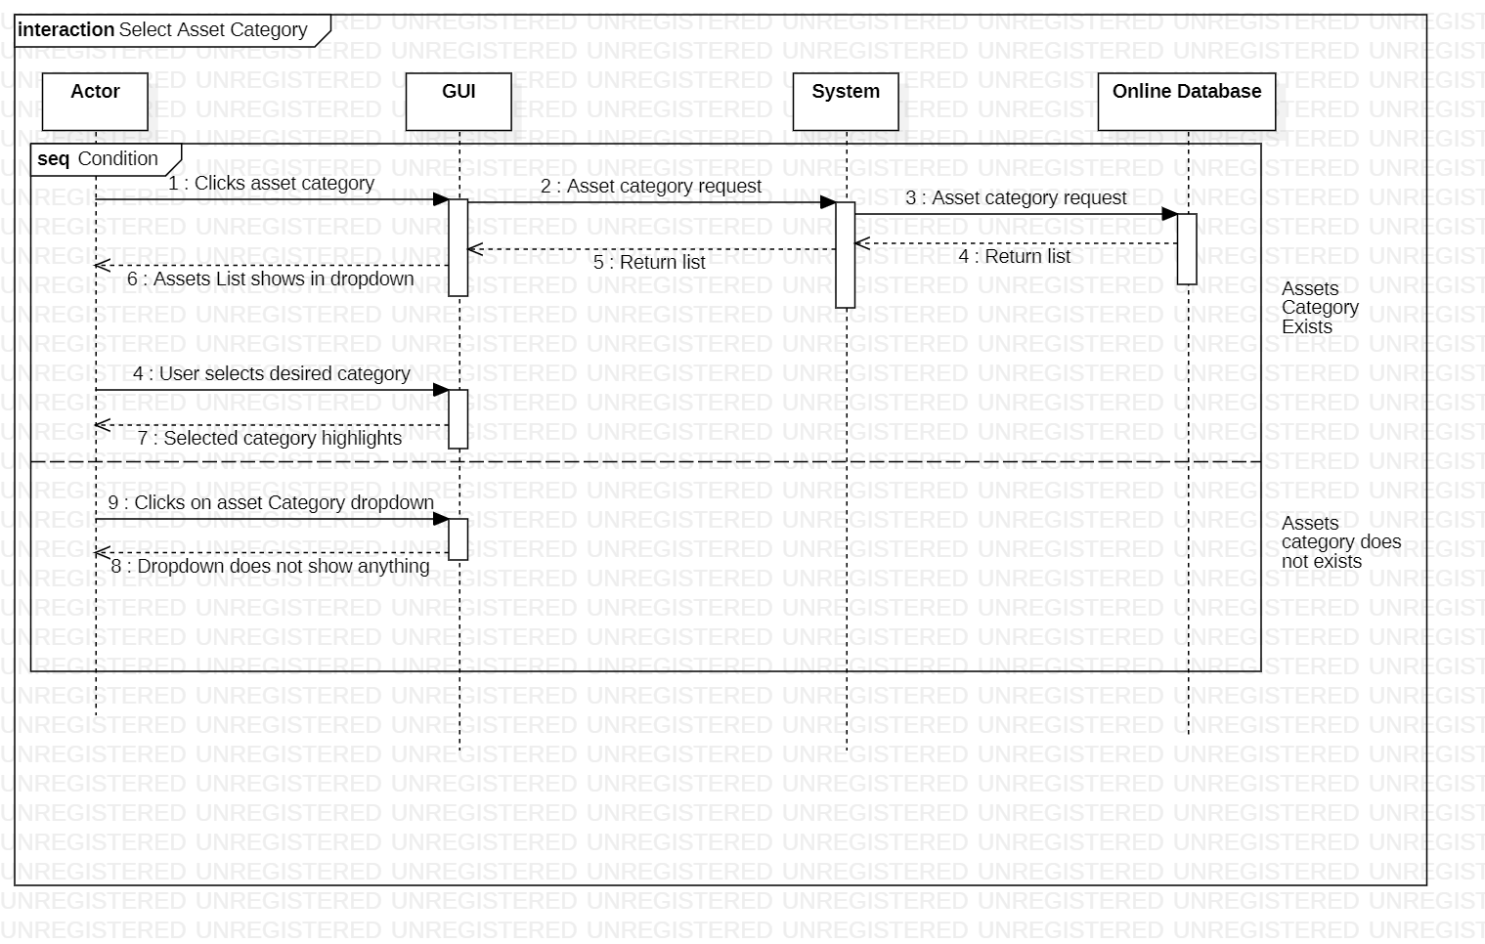

Figure 88: Select Asset Category

This is the sequence diagram of select an asset category.

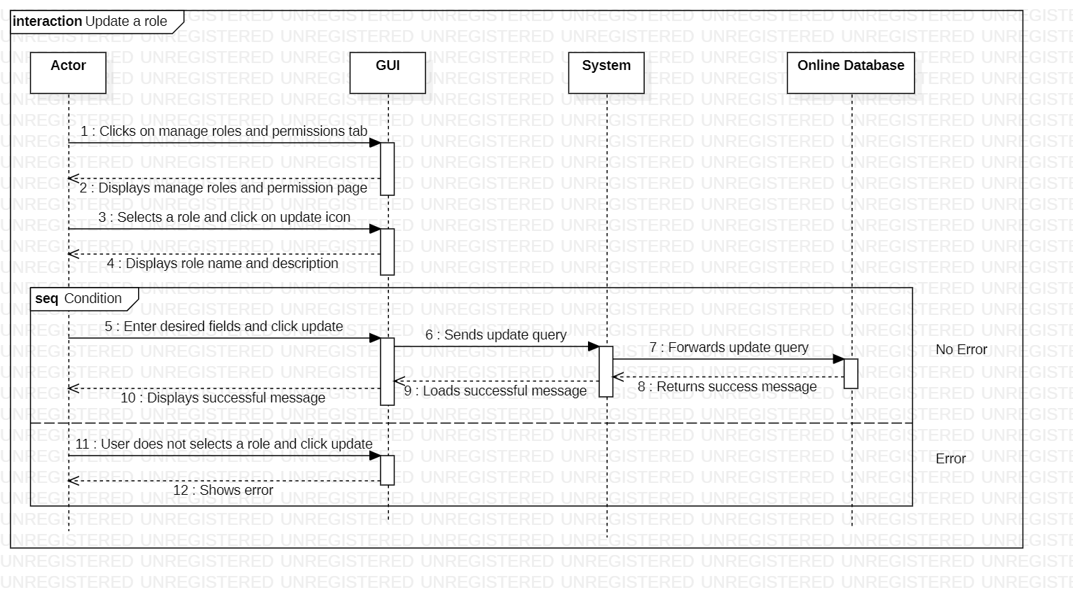

Figure 89: Update a Role

This is the sequence diagram of update a role.

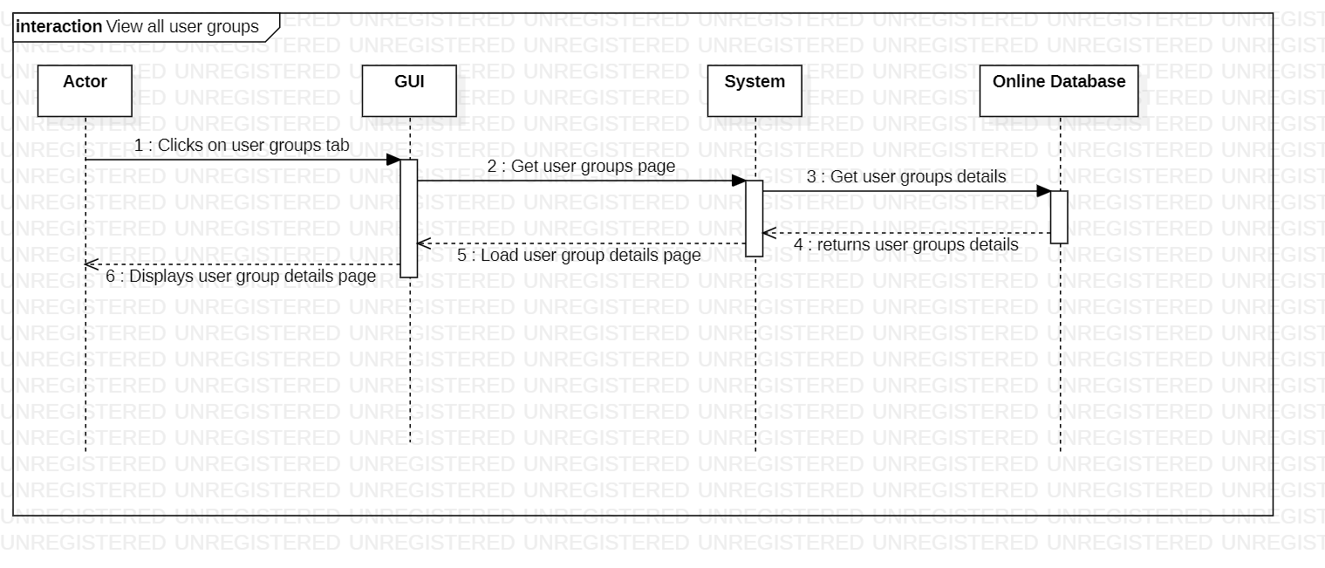

Figure 90: View All User Groups

This is the sequence diagram of view all user groups.

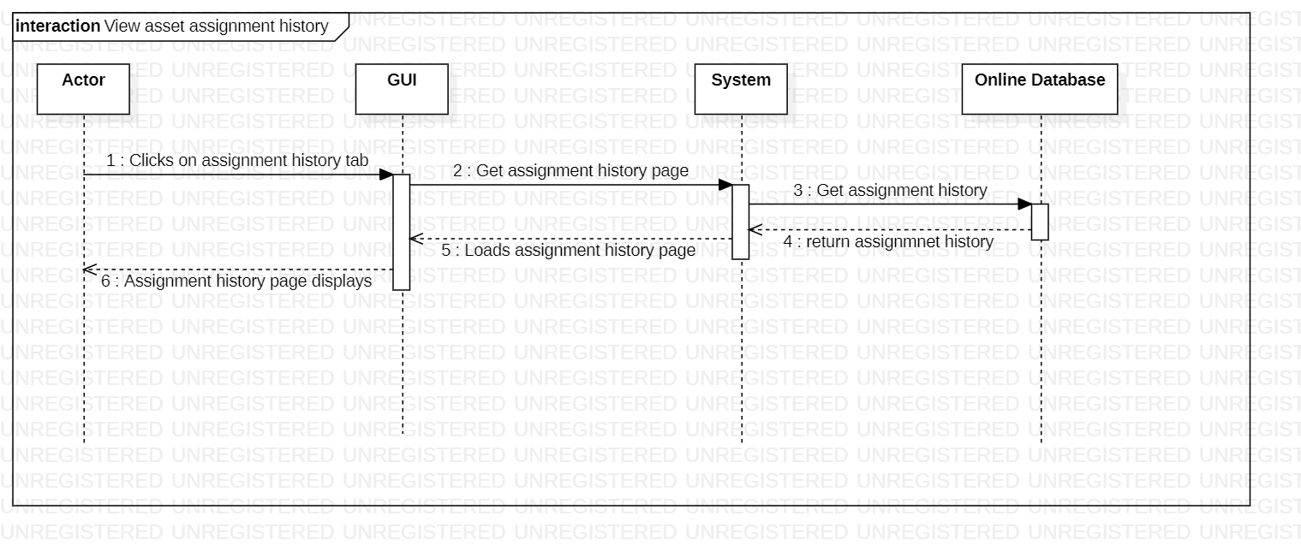

Figure 91: View Asset Assignment History

This is the sequence diagram of view asset assignment history.

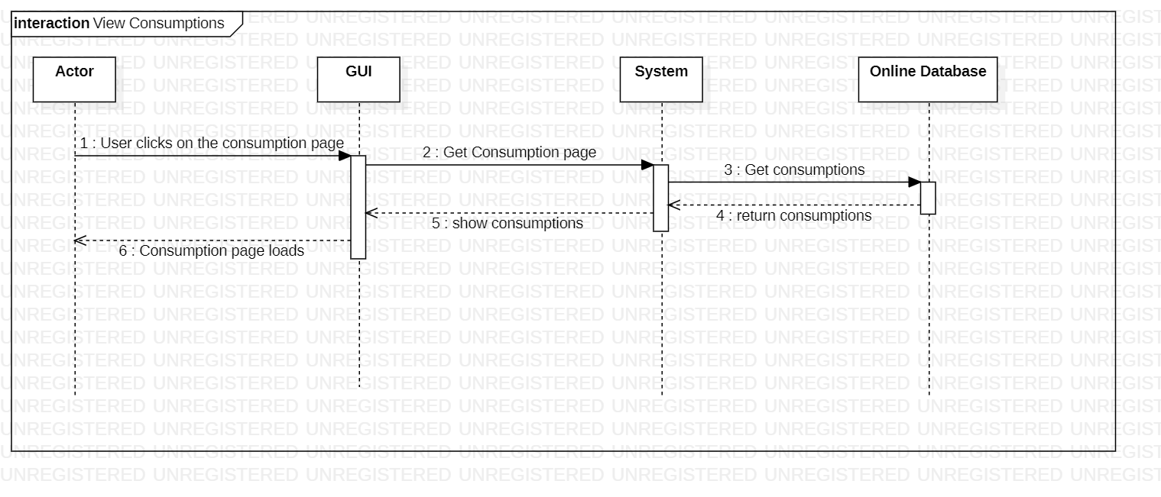

Figure 92: View Consumptions

This is the sequence diagram of view consumptions.

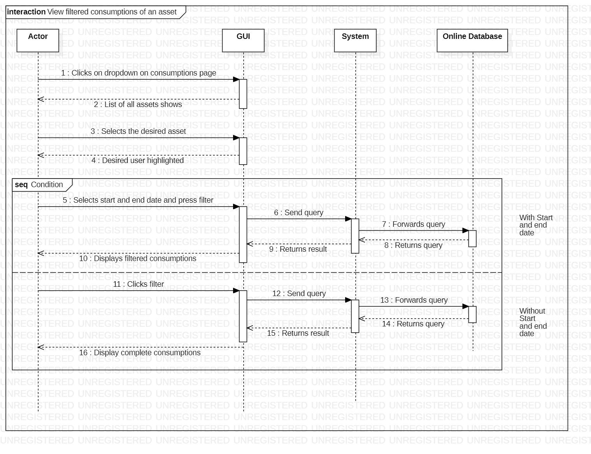

Figure 93: View Filtered Consumptions of an Asset

This is the sequence diagram of view filtered consumptions of an asset.

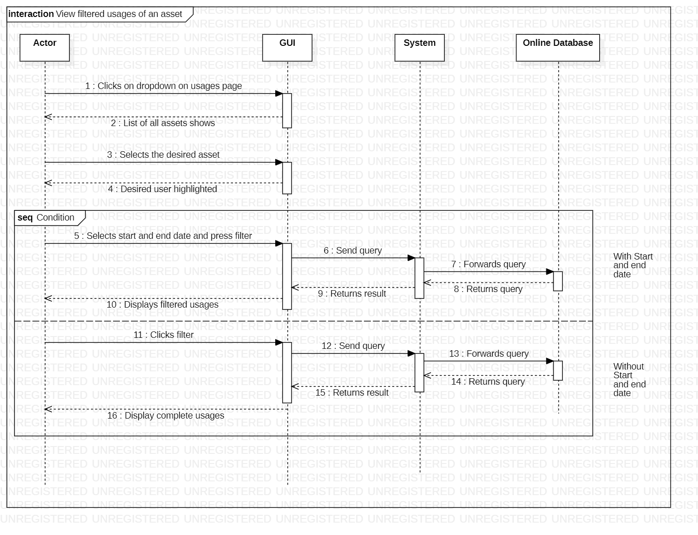

Figure 94: View Filtered Usages of an Asset

This is the sequence diagram of view filtered usages of an asset.

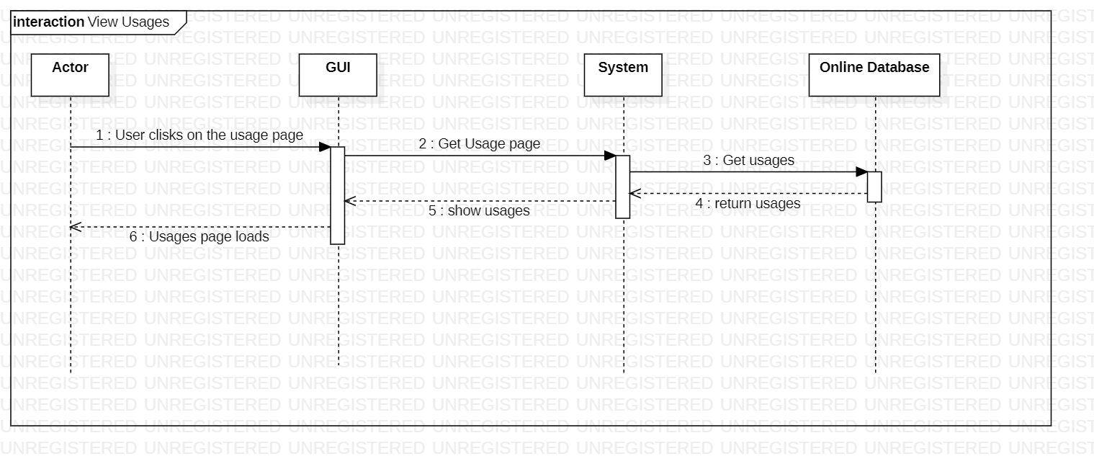

Figure 95: View Usages

This is the sequence diagram of view usages.

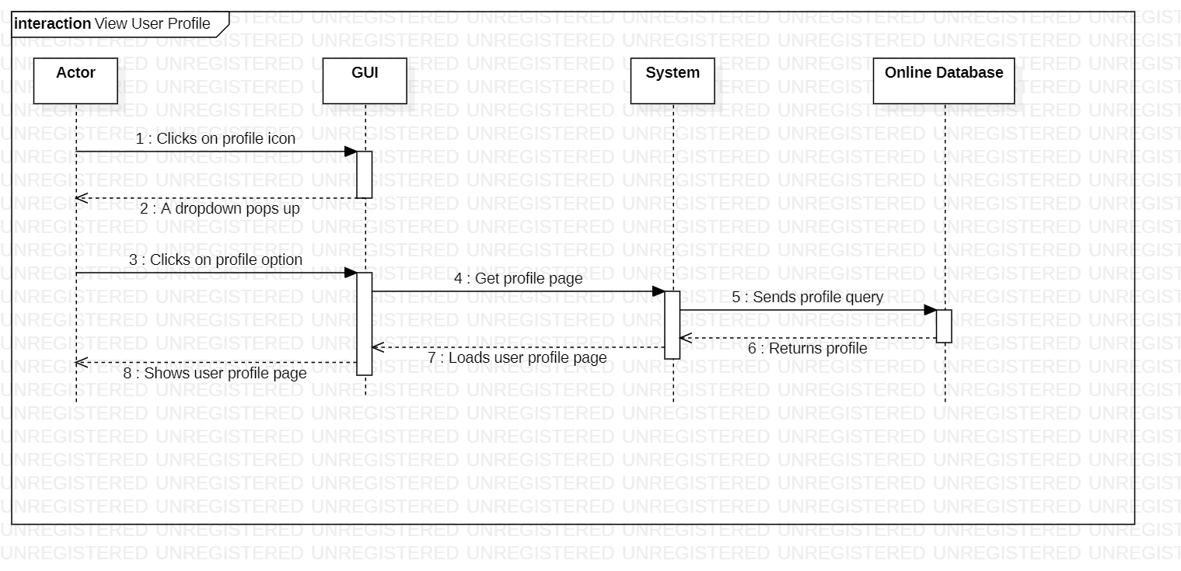

Figure 96: View User Profile

This is the sequence diagram of view user profile.

## Policies and Tactics

### Libraries and Database

All data in our application will be coming from the IoT devices attached to the vehicles. Data will be collected from these devices through an automated mechanism designed by our team.

### Coding guidelines and conventions

For the user interface the eight golden rules of interface design would be utilized as a standard. During the programming phase of the project, rules and standards set in spring boot, python and react would be followed. Moreover, for naming convention of variables camel case will be used.

### Testing the software

SOAP UI testing tool will be used for API testing throughout the project. The accuracy of the different predictive models would be tested with testing data after training the model on the training data provided to choose the best model.

### Maintaining the software

More advanced versions of the software would be introduced after the completion of this project. To increase the scope of the product predictive maintenance of several other assets will be introduced.

### Protocol

HTTP protocol will be used to exchange information among client side and server side on the application. To share information between different microservices Kafka will be used. Moreover, data will be in JSON format while transmitting over a network link.

### Accessing the application

The web application would be hosted on cloud accessible with a URL link. The application would be accessible on the internet via any computer having minimum requirements. Users must authenticate while entering the application.

# Implementation and Test Cases

This chapter provides the implementation details of our prototype.

## Implementation

Initially we have scraped data from websites of few popular clothing brands of Pakistan using Beautiful Soup which is a library of Python. After that we have cleaned the data and after that we worked on extracting the features from our data set that will help us to optimize the accuracy of our prototype. We ran our data on different types of Collaborative filtering algorithms alongside brute force approach in order to test the accuracy of these algorithm.

### Beautiful Soup

It is a Python library that is used to scrape HTML web pages in order to extract data from them and save it in csv files. We are using Beautiful Soup to extract products from websites of different clothing brands.

### Brute Force

We tried to recommend products using brute force method. For example, we stored a count for each product bought and recommended the product that was the bought the most.

### Collaborative Filtering

This is the most popular algorithm when it comes to recommendation systems. It basically recommends user certain products based on the behavior of many users. We implemented both types of Collaborative Filtering;

* User-based Collaborative Filtering: This technique basically filters users based on their similar buying habits and groups them together.
* Item-based Collaborative Filtering: On the other hand, this technique filters items based of similarities among them and recommends them to users based on that.

# 

Figure 96: Collaborative Filtering

This is the diagram explaining the working of Collaborative Filtering Algorithm.

# Conclusion

First, we had to decide what sorts of products we wanted to recommend to consumers. Then there's deciding which features to put on a website and which jobs to add to our database. For each position, we determined the use cases and functionalities that would be offered. We'll next incorporate this into our system design and develop ER and DB diagrams for each role.

We ran into a few issues while scraping different companies' webpages due to the varying website versions and structing customizations. Furthermore, these scraping concerns will exist in the future because brands may change their websites at any time, necessitating the frequent updating of our data and scraping code.

Following February, we expect to be able to complete our FYP 2 development phase in a month or two. We'll work to increase the accuracy of our suggestion algorithm and isolate those specific factors that can help us improve our results. In addition, we will continue to test our project and enhance our website during the FYP 2 phase. We plan to complete this as soon as possible and, if time permits, add further features to our product, such as a shopping cart and payment methods.

1. Reutskaja, E., Lindner, A., Nagel, R. et al. “Choice overload reduces neural signatures of choice set value in dorsal striatum and anterior cingulate cortex.” *Nature Human Behavior,* vol 2, no. 925–935, Oct, 2018. [Online serial]. Available:

<https://doi.org/10.1038/s41562-018-0440-2> [Accessed Sept. 30, 2021]

1. Y. Hu, X. Yi, and L. S. Davis, “Collaborative fashion recommendation: A functional tensor factorization approach,” in Proceedings of the 23rd Annual ACM Conference on Multimedia Conference, 2015.
2. E. A. Nogueira, E. V. De Melo, E. R. De Faria, and D. Guliato, “IKB-MS: A collaborative filtering approach associated with human visual attention for clothing recommendation,” in Proceedings of the 21st Brazilian Symposium on Multimedia and the Web, WebMedia 2015, pp. 149-156, October 2015.
3. N. Landia, “Building Fashion Recommendation System”, *dressipi.com*, Apr. 19, 2018. [Online]. Available:<https://dressipi.com/blog/building-fashion-recommendation-systems/>. [Accessed Sept. 27, 2021].
4. David Chong, “Deep Dive into Netflix’s Recommender System”, *towardsdatascience.com*, Apr. 30, 2020. [Online]. Available: <https://towardsdatascience.com/deep-dive-into-netflixs-recommender-system-341806ae3b48> [Accessed Nov. 2, 2021].